CENTURY
Soil Organic Matter Model
Environment

Technical Documentation
Agroecosystem Version 4.0

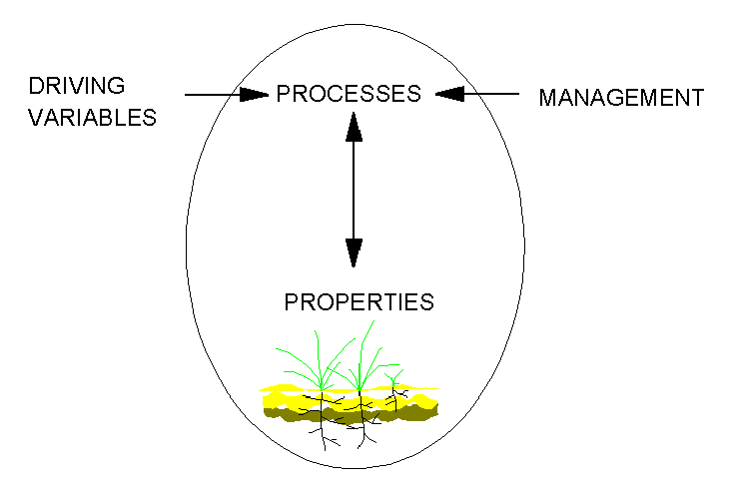
GPSR Technical Report No. 4

United States Department of Agriculture
Agricultrual Research Service
Great Plains Systems Research Unit

CENTURY
Soil Organic Matter Model

Environment

Technical Documentation
Agroecosystem Version 4.0

Great Plains System Research Unit
Technical Report No. 4

USDA-ARS
Fort Collins
Colorado

Alister K. Metherell

Laura A. Harding

C. Vernon Cole

William J. Parton

ACKNOWLEDGEMENTS

Funding of CENTURY Agroecosystem Version 4.0 was provided by USDA-ARS Global Climate Change Research Program to the CRIS Project "Prediction of Long-term Changes in Carbon Storage and Productivity of U.S. Soils as Affected by Changes in Climate and Management". The New Zealand Ministry of Agriculture and Fisheries provided the support of Alister Metherell for Ph. D. studies. We also acknowledge the support of EPA Project AERL 91-01 to Colorado State University and Michigan State University and NSF grant No. 8605191 to Colorado State University.

We would like to acknowledge those who have contributed to the development of CENTURY. The model was developed as a project of the U.S. National Science Foundation Ecosystem Studies Research Projects "Organic Matter and Nutrient Cycling in Semiarid Agroecosystems" (DEB-7911988) and "Organic C, N, S, and P Formation and Loss from Great Plains Agroecosystems" (BSR-9105281 and BSR-8406628). The original model was described by Parton, Anderson, Cole, and Stewart (1983), with computer programming done by Vicki Kirchner. Additional support for model enhancement was provided by the Tallgrass Ecosystem Fire project (BSR-82007015), the Central Plains Experimental Range-Long Term Ecological Research project (BSR-8605191), the NASA-EOS project "Carbon Balance in Global Grasslands" (NAGW-2662), and the Agriculture Research Service USDA. Collaboration with scientists involved in international projects such as the Tropical Soil Biology and Fertility (UNESCO-TSBF) Programme and the Scientific Committee On Problems of the Environment (SCOPE) Project on "Effect of climate change on production and decomposition in coniferous forests and grasslands" also was instrumental in the development of CENTURY. Version 3.0, released in April of 1991, continued the development of CENTURY with work done by W.J. Parton and programming by Rebecca McKeown. We also acknowledge Dennis Ojima as the originator of the conceptual framework for the EVENT100 scheduler interface. The support of William Parton, Dennis Ojima, Rebecca McKeown, and William Pulliam was critical for development of this version of CENTURY.

APPLICATION OF THE CENTURY MODEL

The CENTURY Model Version 4.0 embodies our best understanding to date of the biogeochemistry of Carbon, Nitrogen, Phosphorus, and Sulphur. The primary purposes of the model are to provide a tool for ecosystem analysis, to test the consistency of data and to evaluate the effects of changes in management and climate on ecosystems. Evolution of the model will continue as our understanding of biogeochemical processes improves. The identification of problem areas where processes are not adequately quantified is key to further developments. Ideally, model application will lead to the identification of needed research and new experimentation to improve understanding.

We value the responses and experiences of our collaborators in using CENTURY and encourage their feedback on problems in the current model formulation, as well as insight and suggestions for future model refinement and enhancement. It would be particularly helpful if users would communicate such feedback informally and where possible share with us documented model applications including manuscripts, papers, procedures, or individual model development.

DISCLAIMER

Neither the Great Plains System Research Unit - USDA (GPSR) nor Colorado State University (CSU) nor any of their employees make any warranty or assumes any legal liability or responsibility for the accuracy, completeness, or usefulness of any information, apparatus, product, or process disclosed, or represents that its use would not infringe privately owned rights. Reference to any special commercial products, process, or service by tradename, trademark, manufacturer, or otherwise, does not necessarily constitute or imply endorsement, recommendation, or favoring by the GPSR or CSU. The views and opinions of the authors do not necessarily state or reflect those of GPSR or CSU and shall not be used for advertising or product endorsement.

Copyright © 1993 Colorado State University
All Rights Reserved

TABLE OF CONTENTS

Page
1. INTRODUCTION 1-1

2. CENTURY ENVIRONMENT 2-1
2.1. Overview of the CENTURY Environment 2-1
2.2. Files 2-3
2.3. Units of Major Parameters 2-3
2.4. Hardware Requirements for PC Version 2-4
2.5. Installation of PC Version 2-4
2.6. Version 4.0 Upgrade Information 2-5

3. CENTURY MODEL DESCRIPTION 3-1
3.1. Introduction 3-1
3.2. Soil Organic Matter Submodel 3-1
3.3. Water Budget, Leaching, and Soil Temperature 3-4
3.4. Nitrogen Submodel 3-6
3.5. Phosphorus Submodel 3-8
3.6. Sulfur Submodel 3-10
3.7. Plant Production Submodels 3-13
3.7.1. Grassland/Crop Submodel 3-14
3.7.2. Forest Submodel 3-27
3.7.3. Savanna Submodel 3-32
3.8. Fertilizer 3-35
3.9. Irrigation 3-35
3.10. Cultivation 3-35
3.11. Grazing 3-35
3.12. Fire 3-36
3.13. Labeled C Simulation (¹⁴C and ¹³C) 3-36
3.14. Enriched CO₂ Effects 3-38
3.15. Soil Incubation (Microcosms) 3-40
3.16. Weather Data 3-40
3.17. Event Priority 3-41
3.18. Model Parameterization 3-41

4. PARAMETERIZATION THROUGH FILE100 4-1
4.1. Introduction 4-1
4.2. Using FILE100 4-1
4.3. Reviewing All Options 4-2
4.4. Adding an Option 4-2
4.5. Changing an Option 4-3
4.6. Changing the <site>.100 File 4-4
4.7. Deleting an Option 4-6
4.8. Comparing Options 4-6
4.9. Generating Weather Statistics 4-7
4.10. XXXX.100 Backup File 4-7
5. SCHEDULING EVENTS THROUGH EVENT100 5-1
5.1. Introduction 5-1
5.2. The Concept of Blocks 5-1
5.3. Defaults and Old Values 5-2
5.4. What EVENT100 Needs 5-2
5.5. Using EVENT100 5-2
5.6. Explanation of Event Commands 5-7
5.7. Explanation of System Commands 5-10
5.8. The -i Option: Reading from a Previous Schedule File 5-13
5.9. Examples of EVENT100 Sessions 5-14

6. EXECUTING CENTURY SIMULATIONS 6-1
6.1. Executing the PC VIEW Version 6-1
6.2. Executing the PC Stand-Alone Version 6-1
6.3. Executing the UNIX Stand-Alone Version 6-2
6.4. Using LIST100 with Stand-Alone Versions 6-2

7. WELD COUNTY, COLORADO HISTORICAL SCENARIO 7-1

8. LITERATURE CITED 8-1

APPENDICES
Appendix 1 CENTURY Reprints
Appendix 2 Definitions for CENTURY Parameters
Appendix 3 Sample Weather File and Atmospheric C¹⁴ Label File
Appendix 4 Flow Diagrams for the Subroutines and Model Output Variables
Appendix 5 CENTURY Data Files

INTRODUCTION

1. INTRODUCTION

CENTURY Agroecosystem Version 4.0 was especially developed to deal with a wide range of cropping system rotations and tillage practices for system analysis of the effects of management and global change on productivity and sustainability of agroecosystems. Version 4.0 integrates the effects of climate and soil driving variables and agricultural management to simulate carbon, nitrogen, and water dynamics in the soil-plant system. Simulation of complex agricultural management systems including crop rotations, tillage practices, fertilization, irrigation, grazing, and harvest methods is now possible in this enhanced release of the model.

The CENTURY model is a general FORTRAN model of the plant-soil ecosystem that has been used to represent carbon and nutrient dynamics for different types of ecosystems (grasslands, forest, crops, and savannas). A brief description of the model structure and scientific basis for the model is included in this manual. Aspects of the current version are discussed in Metherell (1992). A more detailed description of the earlier development of the CENTURY model is contained in Parton et al. (1987), Parton et al. (1988), and Sanford et al. (1991).

The model is available on either the PC or UNIX platforms. The PC version is designed to work with the VIEW run time output module of "TIME-ZERO™: the integrated modeling environment." which allows the user to run the model and then generate graphic output analysis. Also available is a stand-alone PC version which produces ASCII text files and does not provide any graphics capabilities. The UNIX version is also stand-alone (with no graphics) and can be run on Sun, Hewlett-Packard, and IBM platforms. These platforms are suggested for batch processing of large numbers of sites.

This document will describe how to use the CENTURY model and the two utility programs which assist the user in creating the input files needed for CENTURY. Section two describes the components of the CENTURY environment and gives the installation instructions. Section three gives a brief description of the scientific basis for the model, with reference to actual variable names where applicable. The fourth section explains the variable parameterization program, FILE100. The fifth section gives instructions on how to use EVENT100, the scheduling utility. Section six explains how to run the CENTURY model for each of the available versions. Section seven describes a specific CENTURY scenario. Finally, section eight lists in bibliographical form the literature cited in the manual.

Note that the CENTURY model output names for the state variables and flows are shown in the figures (output names are shown in standard type under the state names shown in bold). Some of the output variables are not available in PC CENTURY. The exact definitions of these output variables are found in the *.def data files and are available through the FILE100 program. When running the model it is quite useful to have copies of flow diagram figures since they indicate the names of the output variables for the different submodels.

CENTURY ENVIRONMENT

2. CENTURY ENVIRONMENT

2.1. Overview of the CENTURY Environment

The program "CENTURYM" is a Fortran representation of the CENTURY SOM model which was developed by Parton et al. (1987, 1988). It simulates C, N, P, and S dynamics through an annual cycle to centuries and millennia. A grassland/crop, forest or savanna system may be selected as a producer submodel with the flexibility of specifying potential primary production curves which represent the site-specific plant community. While running the simulation, the program writes files which interface with the runtime output module of TIME-ZERO™ (called VIEW in this document). The use of this runtime module allows you to specify which variables are to be plotted or printed. Alternatively, the stand-alone version on either the PC or UNIX platforms creates a binary file and an ASCII list of selected variables can be created using the LIST100 utility.

The CENTURY environment (Figure 2-1) consists of the CENTURY model, which uses the VIEW output program, and two utilities. The FILE100 program assists the user in creating and updating any of the twelve data files used by CENTURY. The EVENT100 program creates the scheduling file which contains the agricultural plants and events that are to occur during the simulation.

The CENTURY model obtains input values through twelve data files. Each file contains a certain subset of variables; for example, the cult.100 file contains the values related to cultivation. Within each file there may be multiple options in which the variables are defined for multiple variations of the event. For example, within the cult.100 file, there may be several cultivation options defined such as plowing or rod-weeder. For each option, the variables are defined to simulate that particular option. Each data input file is named with a ".100" extension to designate it as a CENTURY file. These files can be updated and new options created through the FILE100 program.

The timing variables and schedule of when events are to occur during the simulation is maintained in the schedule file, named with a ".sch" extension. This file can be created and updated through the EVENT100 program.

First, the CENTURY environment must be installed on the computer to be used (see Section 2.5). Then, follow these steps to work through each facet of the environment:

1. Use the FILE100 program to update values or create new options in any of the .100 data files (Section 4).

2. Use the EVENT100 program to establish the simulation time and to schedule events to occur during the simulation (Section 5).

- Run the CENTURY model. Refer to Section 6 for specific instructions based on the PC or UNIX platform to be used.
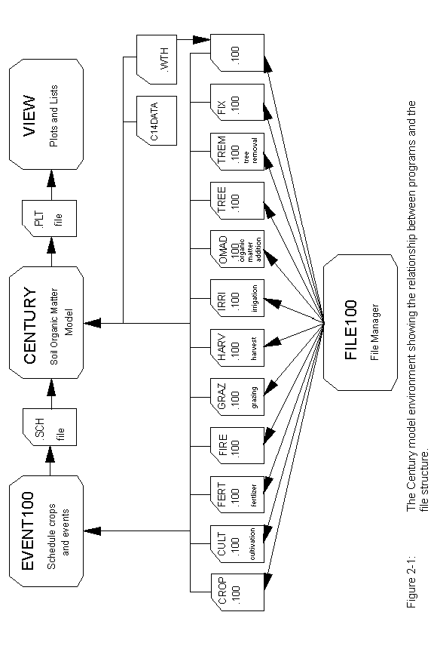
2.2. Files

The CENTURY Environment consists of these files:

century.bat batch file used to run CENTURY and VIEW
centurym.exe the CENTURY executable model
centurym.tab table file generated by TIME-ZERO™ to handle I/O
centurym.dat master list of all variables used in CENTURY, not to be modified by the user
temp.sav file required by VIEW
centuryx.exe the stand-alone CENTURY executable model

fix.100 file with fixed parameters primarily relating to organic matter decomposition and not normally adjusted between runs
<site>.100 site-specific parameters such as precipitation, soil texture, and the initial conditions for soil organic matter; the name of this file is provided by the user

crop.100 crop options file
cult.100 cultivation options file
fert.100 fertilization options file
fire.100 fire options file
graz.100 grazing options file
harv.100 harvest options file
irri.100 irrigation options file
omad.100 organic matter addition options file
tree.100 tree options file
trem.100 tree removal options file

*.def for each *.100 file, there is a corresponding ".def" file which contains the definitions of each parameter needed for each option; the format of these ASCII files should not be modified by the user
sample.wth sample weather file
c14data sample ¹⁴C data file

2.3. Units of Major Parameters

Time step: one month (1/12 year or .083333 year)
Minimum time: year
Soil Organic Matter: grams C, N, P, or S per meter square
Plant Material: grams C, N, P, or S per meter square
Mineral pools: grams N, P, or S per meter square
Temperature: degrees Centigrade
Precipitation: centimeters per month

2.4. Hardware Requirements for PC Version

The CENTURY Model plus the VIEW module from TIME-ZERO™ requires an IBM-PC or compatible with at least 512K of RAM. A graphics adapter (CGA, EGA, VGA, or Hercules monographic) is recommended. The model files supplied on the diskettes require approximately 220 kilobytes of disk space. The VIEW files require 394 kilobytes of disk space. An output file (CENTURYM.PLT) with data saved monthly for 100 years or annually for 1200 years requires 1-2 Mb of disk space.

2.5. Installation of PC Version

The package contains 2 diskettes. Disk 1 is labeled VIEW, and contains the VIEW module from TIME-ZERO™. Disk 2, labeled CENTURY, contains the CENTURY environment files.

The CENTURY model files may be installed in any directory you wish. The CENTURY diskettes contain an installation program. To run the installation program,

1. Insert Disk 1 into an appropriate drive (For example, drive A).
2. Change directories to the drive you chose:
A:
3. At the A:\ prompt enter,
INSTALLC C:\path ... \CENTURY
where path is the directory path to the location where you want to install the model.
4. Follow the directions as they appear on the screen.

The installation procedure will create all the necessary directories and copy all files to the appropriate directory.

During the installation of VIEW, you will be required to select a printer for the screen dump utility. When the menu of printers is shown, select a printer using the cursor keys, then press the TAB key and select the port to which the printer is connected. Press RETURN when you are done.

There are two ways to set up the directory path so that the VIEW module can be found by the CENTURY.BAT program.

1. Update the PATH statement in the AUTOEXEC.BAT file to include the VIEW directory. This has the advantage that the path does not need to be temporarily updated every time CENTURY is run.
OR

2. Allow the CENTURY.BAT file to temporarily update the PATH. If this method is chosen, the batch file will need some environment space. If you get an "OUT OF ENVIRONMENT SPACE" error message while running CENTURY, modify your CONFIG.SYS file to provide additional environment space. A typical entry to expand the environment space would be,
SHELL=COMMAND.COM /P /E:512
where 512 is the number of bytes to be reserved for the environment. There should also be at least 20 file handles reserved by the CONFIG.SYS. To reserve 20 file handles, put the statement,
FILES=20
in the CONFIG.SYS. Be sure to CHECK THE DOS MANUAL for instructions. Some versions of DOS prior to 3.2 used paragraphs (16 bytes/paragraph) as the argument in SHELL. If you try to reserve too much space, DOS will ignore your /E: argument.

2.6. Version 4.0 Upgrade Information

Minor upgrades to version 4.0 will be available free of charge via anonymous ftp. These versions will be numbered 4.x and a text file will be included to describe the changes.

Ftp to "ftp.nrel.colostate.edu", using "anonymous" as the name and your full login name (e-mail address) as the password.

Change to the pub/century4.0 directory by typing "cd pub/century4.0".

You can get a listing of the contents of the directory by typing "dir".

Retrieve files by using the "get filename" command.

CENTURY MODEL DESCRIPTON

3. CENTURY MODEL DESCRIPTION

3.1. Introduction

The CENTURY model simulates the long-term dynamics of Carbon (C), Nitrogen (N), Phosphorus (P), and Sulfur (S) for different Plant-Soil Systems. The model can simulate the dynamics of grassland systems, agricultural crop systems, forest systems, and savanna systems. The grassland/crop and forest systems have different plant production submodels which are linked to a common soil organic matter submodel. The savanna model uses the grassland/crop and forest subsystems and allows for the two subsystems to interact through shading effects and nitrogen competition. The soil organic matter submodel. simulates the flow of C, N, P, and S through plant litter and the different inorganic and organic pools in the soil. The model runs using a monthly time step and the major input variables for the model include:

(1) monthly average maximum and minimum air temperature,
(2) monthly precipitation,
(3) lignin content of plant material,
(4) plant N, P, and S content,
(5) soil texture,
(6) atmospheric and soil N inputs, and
(7) initial soil C, N, P, and S levels.

The input variables are available for most natural and agricultural ecosystems and can generally be estimated from existing literature. Most of the parameters that control the flow of C in the system are in the fix.100 file.

The user can choose to run the model considering only C and N dynamics (NELEM=1) or C, N, and P (NELEM=2) or C, N, P, and S (NELEM=3).

3.2. Soil Organic Matter Submodel

The SOM submodel is based on multiple compartments for SOM and is similar to other models of SOM dynamics (Jenkinson and Rayner, 1977; Jenkinson, 1990; van Veen and Paul, 1981). The pools and flows of C are illustrated in Figure 3-1. The model includes three soil organic matter pools (active, slow and passive) with different potential decomposition rates, above and belowground litter pools and a surface microbial pool which is associated with decomposing surface litter.

Above and belowground plant residues and organic animal excreta are partitioned into structural (STRUCC(*)) and metabolic (METABC(*)) pools as a function of the lignin to N ratio in the residue. With increases in the ratio, more of the residue is partitioned to the structural pools which have much slower decay rates than the metabolic pools. The structural pools contain all of the plant lignin (STRLIG(*)).
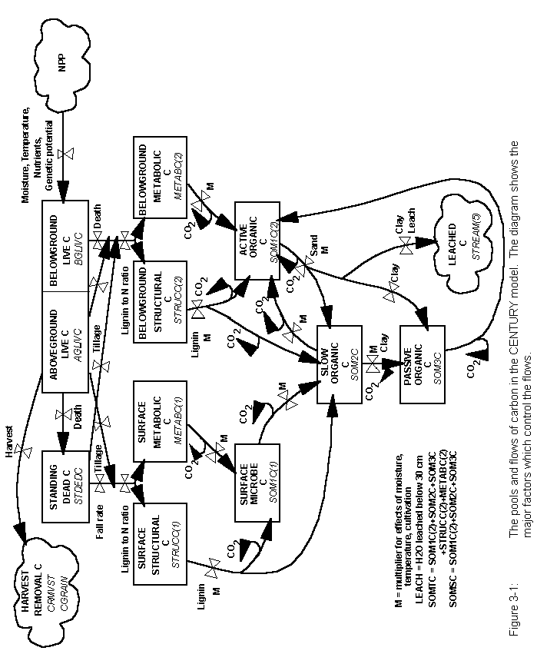
The decomposition of both plant residues and SOM are assumed to be microbially mediated with an associated loss of CO₂ (RESP(*)) as a result of microbial respiration. The loss of CO₂ on decomposition of the active pool increases with increasing soil sand content. Decomposition products flow into a surface microbe pool (SOM1C(1)) or one of three SOM pools, each characterized by different maximum decomposition rates. The potential decomposition rate is reduced by multiplicative functions (DEFAC) of soil moisture and soil temperature and may be increased as an effect of cultivation (CLTEFF(*), cult.100). Average monthly soil temperature near the soil surface (STEMP) is the input for the temperature function while the moisture function uses the ratio of stored soil water (0-30 cm depth, AVH2O(3)) plus current month's precipitation (RAIN) to potential evapotranspiration (PET). The decomposition rate of the structural material (STRUCC(*)) is a function of the fraction of the structural material that is lignin. The lignin fraction of the plant material does not go through the surface microbe (SOM1C(1)) or active pools (SOM1C(2)) but is assumed to go directly to the slow C pool (SOM2C) as the structural plant material decomposes.

The active pool (SOM1C(2)) represents soil microbes and microbial products (total active pool is ~2 to 3 times the live microbial biomass level) and has a turnover time of months to a few years depending on the environment and sand content. The soil texture influences the turnover rate of the active soil SOM (higher rates for sandy soils) and the efficiency of stabilizing active SOM into slow SOM (higher stabilization rates for clay soils). The surface microbial pool (SOM1C(1)) turnover rate is independent of soil texture, and it transfers material directly into the slow SOM pool (SOM2C). The slow pool includes resistant plant material derived from the structural pool and soil-stabilized microbial products derived from the active and surface microbe pools. It has a turnover time of 20 to 50 years. The passive pool (SOM3C) is very resistant to decomposition and includes physically and chemically stabilized SOM and has a turnover time of 400 to 2000 years. The proportions of the decomposition products which enter the passive pool from the slow and active pools increase with increasing soil clay content.

A fraction of the products from the decomposition of the active pool is lost as leached organic matter (STREAM(5)). Leaching of organic matter is a function of the decay rate for active SOM, and the clay content of the soil (less loss for clay soils) and only occurs if there is drainage of water below the 30 cm soil depth (leaching loss increases with increasing water flow up to a critical level - OMLECH(3), fix.100).

Anaerobic conditions (high soil water content) cause decomposition to decrease. The soil drainage factor (DRAIN, <site>.100) allows a soil to have differing degrees of wetness (e.g., DRAIN=1 for well drained sandy soils and DRAIN=0 for a poorly drained clay soil).

A detailed description of the structure of an earlier version of the model and the way in which model parameters were estimated is found in Parton et al. (1987) (see Appendix 1).
The model has N, P, and S pools analogous to all of the C pools. Each SOM pool has an allowable range of C to element ratios based on the conceptual model of McGill and Cole (1981). Reflecting the concept that N is stabilized in direct association with C, C to N ratios are constrained within narrow ranges, while the ester bonds of P and S allow C to P and C to S ratios to vary widely. The ratios in the structural pool are fixed at high values, while the ratio in the metabolic pool is allowed to float in concert with the nutrient content of the plant residues. The actual ratios for material entering each SOM pool are linear functions of the quantities of each element in the labile inorganic mineral pools in the surface soil layers (MINERL(1,*)). Low nutrient levels in the labile pools result in high C to element ratios in the various SOM pools. The N, P, and S flows between SOM pools are related to the C flows. The quantity of each element flowing out of a particular pool equals the product of the C flow and the element to C ratio of the pool. Mineralization or immobilization of N, P, and S occurs as is necessary to maintain the ratios discussed above. Thus, mineralization of N, P, and S occurs as C is lost in the form of CO₂ and as C flows from pools with low ratios, such as the active pool, to those with higher ratios, such as the slow pool. Immobilization occurs when C flows from pools with high ratios, such as the structural pool, to those with lower ratios, such as the active pool. The decomposition rate is reduced if the quantity of any element is insufficient to meet the immobilization demand.

3.3. Water Budget, Leaching and Soil Temperature

The CENTURY model includes a simplified water budget model which calculates monthly evaporation (EVAP) and transpiration (TRAN) water loss, water content of the soil layers (ASMOS(*)), snow water content (SNOW), and saturated flow of water between soil layers (Figure 3-2). If the average air temperature (TAVE) is less than 0°C monthly precipitation (RAIN) occurs as snow. Sublimation and evaporation of water from the snow pack occurs at a rate equal to the potential evapotranspiration rate (PET). Snow melt occurs if the average air temperature is greater than 0°C and is a linear function of the average air temperature.

The potential evapotranspiration rate (PET) is calculated as a function of the average monthly maximum (TMX2M(*)) and minimum (TMN2M(*)) air temperature using the equations developed by Linacre (1977) and may be modified by a user specified multiplier (FWLOSS(4), fix.100). Bare soil water loss is a function of standing dead and litter biomass (lower for high biomass levels), rainfall and PET. Interception water loss is a function of aboveground biomass (increases with biomass level), rainfall and PET. Potential transpiration water loss (PTTR) is a function of the live leaf biomass and PET. Interception and bare soil water losses are calculated as fractions of the monthly precipitation and are subtracted from the total monthly precipitation, with the remainder of the water added to the soil.

Water is distributed to the different layers by adding the water to the top layer (0-15 cm, ASMOS(1)) and then draining excess water (water above field capacity) to the next layer. Transpiration water loss (TRAN) occurs after the water was added to the soil.
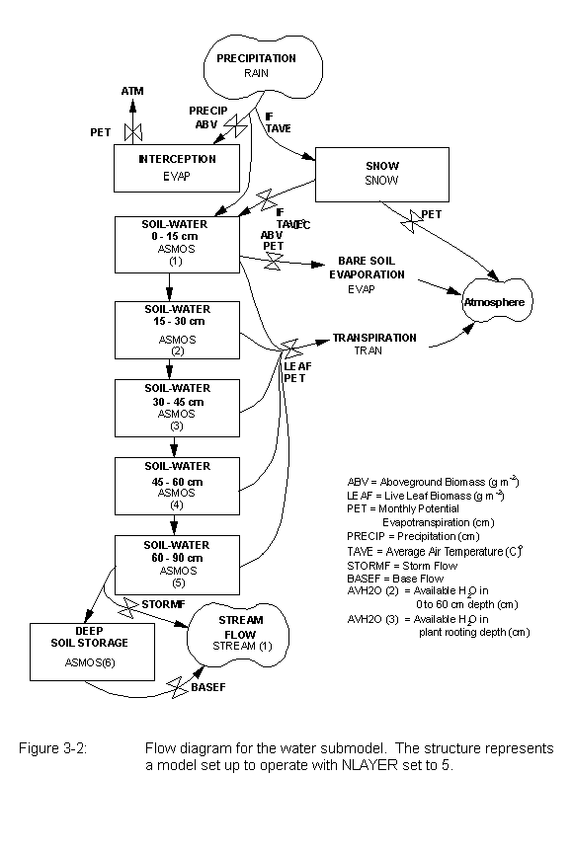
Water loss occurs first as interception, followed by bare soil evaporation and transpiration (the sum does not exceed the PET rate). The maximum monthly evapotranspiration water loss rate is equal to PET.

Depending on the value of SWFLAG (<site>.100), the field capacity (AFIEL(*), <site>.100) and wilting point (AWILT(*), <site>.100) for the different soil layers can optionally be input from the <site>.100 file or calculated as a function of the bulk density (BULKD, <site>.100), soil texture (SAND, SILT, CLAY, <site>.100), and organic matter content (SOMSC) using a choice of equations developed by Gupta and Larson (1979) or Rawls et al. (1982). The number of soil layers (NLAYER, <site>.100) is an input variable in the model. 15 cm increments were used for each layer up to the 60 cm soil depth and 30 cm increments below the 60 cm depth (NLAYER = 4 has this structure: 0-15,15-30,30-45,45-60, and NLAYER = 6 has this structure: 0-15,15-30,30-45,45-60,60-90,90-120). Water leached below the last soil layer is not available for evapotranspiration and is a measure of interflow, runoff or leaching losses from the soil profile. Water going below the profile can be lost as storm flow (STORMF, <site>.100 - fraction lost as fast stream flow) or leached into the subsoil where it can accumulate or move into the stream flow (STREAM(1)) at a specified rate (BASEF, <site>.100 - fraction per month of subsoil H₂O going into stream flow). The model can simulate watershed stream flow by adjusting STORMF and BASEF.

Leaching of labile mineral N, (NO₃ + NH₄), P, and S pools occurs when there is saturated water flow between soil layers. The fraction of the mineral pool that flows from the upper layer to the lower layer is a function of the sand content (increasing with increasing sand content - FLEACH(1) and FLEACH(2), fix.100) and the amount of water that flows between layers (linear function up to a maximum value - MINLCH, fix.100 cm per month). FLEACH(3), FLEACH(4) and FLEACH(5) (fix.100) control inorganic N, P, and S leaching respectively. Monthly watershed losses of H₂O (STREAM(1)), inorganic N, P, and S (STREAM(2), STREAM(3) and STREAM(4)), and organic C, N, P, and S (STREAM(5), STREAM(6), STREAM(7), and STREAM(8)) are simulated by the model.

Average monthly soil temperature near the soil surface (STEMP) is calculated using equations developed by Parton (1984). These equations calculate maximum soil temperature as a function of the maximum air temperature and the canopy biomass (lower for high biomass) while the minimum soil temperature is a function of the minimum air temperature and canopy biomass (higher for higher biomass). The actual soil temperature (STEMP) used for decomposition and plant growth rate functions is the average of the minimum and maximum soil temperatures.

3.4. Nitrogen Submodel

The N submodel (Figure 3-3) has the same structure as the soil C model. The N flows follow the C flows (Figure 3-3, N flows between organic pools not shown can be seen in Figure 3-1) and are equal to the product of the carbon flow and the N:C ratio of the state variable that receives the carbon. The C:N ratio of the structural pools (150) remains fixed while the N contents of the metabolic pools vary as a function of the N content of the
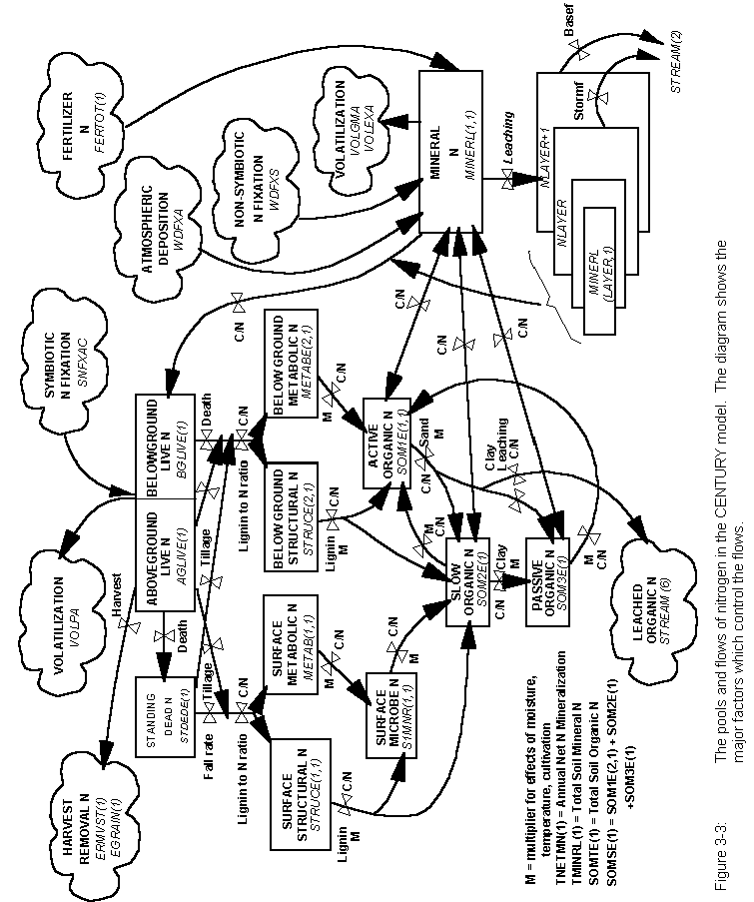
incoming plant residue. The C:N ratio of newly formed surface microbial biomass is a function of the N content of the material being decomposed (increases for low N content). The C:N ratios of organic matter entering each of the three soil pools vary as linear functions of the size of the mineral N pool. As mineral N in the surface soil layer increases from 0 to 2 g N / m², the C:N ratios decrease from 15 to 3 for the active pool, from 20 to 12 for the slow pool and from 10 to 7 for the passive pool. The C:N ratio for slow material formed from surface microbial biomass is a function of C:N ratio of the surface microbe pool.

The N associated with carbon lost in respiration (30% to 80% of the carbon flow is respired) is assumed to be mineralized. Given the C:N ratio of the state variables and the microbial respiration loss for each flow, decomposition of metabolic residue, active, slow, and passive pools generally result in net mineralization of N, while decomposition of structural residue immobilizes N.

The model uses simple equations to represent N inputs due to atmospheric deposition and soil and plant N fixation. Atmospheric N inputs (EPNFA(*), <site>.100) are a linear function of annual precipitation (PRCANN). The model has the option (NSNFIX) of calculating soil N fixation rates as a function of the mineral N to labile P ratio (high fixation with lower ratios) or as a linear function (EPNFS(*), <site>.100) of annual precipitation. Symbiotic plant N fixation (SNFXAC, crop.100) is assumed to occur only when there is insufficient mineral N to satisfy the plant N requirement, having taken into account all possible growth reductions including P or S deficiency. Symbiotic N fixation can occur up to a maximum level of g N fixed per g C fixed (SNFXMX, crop.100) specified for each crop type and is hence related to the plant growth rate. The model also includes fertilizer N inputs and N inputs through organic matter additions (see parameters in the fert.def and omad.def files, Appendix 2).

The losses of N due to leaching of NO₃ are related to soil texture and the amount of water moving through the soil profile (see water flow submodel description, Section 3.3). Losses accumulate in the layer below the last soil layer (MINERL (NLAYER+1,1)) or are lost in the stream flow (STREAM(2)). Loss of organic N (STREAM(6) occurs with the leaching of organic matter. Gaseous losses of N compounds associated with mineralization /nitrification (VOLGMA), denitrification (VOLEXA), volatilization from maturing crops or senescing grassland (VOLPLA) are calculated. Losses due to crop removal, burning, transfer of N in animal excreta, and soil erosion are also accounted for.

3.5. Phosphorus Submodel

The P submodel (Figure 3-4) has the same general structure as the N submodel. The major difference is that there are five mineral P pools (labile P (PLABIL), sorbed P, strongly sorbed P (SECNDY(2)), parent P (PARENT(2), and occluded P (OCCLUD)). The phosphorus submodel (Figure 3-4) has been revised to give a better representation of phosphorus sorption. Because CENTURY uses a relatively long timestep (¼ month for the soil nutrient submodel) and soil solution very rapidly equilibriates with the labile fraction of adsorbed P (Cole et al., 1977) it is not appropriate to use soil solution P for the available
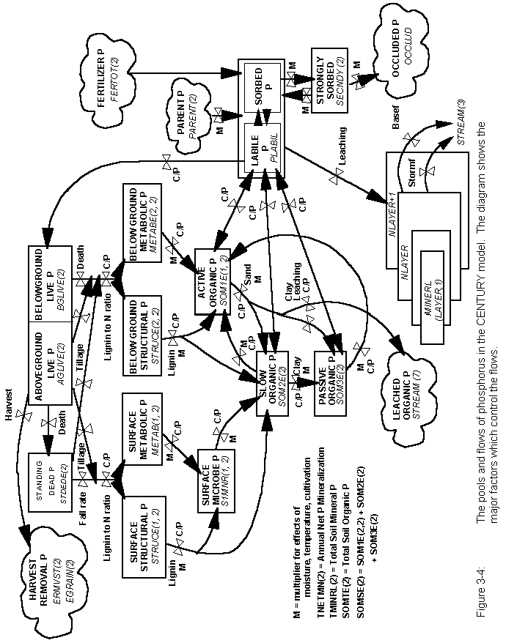
nutrient pool. Instead, a labile P pool (PLABIL) has been defined, equivalent to resin extractable P, which is in equilibrium with a sorbed P pool (Figure 3-5). The equilibrium between the labile and sorbed P pools is recalculated after any P additions or removals from the soil. The sum of labile P and sorbed P are represented by the state variable MINERL(1,2). Plant uptake, immobilization and leaching of P (if allowed) are controlled by the size of the labile P pool. The fraction of labile P that is available for plant uptake varies from 0.4 to 0.8 as a function (FAVAIL(*)) of the mineral N pool size (higher fractions for high mineral N levels). As more P is removed through plant and soil microbial uptake, larger amounts become immobilized in organic matter.

The equilibrium relationship between labile P and sorbed P is defined in terms of two parameters, sorption affinity (PSLSRB, <site>.100) and sorption maximum (SORPMX, <site>.100). The sorption affinity parameter controls the fraction of the labile plus sorbed pools which is in the labile pool at low levels of P in these pools. The sorption maximum is the maximum amount of P which can be in the sorbed P pool. The sorption maximum controls the curvature of the relationship between labile P and the sum of the labile and sorbed P pools.

The sorbed P is in dynamic equilibrium (PSECMN(2), PMNSEC(2), fix.100) with a more strongly sorbed P pool (SECNDY(2)) which may in turn lose P (PSECOC, fix.100) to an occluded P pool (OCCLUD). Phosphorus can enter the cycling P pools by weathering of parent material P (PARENT(2)), which is typically apatite. The rate of weathering (PPARMN(2), fix.100) can be a function of soil texture (TEXEPP(*), fix.100) (higher for fine textured soils). The rate of these P flows are all multiplied by the same moisture and temperature functions (DEFAC) that are used for organic matter decomposition.

The organic part of the P submodel operates in the same way that the N submodel works; C:P ratios of organic fractions are fixed for the structural P pool (500) and vary as a function of the labile P pool (PLABIL) for the active (30-80), slow (90-200), and passive (20-200) SOM pools. C:P ratios of newly formed surface microbes are functions of the P content of the material decomposing, and the C:P ratio of slow material formed from the surface microbes is a function of the C:P ratio of surface microbes. The flows for the organic P pools are calculated in exactly the same way as organic N flow.

Phosphorus losses from the system occur as result of leaching of labile P (MINERL(NLAYER+1,2) - P losses accumulate in the soil layer below the last layer) and organic P compounds (STREAM(7)), soil erosion, crop removal, grazing, and burning P losses. P additions come from P fertilizer and organic matter additions (see parameters in the fert.def and omad.def file).

3.6. Sulfur Submodel

The structure of the sulfur submodel (Figure 3-6) is similar to the P submodel. The only major difference is that the S model does not include occluded or sorbed pools. The main source of S in most soils is the weathering of primary minerals. Secondary S is formed as a result of adsorption of S on clay minerals. Organisms in the soil and plant
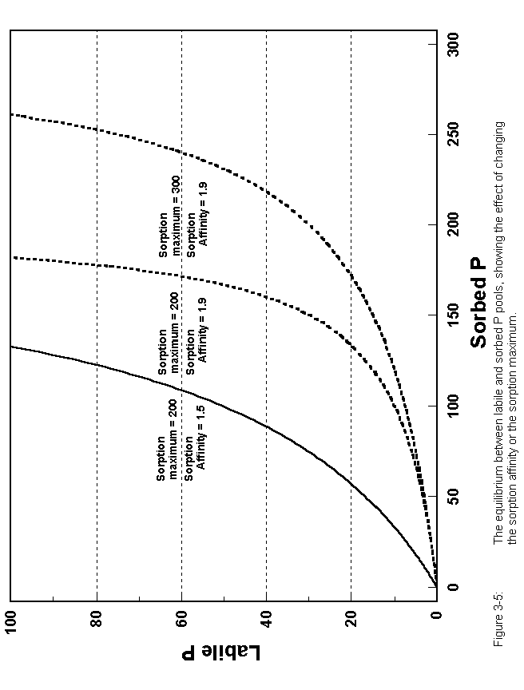
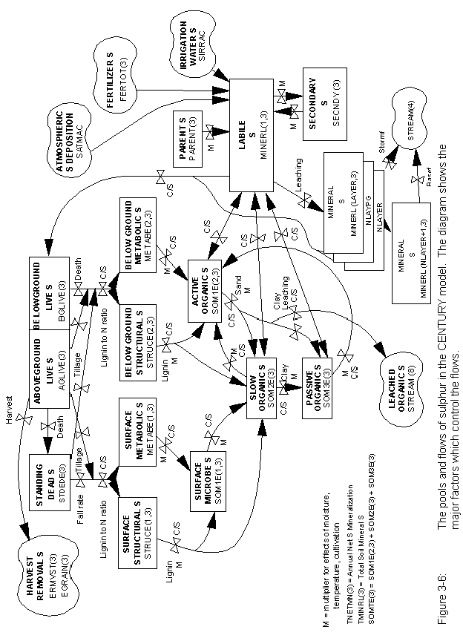
roots take up S from soil solution (MINERL(layer,3) and start the formation of organic S compounds. The organic component of the S model operates in the same way as the organic N and P submodels with the C:S ratio of the structural pool being fixed (500) while the C:S ratios for the active (20-80), slow (90-200) and passive (20-200) pools vary as a function of the labile S pool (MINERL(1,3)). C:S ratios for surface microbes are calculated in the same way as the C:N and C:P ratios. The C:S ratios for the organic components are specified in the file fix.100 (see Appendix 2). The organic S flows are calculated in the same manner as the organic N and P flows while the inorganic S flows are functions of specified rate parameters (PPARMN(3), PSECMN(3), PMNSEC(3), fix.100) and the moisture and temperature functions that are used for organic matter decomposition (DEFAC). The model allows for S fertilization, addition of organic S material (see parameters in the fert.def and omad.def files, Appendix 2), atmospheric deposition (SATMOS(*), <site>.100), S in irrigation water (SIRRI, <site>.100), and accounts for S losses due to crop removal, grazing, leaching of organic S compounds (STREAM(8)), erosion of SOM, and fire. The S submodel has not been as well tested as the N and P submodels. Parton et al. (1988), Metherell (1992), and Metherell et al. (1993a) describe interactions of S with C, N, and P. The S model could be set up to simulate K dynamics instead of S dynamics if K is a limiting factor in particular soils.

3.7. Plant Production Submodels

The CENTURY model is set up to simulate the dynamics of grasslands, agricultural crops, forests, and savanna (tree-grass) systems. The grassland/crop production model simulates plant production for different herbaceous crops and plant communities (e.g. warm or cool season grasslands, wheat and corn). Grassland/crop options are selected from the crop.100 file. Existing crop options may be altered to suit particular varieties or environments or new options created using the FILE100 program. Harvest, grazing, fire and cultivation can all directly effect aboveground biomass, while grazing and fire may also impact root to shoot ratios and nutrient content. The forest model simulates the growth of deciduous or evergreen forests in juvenile and mature phases. Fire, large scale disturbances (e.g. hurricanes), and tree harvest practices may impact forest production. The savanna system is simulated as a tree-grass system, essentially using the existing tree and grassland/crop submodels with the two subsystems interacting through shading effects and nitrogen competition.

Both plant production models assume that the monthly maximum plant production is controlled by moisture and temperature and that maximum plant production rates are decreased if there are insufficient nutrient supplies (the most limiting nutrient constrains production). The fraction of the mineralized pools that are available for plant growth is a function of the root biomass with the fraction of nutrients available for uptake increasing exponentially as live root biomass increases from 20 to 300 gm⁻². Most forest or grassland/crop systems are limited by nutrient availability and generally respond to the addition of N and P. The savanna model modifies maximum grass production by a shade modifier that is a function of tree leaf biomass and canopy cover. Additional nutrient constraints on plant production due to nutrient allocation between trees and grasses decrease maximum production rates for the grasses.
3.7.1. Grassland/Crop Submodel

The model can simulate a wide variety of crops and grasslands by altering a number of crop specific parameters (see Appendix 2 for the crop.100 parameters). CENTURY is not designed to be a plant production model and some parameters may have to be calibrated for specific environments.

The plant production model (Figure 3-7) has pools for live shoots and roots, and standing dead plant material. Potential production (g C / m² / month) is a function of a genetic maximum defined for each crop (PRDX(1), crop.100) and 0-1 scalars depending on soil temperature, moisture status, shading by dead vegetation, and seedling growth.

The maximum potential production of a crop, unlimited by temperature, moisture or nutrient stresses, is primarily determined by the level of photosynthetically active radiation, the maximum net assimilation rate of photosynthesis, the efficiency of conversion of carbohydrate into plant constituents, and the maintenance respiration rate (van Heemst, 1986). Thus, the parameter for maximum potential production (PRDX(1)) has both genetic and environmental components. However, in CENTURY, the seasonal distribution of production is primarily controlled by the temperature response function rather than the seasonal variation in photosynthetically active radiation, so the maximum potential production parameter should reflect aboveground crop production in optimal summer conditions. This parameter will frequently be used to calibrate the predicted crop production for different environments, species, and varieties. In the CENTURY model formulation the potential production is based on aboveground production, therefore root-shoot allocation must also be taken into account. The value used should be set according to estimates of potential crop production. In general, C4 species have higher potential growth rates than C3 species because of higher maximum net assimilation rates (van Heemst, 1986). The range of potential production from 200 to 580 kg DM / ha / day corresponds to 240 to 700 g C / m² / month.

The growth of most plant species exhibits a response curve to root temperature which is sigmoidal up to an optimum temperature, has a band of optimum temperatures over which there is relatively little effect on growth, and a rapid decline above the optimum (Cooper, 1973). Plant growth rates will depend on the combined temperature response of photosynthesis and respiration. For most temperate species the lower limit at which the rate of development is perceptible is between zero and 5° C. Development increases in rate up to an optimum of 20° to 25° C and then declines to an upper limiting temperature between 30° and 35° C. For tropical species the base, optimum and maximum temperatures are approximately 10° higher (Monteith, 1981). In the CENTURY model the temperature response curve can be parameterized for each crop using a generalized Poisson density function (PPDF(1...4), crop.100) as shown in Figure 3-8.
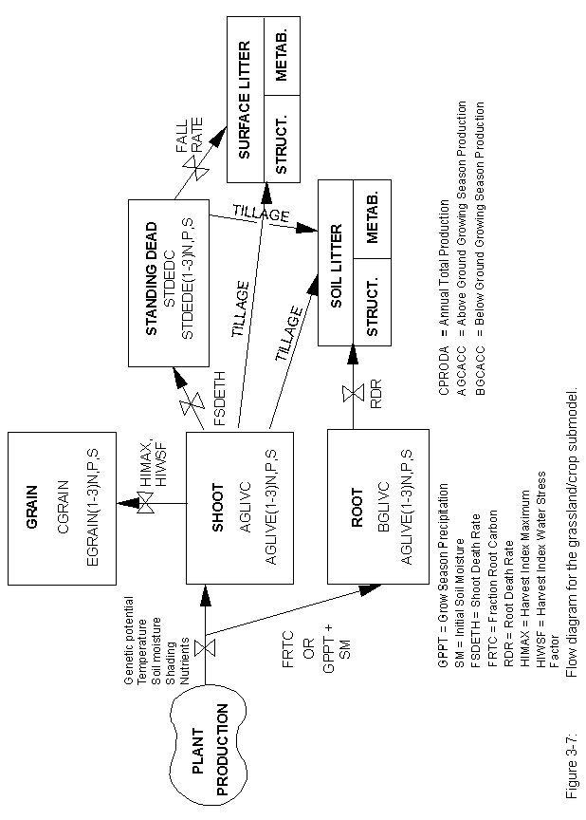
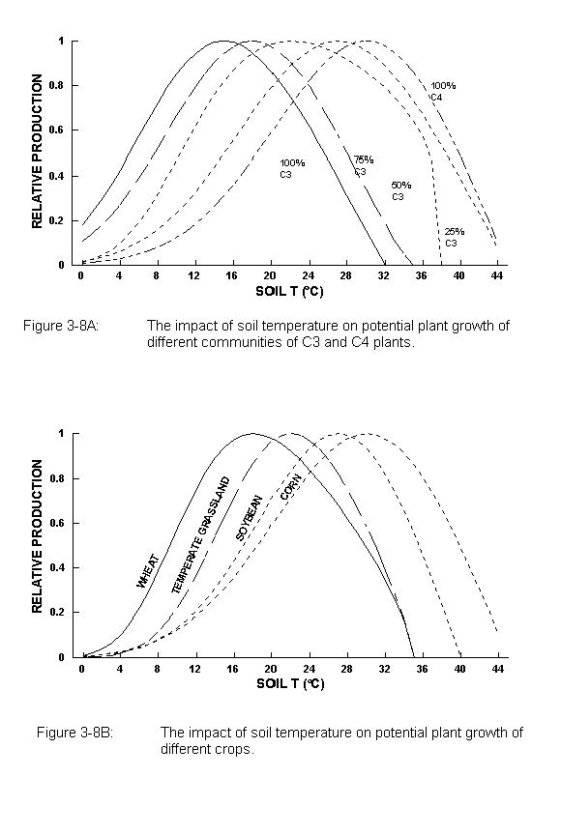
The moisture status effect reduces growth when
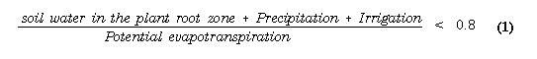
The slope of the linear relationship is dependent on the available soil water holding capacity, which varies with soil texture (Figure 3-9). This effect of soil texture has been observed in field data (Sala et al., 1988) and accounts for the "reverse texture effect" (Noy-Meir, 1973), in which the greater infiltration rate and hence lower bare soil evaporation rate in coarser textured soils results in higher production in arid environments. NLAYPG (<site>.100) is the number of soil layers that control plant growth (e.g. 0-60 cm depth for NLAYPG=4 and 0-45 cm depth for NLAYPG=3) and can be less than or equal to the total number of soil layers.

The shading effect on potential growth rate is a response surface dependent on the amounts of live and dead vegetation. This function, which was originally developed for the tall grass prairie, was found to be too restrictive for no-till cropping systems. Therefore, the magnitude of the effect has been greatly reduced for crops by increasing the value of BIOK5 (crop.100).

A scaling factor for crops growing from seedlings (PLTMRF, FULCAN, crop.100) reflects the partial interception of light with less than a full canopy present (Figure 3-10). This factor takes effect after a PLTM (planting month) command in EVENT100, but not after a FRST (first month of growth) command.

Root growth is proportional to potential shoot growth, but the allocation of carbon to root growth can be made a function of time since planting (FRTC(1...3)) (Figure 3-11) to reflect the dominance of root growth in seedling cereal crops or the initial dominance of shoot growth in root crops. To account for winter dormancy the root - shoot ratio does not change in months when soil temperature is below 2° C (RTDTMP, crop.100). In an alternative formulation (FRTC(1) = 0.0) developed for Great Plains grasslands, the root-shoot ratio is controlled by annual precipitation (Parton et al., 1987) as shown in Figure 3-12.

The actual production is limited to that achievable with the currently available nutrient supply with plant nutrient concentrations constrained between upper and lower limits set separately for shoots and roots. Invoking Liebig's Law of the Minimum, the most limiting nutrient (ELIMIT) constrains production (RELYLD). The limits of nutrient content for shoot growth are a function of plant biomass in order to reflect the changing nutrient content with plant age (Figure 3-13). The user specifies the effect of live shoot biomass on maximum and minimum nutrient content (BIOMAX, PRAMN(*,*), PRAMX(*,*), crop.100). This formulation does cause some anomalies when growth is limited by nutrients, as a nutrient limited crop can have a higher nutrient concentration than an unlimited crop of the same age with greater biomass. The limits on nutrient content of roots are a function of annual precipitation (PRBMN(*,*), PRBMX(*,*), crop.100). CENTURY also incorporates a function to restrict nutrient availability in
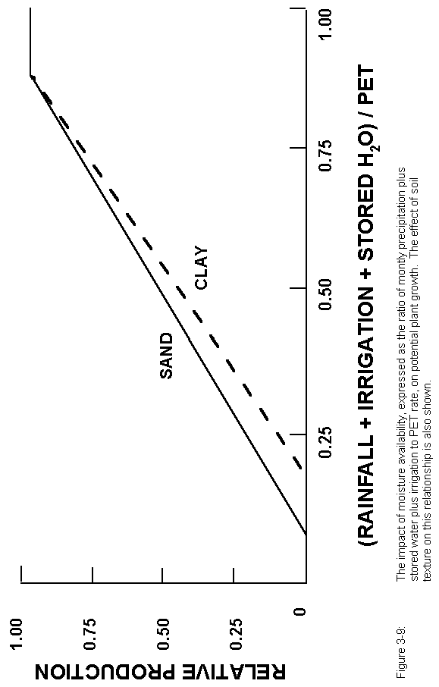
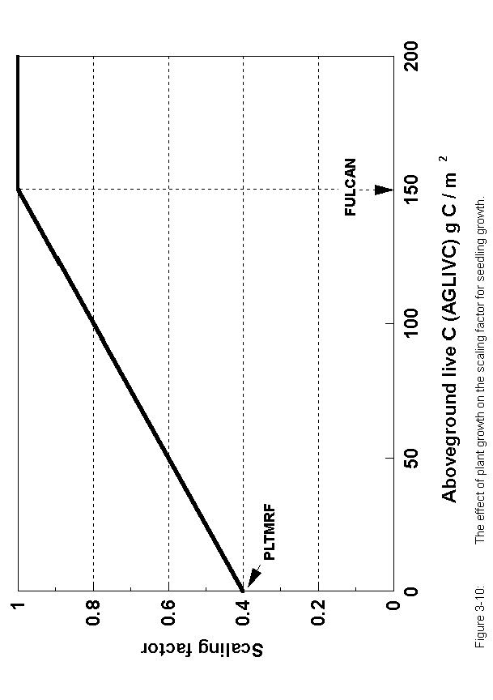
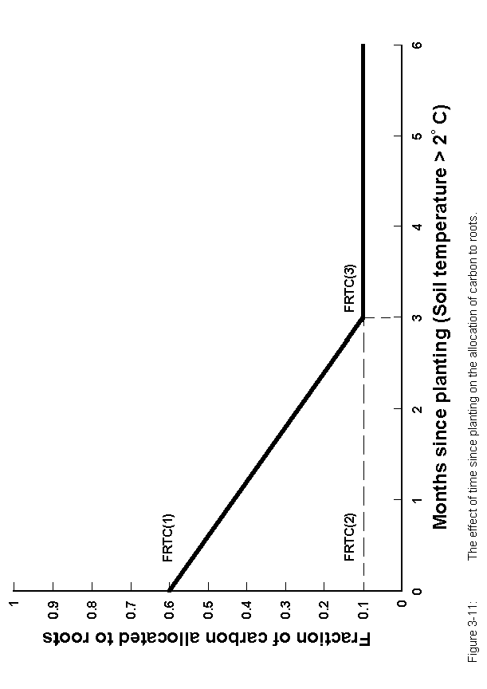
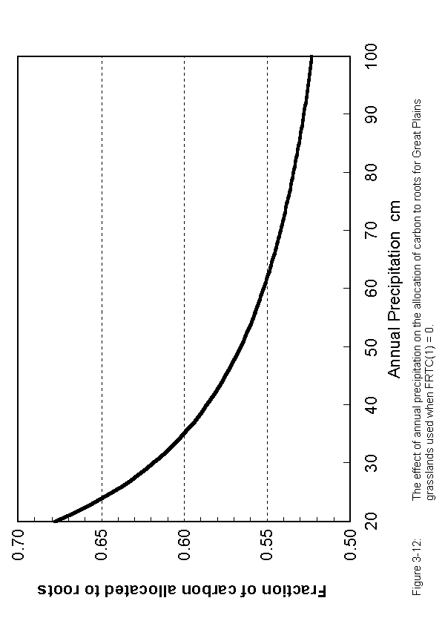
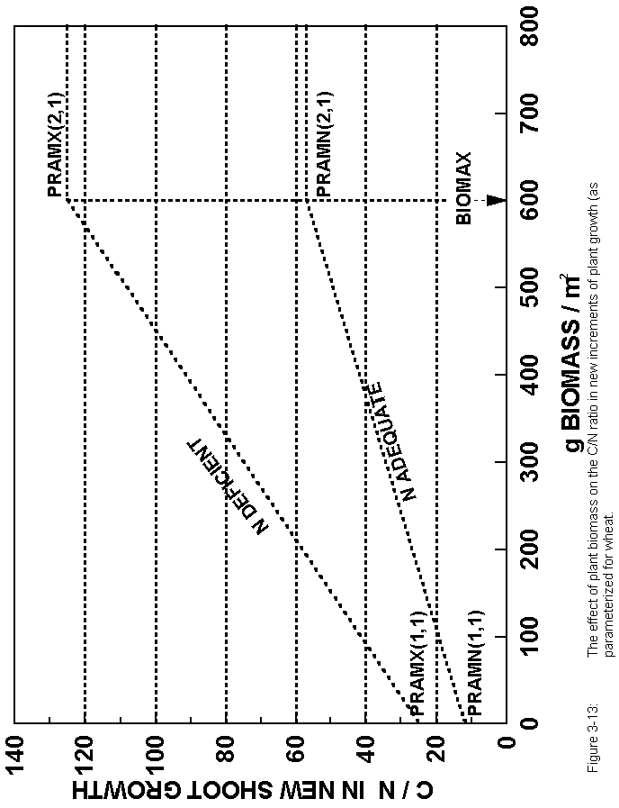
relation to root biomass (RTIMP; Figure 3-14). For legume crops the potential rate of symbiotic nitrogen fixation is specified in terms of grams N fixed per gram C fixed (SNFXMX, crop.100). It is assumed that plant available soil N will be preferentially used by the crop. All other potential limitations to growth, including P and S supply, are taken into account before calculating symbiotic N₂ fixation.

Fertilizer addition can be either fixed amounts (FERAMT, fert.100) or calculated automatically according to the crop requirements. The automatic option (AUFERT, fert.100) can be set to maintain crop growth at a particular fraction of potential production with the minimum nutrient concentration or to maintain maximum production with plant nutrient concentrations at a nominated level between the minimum and maximum for that growth stage.

At harvest, grain is removed from the system and live shoots can either be removed or transferred to standing dead and surface residue. For grain crops a harvest index is calculated based on a genetic maximum (HIMAX, crop.100) and moisture stress (HIWSF, crop.100) in the months corresponding to anthesis and grain fill (HIMON(1,2), crop.100) as shown in Figure 3-15. Moisture stress is calculated as the ratio of actual to potential transpiration in these months. The fractions of aboveground N, P, and S partitioned to the grain are crop-specific constants (EFRGRN(*), crop.100) modified by the square root of the moisture stress term, resulting in higher grain nutrient concentrations when moisture stress reduces the harvest index. At harvest a proportion of the aboveground nitrogen is lost to volatilization (VLOSSP, crop.100). The crop harvest routine also allows for the harvest of roots, hay crops or straw removal after a grain crop (see harv.100; Appendix 2). The crop may be killed at harvest, as for cereal grain crops, or a fraction of roots and shoots may be unaffected by harvest operations and growth may continue.

The crop model allows for the death of shoots and roots during the growing season. Shoot and root death are functions of available soil water in the whole profile and the plant root zone respectively (Figure 3-16). Both are multiplied by crop specific maximum death rates (FSDETH(1), RDR, crop.100). Shoot death rates may be further increased (FSDETH(3)) due to shading if the live biomass is greater than a critical level (FSDETH(4)). Root death is only allowed to occur when roots are physiologically active, defined by soil temperature being greater than 2°C (RTDTMP, crop.100). In months nominated as senescence months the shoot death rate is set to a fixed fraction of live biomass (FSDETH(2)). Standing dead material is transferred to surface litter at a crop specific relative fall rate (FALLRT, crop.100).

Plant lignin contents (FLIGNI(*,*), crop.100) are specified for shoots and roots, and may be constants or a linear function of annual precipitation (Parton et al., 1992). They should reflect the lignin content of senescent plant material.

The effects of grazing and fire on plant production are represented in the model by using data from Holland et al. (1992) and Ojima et al. (1990). The major impact of fire is to increase the root to shoot ratio (FRTSH, fire.100), increase the C:N ratio of live shoots and
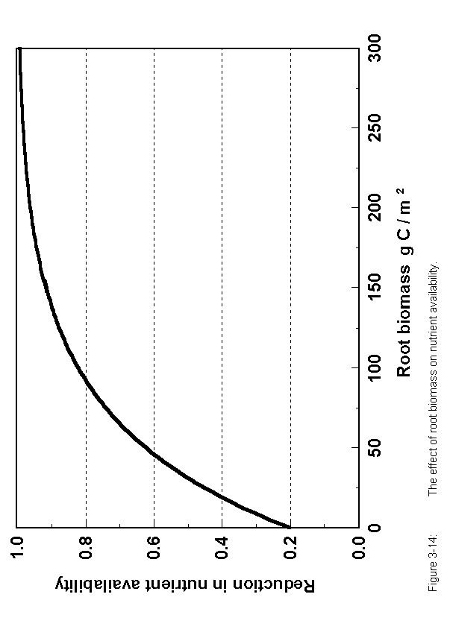
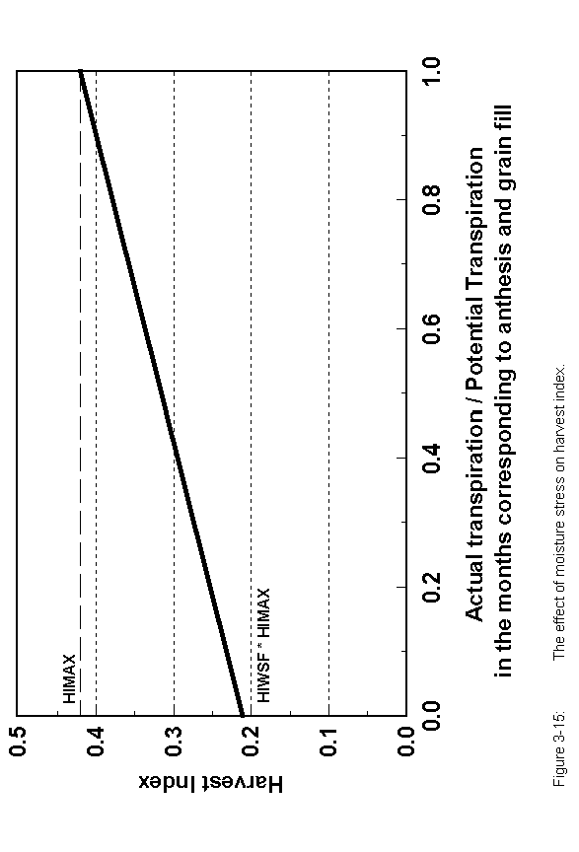
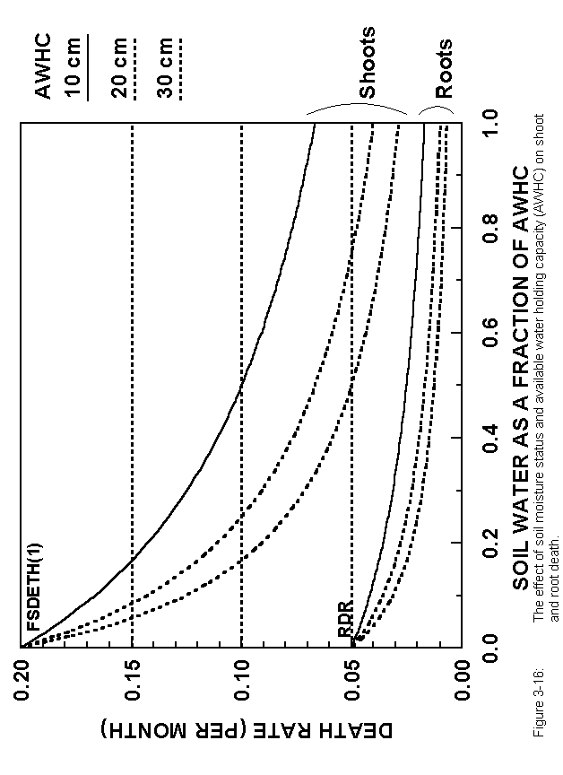
roots (FNUE(*), fire.100), remove vegetation and return nutrients during the years when fire occurs (Ojima et al. 1990). Grazing removes vegetation, returns nutrients to the soil, alters the root to shoot ratio, and increases the N content of live shoots and roots (Holland et al. 1992). The model has three options (GRZEFF = 0, 1, 2) for dealing with the impact of grazing on the system. For option 1 (GRZEFF=0) there are no direct impacts of grazing on plant production except for the removal of vegetation and return of nutrients by the animals. Option 2 (GRZEFF=1) is referred to as the lightly grazed effect (Holland et al., 1992) and includes a constant root:shoot ratio (not changing with grazing) and a linear decrease in potential plant production with increasing grazing intensity. Option 3 (GRZEFF=2) is referred to as the heavy grazed (Holland et al., 1992) option and includes a complex grazing optimization curve where aboveground plant production is increased for moderate grazing and decreasing sharply for heavy grazing levels (>40% removed per month). The root:shoot ratio is constant for low to moderate grazing levels and decreases rapidly for heavy grazing levels. In all three options the nutrient content of new shoot will increase in relation to the residual biomass (PRAMN(*,*), PRAMX(*,*), BIOMAX, crop.100).

3.7.2 Forest Submodel

The forest plant production model (Figure 3-17) divides the tree into leaves, fine roots, fine branches, large wood, and coarse roots with carbon and nutrients allocated to the different plant parts using a fixed allocation scheme. Maximum monthly gross production is calculated as the product of maximum gross production rate (PRDX(2), tree.100), moisture, soil temperature and live leaf-area-index terms. The effect of moisture and temperature on potential productions are the same functions used for the monthly grassland model (Figures 3-8 and 3-9), while the effect of live leaf-area-index on production is shown in Figure 3-18. Plant respiration is calculated as a function of wood N content and temperature using an equation developed by Ryan (1991) and subtracted from the gross production rate in order to get the net potential production rate. The net potential production rate is not allowed to exceed the tree specific maximum net production rate (PRDX(3) times the other limiting factors). The model assumes that only the sapwood part of the tree respires C and the sapwood fraction of aboveground large wood biomass is calculated using the relationship shown in Figure 3-19. The same sapwood fraction is used for coarse woody roots (Ryan, 1991). The leaf biomass is not allowed to exceed a maximum value that is a function of the live wood biomass (Figure 3-20). This function specifies the effect of tree allometry and structure on maximum leaf area and is potentially different for different species. Some of the important forest specific parameters include the maximum gross and net production rates (PRDX(2), PRDX(3), tree.100), the leaf area index to wood biomass relationship parameters (MAXLAI, KLAI, tree.100), the sapwood to large wood C ratio parameter (SAPK, tree.100), and the allocation of C into different plant parts (FCFRAC(1-5,1-2), tree.100).

The model has two carbon allocation patterns for young and mature forests and can represent either deciduous forests or forests that grow continuously. With a continuous growth or evergreen forest the death of the live leaves is specified as a function of month (LEAFDR(1-12), tree.100), while with a deciduous forest the leaf death rate is very high
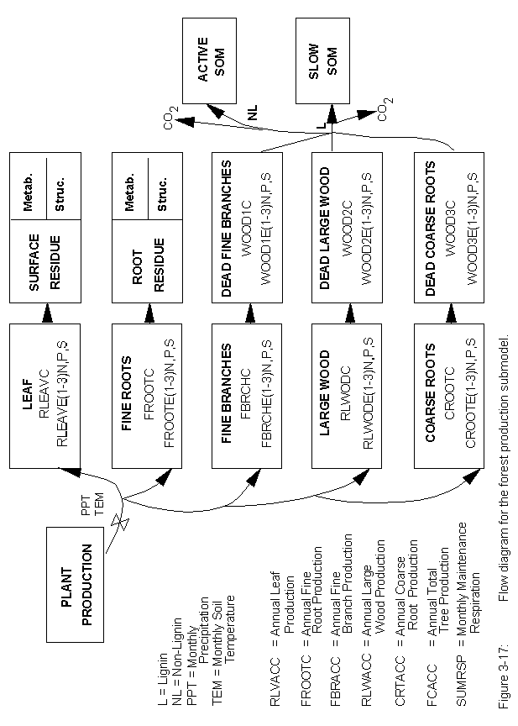
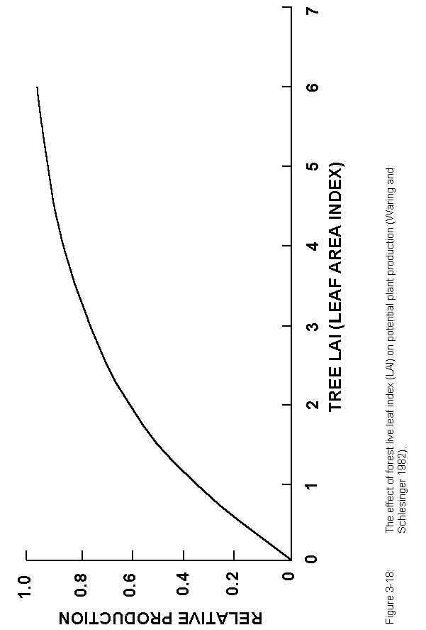
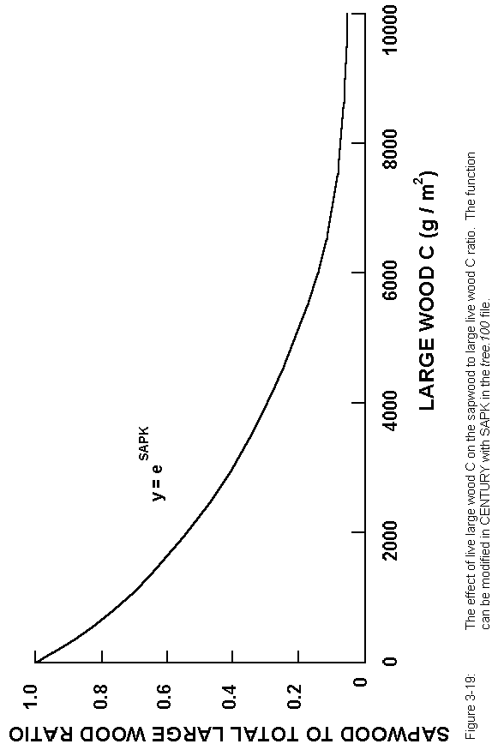
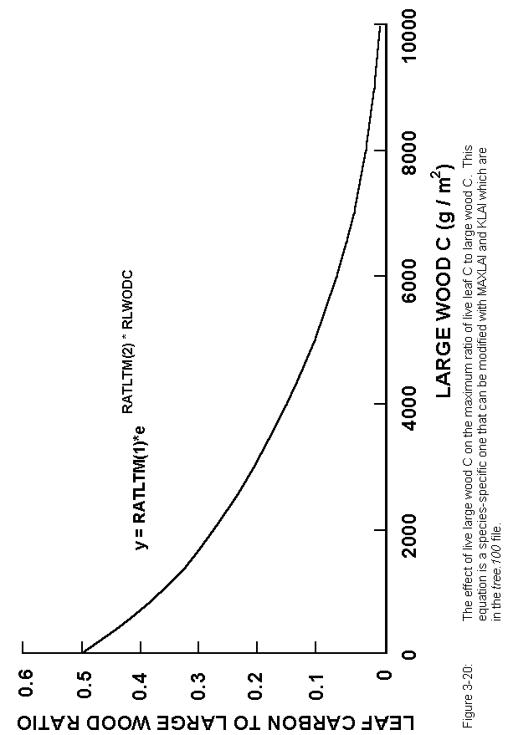
at the senescence month. For deciduous forest the leaf growth rate is also much higher during the first month of leaf growth. Dead leaves and fine roots are transferred to the surface and root residue pools and are then allocated into structural and metabolic pools. Dead fine branch, large wood, and coarse root pools receive dead wood material from the live fine branch, large wood, and coarse root pools respectively. Each dead wood pool has a specific decay rate. The dead wood pools decay in the same way that the structural residue pool decomposes with lignin going to the slow SOM pool and the non-lignin fraction going to surface microbes or active SOM pool (above- or belowground material). The decay rates of the dead wood pools are also reduced by the temperature and moisture decomposition functions, and include CO₂ losses.

A forest removal event, which is defined in the trem.100 file, can simulate the impact of different forest harvest practices, fires, and the effect of large scale disturbances such as hurricanes. For each disturbance or harvest event, the fraction of each live plant part lost and the fraction of material that is returned to the soil system is specified (see trem.def Appendix 2). Death of fine and coarse roots are also considered in the removal event along with the removal of dead wood. Another feature is that the nutrient concentration of live leaves that go into surface residue can be elevated above the dead leaf nutrient concentration (e.g. simulating the effect of adding live leaves to surface residue as a result of hurricane disturbance) by specifying the return nutrient fraction of the leaves to be greater than one (RETF(1,*), trem.100).

3.7.3. Savanna Submodel

The savanna model is a coupled tree-grass system and uses the forest and grassland/crop submodels already described. The fundamental difference in the savanna submodel is the manner in which total system production is obtained. Total system production is the sum of forest and grass production. Potential maximum production of forest is computed in the manner described above. Grassland/crop production is modified to include the effect of tree canopy cover on grassland/crop production. A shade modifier is calculated as a function of the canopy cover and leaf biomass (Figure 3-21) and is multiplied by the normal grassland/crop production equation (see Grassland/Crop Submodel, Section 3.7.1). Increasing canopy cover and leaf biomass reduces the potential grass production. Removal of grass or forest is accomplished independently with the FIRE and TREM commands in EVENT100, so that user can specify fire intensity and frequency as desired. Fire removal parameters for grassland/crop vegetation are specified in fire.100, while forest fire parameters are specified in trem.100. In this manner, a grass fire can occur at a higher intensity and/or frequency than fires affecting forest combustion losses. In the present model, fire does not influence tree distribution and establishment.

Nitrogen competition is the other major interaction between the forest and grass systems. The interaction is controlled by the amount of tree basal area, total nitrogen available, and site potential for plant production. The fraction of N available for tree uptake is calculated as a function of tree basal area (m² ha⁻¹) and available mineral N using the function shown in Figure 3-22. The fraction of N uptake by grass is one minus the forest fraction and if grass N uptake did not consume all of the N allocated to it, this
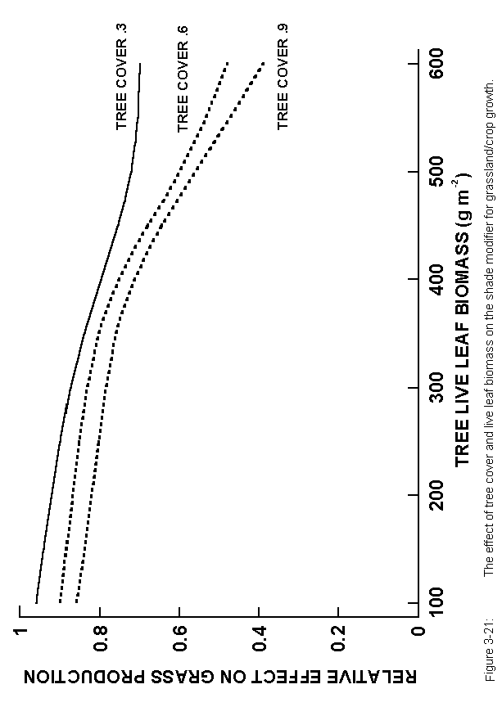
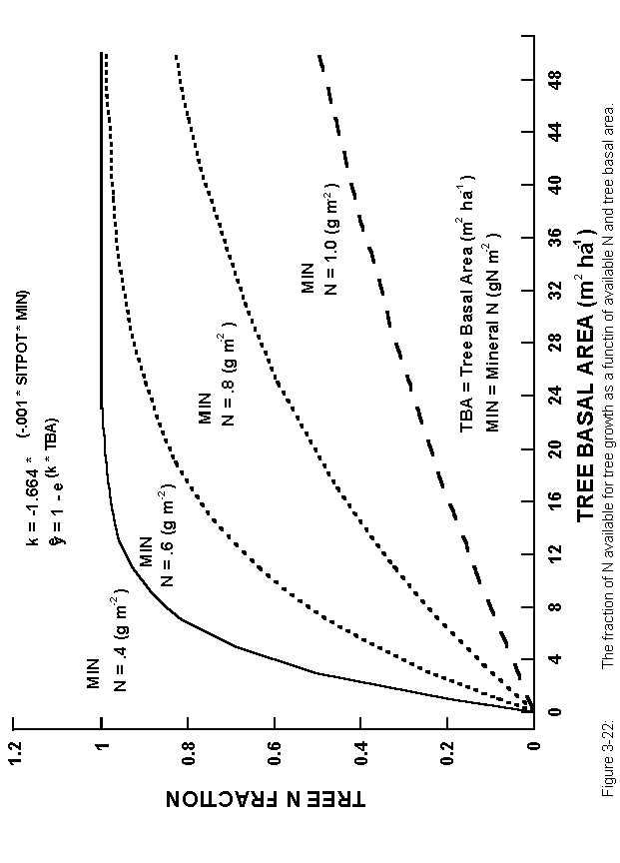
amount is added to the pool of N which is available to the trees. Two important site-specific parameters for the savanna model are the site potential parameter (SITPOT, tree.100) and the basal area conversion factor (BASFCT, tree.100) which calculates tree basal area as a function of large wood C level. SITPOT controls how fast trees can dominate grasslands with lower numbers (1200 vs. 2400) leading to quicker dominance by trees.

3.8. Fertilizer

Fertilizer addition can be either fixed amounts (FERAMT(*), fert.100) or calculated automatically (AUFERT <> 0.0, fert.100) according to the crop requirements. The automatic option can be set to maintain crop growth at a particular fraction of potential production with the minimum nutrient concentration (0.0 < AUFERT <= 1.0) or to maintain maximum production with plant nutrient concentrations at a nominated level between the minimum and maximum for that growth stage (1.0 < AUFERT <= 2.0).

Organic matter additions are specified in omad.100.

3.9. Irrigation

Irrigation amounts can be either fixed amounts (IRRAMT, irri.100) or automatically set (AUIRRI, irri.100) according to the soil moisture status. Automatic irrigations are scheduled if the available water stored in the plant root zone falls below a nominated fraction of the available water holding capacity (FAWHC, irri.100). The amount of water applied by the automatic option allows for the addition of a nominated amount of water (IRRAUT, irri.100) or for irrigation up to field capacity or up to field capacity plus an allowance for potential evapotranspiration.

3.10. Cultivation

Cultivation options allow for the transfer of defined fractions (CULTRA(*), cult.100) of shoots, roots, standing dead and surface litter into standing dead, surface and soil litter pools as is appropriate. Thus the model can simulate a variety of conventional cultivation methods, such as plowing or sweep tillage, thinning operations or herbicide application. Each cultivation option also has parameters (CLTEFF(*) cult.100) for the multiplicative effect of soil disturbance by cultivation on organic matter decomposition rates for the structural, active, slow and passive pools. The values for these parameters range from 1.0 to about 1.6 with the actual value dependant on the degree of soil stirring and disruption caused by each implement.

3.11. Grazing

The grazing options can be parameterized to remove defined fractions of aboveground live (FLGREM, graz.100) and standing dead (FDGREM, graz.100) plant material each month. The fractional returns of C (GFCRET, graz.100), N, P, and S (GRET(*), graz.100) are specified, having allowed for losses in animal carcasses and milk, transfer of dung and urine off the area being simulated, volatile losses of N from dung and urine patches, and leaching of N and S under urine patches. The proportion of N, P, and S returned in organic forms (FECF(*), graz.100) is also specified as is the lignin content of the feces (FECLIG, graz.100). As discussed above in Section 3.7.1, grazing can have variable effects on plant production (GRZEFF, graz.100).

3.12. Fire

The effect of different intensities of fire in herbaceous vegetation can be parameterized by specifying the fractions of live shoots (FLFREM, fire.100), standing dead (FDFREM(1), fire.100) and surface litter (FDFREM(2), fire.100) removed by a fire along with the return of N, P, and S in inorganic forms. As discussed above in Section 3.7.1, fire can also affect plant growth.

3.13. Labeled C Simulation (¹⁴C and ¹³C)

The CENTURY model can simulate labeling by either ¹⁴C or ¹³C. C labeling is specified in the .sch schedule file, created by EVENT100. The ¹⁴C simulations act as a labeled tracer from atmospheric sources or added organic matter (ASTLBL, omad.100). The c14data file contains a record of atmospheric ¹⁴C concentrations which are used by the model to label new plant material, which then flows through the other organic matter pools. A sample c14data data file is included on the CENTURY diskette.

Simulations using the option for ¹³C give a constant label to plant material based on the value of DEL13C in the crop.100 and tree.100 files. This option will primarily be of use to follow the change in stable isotope signal when there has been a switch from C3 to C4 vegetation or vice-versa. Fractionation of the stable carbon isotopes is included in the model as discussed below.

The ¹³C/¹²C ratio in soil organic matter remains close to the ratio in the original vegetation, but fractionation during decomposition of the plant residues and soil organic matter can produce significant changes in the ratio. The magnitude and direction of the change in the ratio may vary with time and the prevailing environmental conditions (Stout and Rafter, 1978; Stout et al., 1981).

¹³C/¹²C ratios are expressed relative to a standard as δ¹³C values, where
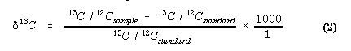
The standard is carbonate from Pee Dee belemnite limestone and units are per mille (‰). Atmospheric CO₂, plant material, and soil organic matter are depleted in ¹³C relative to the standard and therefore have negative δ¹³C values. The more depleted in ¹³C a material is, the more negative the δ¹³C value will be.
Stout et al. (1981) identified four points in the biological carbon cycle where major fractionation of carbon isotopes occurs. The first takes place during photosynthesis with plant tissue being depleted in ¹³C relative to atmospheric CO₂. Of considerable interest is the difference in δ¹³C between plants with different photosynthesis pathways (Bender, 1971; Smith and Epstein, 1971). The C3 plants, with the Calvin pathway, have low δ¹³C values (-24 to -34‰), while the C4 plants, with the Hatch and Slack pathway, have high δ¹³C values (-6 to -19‰). This difference in stable carbon isotope signature can be used as a tracer for in situ labelling of soil organic matter when the dominant vegetation type has changed from C3 to C4 species or vice-versa (Cerri et al., 1985; Schwartz et al., 1986; Balesdent et al., 1987; Balesdent et al., 1988; Martin et al., 1990; Balesdent and Balabane, 1992). The CENTURY model has been modified to partition carbon production by plants to the two isotope pools on the basis of a δ¹³C value nominated in the crop.100 file for each grassland or crop type.

The second major biological fractionation occurs in the synthesis of the major cell components (Stout et al., 1981). The data of Benner et al. (1987) for a variety of vascular plants showed that cellulose and hemicellulose were typically enriched in ¹³C by 1 to 2 ‰ relative to whole plant material while lignin was depleted by 2 to 6‰. They observed a greater depletion of ¹³C in grass lignins than in wood lignins, which they attributed to different amino acid precursors. In the CENTURY model this fractionation in the partitioning of plant material (shoots and roots from crops and grasses, and leaves and fine roots from trees) to the structural and metabolic pools is accounted for as all of the plant lignin is assumed to enter the structural pool. The ¹³C depletion of lignin relative to the whole plant ¹³C signature can be altered (DLIGDF, fix.100). Because all dead wood and large tree roots enter dead wood pools, which are analogous to the structural pool, there was no need to account for ¹³C fractionation in wood lignin.

The third major biological fractionation of carbon noted by Stout et al. (1981) is associated with animal consumption of plant material, with animal tissues being depleted in ¹³C relative to the plant material on which they feed. This is not accounted for this in the model because the important comparison for the CENTURY model is between δ¹³C levels in feces and plant material.

The fourth major biological fractionation of carbon takes place during microbial metabolism (Stout et al., 1981). Macko and Estep (1984) examined the isotopic composition of an aerobic, heterotrophic bacteria growing on a variety of amino acid substrates. With most of substrates the bacterial cells were enriched in ¹³C relative to the amino acid. They suggested that the CO₂ respired during the Krebs cycle would be isotopically depleted in ¹³C. However, in an anaerobic environment methane evolved is very depleted in ¹³C relative to the organic substrate, but the CO₂ evolved is enriched (Games and Hayes, 1976). The net effect on the residual organic matter would depend on the relative size of the fluxes. Environmental effects on fractionation are also reflected in different patterns of stable isotope distribution in soil profiles (Stout and Rafter, 1978). In well-drained mineral soils δ¹³C values increase slightly with depth and soil age, which is consistent with respired CO₂ being slightly depleted in ¹³C. In organic soils where decomposition is inhibited the δ¹³C values decrease with depth. This could be due to the loss of readily decomposable plant fractions, such as sugars and proteins, with an accumulation of lignin, lipids and waxes in the residual plant material, resulting in depletion of ¹³C relative to the original plant material (Stout et al., 1981). In other soils, with intermediate levels of drainage and organic matter accumulation, there may be no change in δ¹³C values with depth indicating a balance between fractionation due to respiration and accumulation of the depleted plant fractions. All decomposition flows in the CENTURY model are assumed to be the result of microbial activity and have an associated loss of CO₂. Fractionation of the carbon isotopes in the loss of CO₂ is allowed for (DRESP, fix.100). The coefficient for isotope discrimination was calibrated to give a slight increase in the δ¹³C value for the total soil organic matter relative to the vegetation.

3.14. Enriched CO₂ Effects

The model was also enhanced to include the effects of documented changes in atmospheric CO₂ and thus predict the effects on crop production. The direct effects of an increase in atmospheric CO₂ concentration on soil processes will be insignificant because the CO₂ concentration in the soil atmosphere is already greatly elevated. However, the indirect effects on SOM mediated through effects on plant processes could be substantial and must be accounted for in simulations of the effect of global change on SOM (Long, 1991). Net primary production, litter quality, and transpiration are all likely to be affected. Increases in atmospheric CO₂ concentration have increased plant production of a wide variety of species by an average of 33% (Kimball, 1983). Generally, the plant dry matter response to increasing rates of CO₂ can be approximated with a logarithmic response function (Gifford, 1979; Goudriaan, 1992):
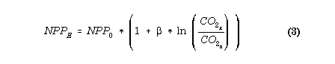
where NPP_{E} and NPP₀ refer to net primary production in enriched and control CO₂ environments respectively. β is an empirical parameter which ranges between 0 and approximately 0.7.

The response to CO₂ is not simply due to the removal of a single limiting factor (Sinclair, 1992), but results from a hierarchy of effects (Acock, 1990).

First, increasing CO₂ has a direct effect on C availability by stimulating photosynthesis and reducing photorespiration. There is a very important difference between C3 species, such as wheat, and C4 species, such as corn, in this response. At present day CO₂ concentrations around 350 µmol / mol, C4 plants have higher rates of photosynthesis than C3 species. However, net photosynthesis in corn does not increase much beyond 400 µmol CO₂ / mol, while wheat responds to CO₂ levels up to 800 µmol / mol (Akita and Moss, 1973). The growth response to CO₂ is usually lower in C4 species than in C3 species (Wong, 1979; Rogers et al., 1983; Morrison and Gifford, 1984b; Cure and Acock,
1986). With wheat, a growth response to elevated CO₂ is almost invariably obtained (Kimball, 1983; Cure and Acock, 1986). Corn sometimes shows no response to CO₂ (Hocking and Meyer, 1991b). In a field study with elevated CO₂ in open top chambers, in which corn growth was increased by about 40%, there was no effect on net photosynthesis per unit leaf area (Rogers et al., 1983). Summarizing a number of experiments, Cure and Acock (1986) found average biomass responses of 31, 9, and 9% for wheat, corn and sorghum respectively. The main reason for responses to CO₂ in C4 species is due to improved water use efficiency as discussed below.

The second effect of increased CO₂ concentrations is a decrease in stomatal conductance (Moss et al., 1961; Akita and Moss, 1973; Wong, 1979; Rogers et al., 1983; Morrison and Gifford, 1984a) at high CO₂ concentrations, which reduces the transpiration rate per unit leaf area. Reduced transpiration will also increase the leaf temperature which can further increase photosynthesis (Acock, 1990). The effect on stomatal conductance and transpiration is observed in both C3 and C4 species. Over a range of species Morrison and Gifford (1984a) found that stomatal conductance was reduced by 36% while transpiration was reduced by 21%, the difference being attributed to the higher leaf temperatures. Similar average values of 34% and 23% for stomatal conductance and transpiration respectively were found in the literature survey of Cure and Acock (1986). Both an increase in photosynthesis and a decrease in transpiration result in an increase in the plant's water use efficiency.

The third major effect of increased CO₂ is a decrease in the plant N concentration in C3 species (Schmitt and Edwards, 1981; Hocking and Meyer, 1991b). Clearly with a fixed nutrient supply, an increase in C assimilation is likely to result in lower plant nutrient concentrations due to a dilution effect, but this is not the only effect. Hocking and Meyer (1991a) clearly demonstrated that the critical plant N concentration for 90% maximum yield is decreased under elevated CO₂. However, CO₂ had little effect on the relationship between relative yield and the external N concentration. A practical implication of this is that similar fertilizer application rates will still allow near maximum yields under a high CO₂ environment, but that more fertilizer may be required to maintain similar grain protein concentrations (Hocking and Meyer, 1991b). Physiologically, an increase in N use efficiency in C3 species with elevated CO₂ has been related to decreased concentrations of the enzyme ribulose 1,5-bisphosphate carboxylase (Schmitt and Edwards, 1981) which catalyses the initial carboxylation reaction in C3 species and accounts for a large proportion of the leaf protein.

A fourth effect of increased CO₂ on plant growth which affects SOM levels is an increase in root growth. Most studies with elevated CO₂ with grain crops in which root growth has been measured show very little or no effect on the root to shoot ratio (Cure and Acock, 1986).

The above effects can be taken into account in CENTURY model simulations of global change effects by selecting the enriched CO₂ option in EVENT100. This option can be implemented with either a constant CO₂ concentration or with a linear ramp with annual increments from an initial concentration to a final concentration; the parameters CO2RMP, CO2PPM(1), and CO2PPM(2) are found in the fix.100 file. The various effects of CO₂ described above are controlled by functions of the CO₂ concentration and crop or tree specific parameters in crop.100 and tree.100. Parameter values are set using reference concentrations of 350 and 700 ppm CO₂ for ambient and doubled CO₂ respectively.

The impact on maximum potential monthly production is described by a transformation of Equation 3 given above in order that the relative production for doubled CO₂ can be set for each crop (CO2IPR(*), crop.100, tree.100). The effect on potential transpiration rate also uses this equation with the fraction to which the transpiration will be reduced with a doubling of atmospheric CO₂ set (CO2ITR(*), crop.100, tree.100). The effect of elevated CO₂ on carbon to element ratios is similarly modelled with the effect of doubled CO₂ on the minimum and maximum ratios for N, P, and S, in the shoots of grasses and crops and in the leaves of trees set (CO2ICE(*,*,*), crop.100, tree.100). The effect of CO₂ on the allocation of C to roots is set by (CO2IRS(*), crop.100, tree.100) which specifies the proportional increase in the root to shoot ratio at doubled CO₂. A linear relationship of this effect with CO₂ concentration is assumed.

3.15. Soil Incubation (Microcosms)

The model can be set up to simulate litter bag decomposition and soil incubations at constant temperature and soil moisture. The incubation option will simulate the dynamics of soil organic matter and surface or buried litter under constant soil temperature and soil water conditions. Changes in carbon levels and nutrient mineralization can be simulated for laboratory incubations using this option. The soil temperature (MCTEMP, .sch schedule file) is the only abiotic input parameter; it is specified in the schedule file. To simulate a litter bag simulation you would specify the initial litter level (CLITTR, <site>.100) and C:N, C:P and C:S ratio of the litter (RCELIT, <site>.100). The lignin content of the litter bag (FLIGNI, crop.100) would be specified for either above- or belowground material depending on the placement of the bag. Incubation of the soil occurs in a similar manner by initializing all of the soil variables. Some of the options include fertilization, cultivations (mixing of the soil) and the addition of new labeled or unlabeled plant material during the incubations. Plant growth does not occur during the incubation.

Microcosm simulation is specified in the .sch schedule file, created by EVENT100.

3.16. Weather Data

CENTURY uses monthly precipitation (PRECIP, <site>.100) and mean monthly minimum and maximum temperatures (TMN2M, TMX2M, <site>.100). For each block in the simulation, EVENT100 allows the user to choose between four options for weather data. The first option uses the mean values for each month in every year of the block simulation. The second option uses the mean monthly temperature values in every year and stochastically generates precipitation from a skewed distribution (Nicks, 1974). If skewness parameters are unavailable, a truncated normal distribution is used but this will
increase the overall mean precipitation when the coefficient of variation for precipitation is high. The third option reads the monthly values for precipitation, minimum and maximum air temperature from the start of a weather data file, while the fourth option will continue reading from the same file without rewinding.

If a monthly value is missing from an actual weather file, it should be set equal to the value "-99.99" within the file. When reading in this missing value flag, CENTURY will replace the flag as follows:
for a minimum or maximum temperature, the mean monthly value (TMN2M or TMX2M) from the <site>.100 file will be used.
for a precipitation value, the skewed distribution value will be calculated if possible (if PRCSKW is not zero). Otherwise, the monthly mean (PRECIP) will be used.

FILE100 can automatically analyze a CENTURY model weather file with monthly precipitation and temperatures and place the parameters for climate statistics in a <site>.100 file.

3.17. Event Priority

Because CENTURY uses a monthly timestep and incorporates both continuous events such as crop growth and decomposition, and discrete events such as fertilizer addition, cultivation and harvest, it is necessary to set a priority order for calls to the model's subroutines (Figure 3-23). This is also necessary because the combined effect of subroutines on the changes in pool sizes can be large relative to the amount present and negative overflows would otherwise be a problem. Furthermore, because of the importance of nutrient availability to immobilization in organic matter, and the limitation that immobilization can place on the rate of organic matter decomposition, the decomposition and soil nutrient routines have a timestep of one quarter of a month.

3.18. Model Parameterization

Most of the internal parameters in CENTURY were determined by fitting the model to long-term soil decomposition experiments (1 to 5 year) where different types of plant material were added to soils with a number of soil textures (Parton et al., 1987). Other more general databases (Parton et al., 1988; Parton et al., 1989) were used to parameterize the P and S submodels and flows for the formation of passive SOM. Many of the parameters such as the plant nutrient content and lignin content were determined using a linear equation where the slope and intercept were the input parameters. Work in the Great Plains suggested that lignin and N content changed as a linear function of annual precipitation. To specify constant values for these parameters, set the slope parameter (FLIGNI(2,*), crop.100) equal to zero and set the intercept (FLIGNI(1,*), crop.100) equal to the desired value for the parameter.

The model includes a method for estimating steady state soil C and N levels in grassland systems which was developed for the U.S. Great Plains. If IVAUTO (<site>.100)
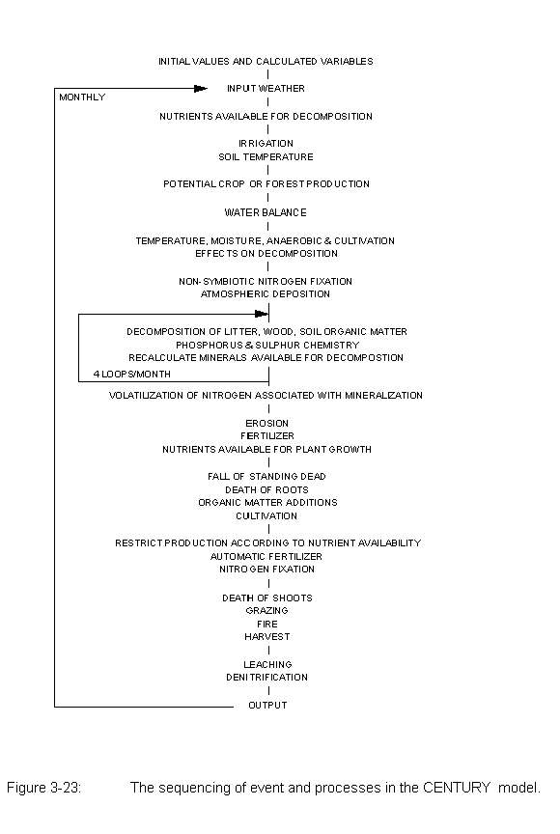
is set to 1, the model will estimate initial soil C and N levels for the different soil fractions based on the mean annual temperature, annual precipitation and soil texture of grassland (Burke et al., 1989). IVAUTO = 2 uses the cultivated fields equations to estimate these levels. The soil P and S levels are quite different depending on soil parent material and need to be estimated with site-specific data.

One of the most difficult parts of initializing the model is estimating the C, N, P, and S levels for the different soil fractions. However, substantial progress has been made recently in estimating the size of the soil fractions. The active soil fraction includes the live soil microbes and microbial products. This fraction can be estimated by using the microbial fumigation technique (Jenkinson and Powlson, 1976; Jenkinson et al.,1976; Jenkinson and Rayner 1977) to estimate the live microbial biomass and then doubling the live microbial biomass to account for the microbial products (active SOM = 2 to 3 times the live microbial biomass). In most soils the active soil fraction is approximately 2 to 4% of the total soil C. The slow SOM fraction is made up of lignin derived plant material and stabilized microbial products. This fraction makes up approximately 55% of the total SOM. Recent developments in SOM fractionation (Elliott and Cambardella, 1992) suggest that 40% of the total SOM in grasslands is lignin-derived plant material (referred to as POM (partial organic matter) in the paper). Comparison of the size of the slow pool from C simulations with measurements of SOM indicate that the slow pool is approximately 1.6 times the amount of POM (Metherell et al., 1993b).

Unfortunately there is not a good technique for estimating the size of the stabilized microbial products pool; however, it is estimated that it is approximately 10 to 20% of the soil. The passive SOM generally makes up 30 to 40% of the total SOM and will have a higher value for high clay content soils. The best estimate of the N content of these fractions are that the slow fraction has a C:N ratio of 15 to 20, the active SOM has a C:N ratio of 8 to 12, while the passive SOM has a C:N ratio of 7 to 10. Clay soils have lower C:N ratios while silty soils have higher C:N ratios for the passive SOM. These approximations seem to work well for a large number of different soils.

The C:P and C:S ratios are not as predictable and are functions of the initial soil parent material and degree of soil weathering. The same general rules apply for C:P and C:S ratios with the active SOM having relatively low ratios (50-100), the slow SOM the highest C:P and C:S ratios (100-300), while the passive C:P and C:S ratios are fairly low (40-120). These values are appropriate for the relatively unweathered soils in the U.S. Great Plains. More weathered tropical soils have much higher C:P and C:S ratios that can be as high as 800. To use the P and S submodels, determine the organic P and S levels and it would be preferable to run full P fractionation of the soil (see citations in Hedley et al., 1982). The C:N ratio and relative size approximations are incorporated into the model when the Burke equations are used (IVAUTO=1, <site>.100) to estimate initial SOM pools. For cultivated soils it is generally assumed that the size of the slow pool is lower because of cultivation (40 to 50% of the total SOM) while the size of the passive pool is increased (45 to 50%).
The model has been parameterized to simulate soil organic matter dynamics in the top 20 cm of the soil. The model does not simulate organic matter in the deeper soil layers and increasing the soil depth parameter (EDEPTH, fix.100) does not have much impact on the model. EDEPTH is only used to calculate C, N and P loss when erosion occurs. To simulate a deeper soil depth (i.e., 0-30 or 0-40 cm depth) the soil organic matter pools must be initialized appropriately. As a general rule deeper soil depths have older soil carbon dates (Jenkinson et al., 1992) and lower decomposition rates (lower temperature at deeper depths). Thus, it would be assumed that the fraction of total SOM in the passive SOM would be greater. The major change for initializing the model for deep soil depths is adjusting the fraction of SOM in the different pools (more C in passive SOM). The initial soil C levels should reflect the observed soil C levels over that depth and the decomposition rates should be decreased for all of the SOM pools (DEC3, DEC4, DEC5). To increase the soil depth from 20 cm to 30 cm, the decomposition rates should be decreased by 15%. The other adjustment would be to increase the rate of formation of passive SOM; the recommended way is to increase the flow of C from active and slow SOM to passive SOM (PS1S3 and PS2S3, fix.100). For example, increasing the coefficients in PS2S3 and PS1S3 will increase the amount of passive SOM formed from slow SOM and active SOM.

PARAMETERIZATION THROUGH FILE100

4. PARAMETERIZATION THROUGH FILE100

4.1. Introduction

The FILE100 program is designed to help the user create new options or change values in existing options in any of the .100 data files used with EVENT100 and CENTURY. This utility also provides parameter definitions, units, and valid values or ranges. The instructions given below apply to both the PC and UNIX versions.

4.2. Using FILE100

The program begins with a numbered list of the .100 files, and asks the user to enter the number of the file he wishes to work with:

File Updating Utility

Enter the number of the file you wish to update:
0. quit
1. crop.100
2. cult.100
3. fert.100
4. fire.100
5. fix.100
6. graz.100
7. harv.100
8. irri.100
9. omad.100
10. tree.100
11. trem.100
12. <site>.100
13. weather statistics
Enter selection:

Within that .100 file, the user may take any of five actions, as shown by the next menu:

What action would you like to take:
0. Return to main menu
1. Review all options
2. Add a new option
3. Change an option
4. Delete an option
5. Compare options
Enter selection:
Reviewing a file will list the abbreviations and descriptions found in the file. Adding an option will allow the user to choose an existing option to copy, and then allow the user to enter a new abbreviation and new values for the new option. Changing an option will allow the user to change the abbreviation or any of the values associated with that option. Deleting an option will completely remove the option from the .100 file. Comparing shows the differences between options in the .100 file. Each of these actions is described in more detail in the following sections.

Entering a "q" or "quit" at any point will return the user to the next highest menu.

4.3. Reviewing All Options

"Review all options" will print a list on the screen of the options found in that .100 file by listing each option's abbreviation and corresponding descriptions. After reviewing, the user may choose any of the five actions, or return to the main menu to choose another .100 file. Note that reviewing automatically causes the file to be re-formatted to the specifications needed by the PC version of CENTURY.

4.4. Adding an Option

The user may choose to add a new option to the file. After entering 1, for adding, the program will display each option already existing in the file and ask if the user would like to begin with that option:

Current option is W1 Wheat-type-one
Is this an option you wish to start with?
A response of "Y" or "y" will cause the program to copy this option to begin the addition phase. If no option is responded to with a yes answer, the program will return to the previous menu of five actions. Once an affirmative response has been given, the user will be asked for a new abbreviation and description:

Enter a new abbreviation:
The abbreviation must be unique to that file and no more than 5 characters; if a duplicate is entered, the user will be asked to enter another abbreviation.

Enter a new description:
The description may not be longer than 65 characters.

Then, for each value in that option, the program will display the value which the original option had for that parameter and ask the user for a new value:

Commands: D F H L Q <new value> <return>
Name: PRDX(1) Previous value: 300
Enter response:
The user may enter any of these possible responses, as shown on the Command line:
see the definition of that parameter enter D
find a specific parameter in that option enter F
see a help message enter H
list the next 12 parameters enter L
quit, retaining the old values for
this and the remaining parameters
in this option enter Q
take the old value enter <return>
enter a new value enter a new value

The command and previous value lines will continue to be shown until the user enters Q, to quit, or until the end of the option is reached.

4.5. Changing an Option

The user may change values of parameters within an existing option. After entering 2, for changing, the program will display each option which exists in the file and ask if the user would like to change that option:

Current option is W1 Wheat-type-one
Is this an option you wish to change?
A response of "Y" or "y" will cause the program to move on to the change phase. If no option is responded to with a yes answer, the program will return to the previous menu of five actions. Once an affirmative response has been given, the user will be asked for a new abbreviation and description:

Enter a new abbreviation or a <return>
to use the existing abbreviation:
A new abbreviation must be unique to that file and no more than 5 characters; if a duplicate is entered, the user will be asked to enter another abbreviation.

Enter a new description or a <return>
to use the existing description:
The description may not be longer than 65 characters.

Then, for each value in that option, the program will display the existing value for that parameter and ask the user for a new value:
Commands: D F H L Q <new value> <return>
Name: PRDX(1) Previous value: 300
Enter response:
The user may enter any of these possible responses, as shown on the Command line:
see the definition of that parameter enter D
find a specific parameter in that option enter F
see a help message enter H
list the next 12 parameters enter L
quit, retaining the old values for
this and the remaining parameters
in this option enter Q
take the old value enter <return>
enter a new value enter a new value

The command and previous value lines will continue to be shown until the user enters Q, to quit, or until the end of the file is reached. Finally, the user is asked if changes made should be saved:

Do you want to save the changes made?
If this is answered with "y" or "Y", the changed values will be saved. Otherwise, the changes will be lost.

4.6. Changing the <site>.100 File

Making changes to the <site>.100 file is different in that the parameters in this file are subdivided for easier review. After selecting <site>.100 from the main menu, enter the name of the site file without the .100 extension. The user may name a new <site>.100 file to save these changes to:

Enter a new site filename to save changes
to or a <return> to save to (original filename).100:

The program will then display the existing abbreviation and description and allows the user to provide new ones:

Enter a new abbreviation or a <return>
to use the existing abbreviation:
Enter an abbreviation of no more than 5 characters.

Enter a new description or a <return>
to use the existing description:
The description may not be longer than 65 characters.
The next menu will show the subheadings within the file:

Which subheading do you want to work with?
0. Return to main menu
1. Climate parameters
2. Site and control parameters
3. External nutrient input parameters
4. Organic matter initial parameters
5. Forest organic matter initial parameters
6. Mineral initial parameters
7. Water initial parameters
Enter selection:

Entering a response of 1 through 7 will cause the first parameter shown to be from that subheading. The program then continues as with the regular Change function.

For each value in that subheading, the program will display the value which the original had for that parameter and ask the user for a new value:

Commands: D F H L Q <new value> <return>
Name: PRDX(1) Previous value: 300
Enter response:

The user may enter any of these possible responses, as shown on the Command line:
see the definition of that parameter enter D
find a specific parameter in that option enter F
see a help message enter H
list the next 12 parameters enter L
quit, retaining the old values for
this and the remaining parameters
in this option enter Q
take the old value enter <return>
enter a new value enter a new value

The command and previous value lines will continue to be shown until the user enters Q, to quit, or until the end of the subheading is reached.

After selecting choice 0, Return to the main menu, from the subheadings menu, the user is asked if the changes made should be saved:

Do you want to save the changes made?
If this is answered with "y" or "Y", the changed values will be saved. Otherwise, the changes will be lost.
4.7. Deleting an Option

The user may choose to delete one or more options from that .100 file. After entering 4, for delete, each abbreviation and description of each option found is shown:

Current option is W1 Wheat-type-one
Is this an option you wish to delete?
If the user responds with a "Y" or "y", a double check is made to insure that no error was made:

Are you sure you want to delete W1 Wheat-type-one?
If the answer is again "Y" or "y", the option is completely deleted from the .100 file and is not recoverable.

4.8. Comparing Options

The user may choose to compare options from that .100 file. After entering 5, for compare, all abbreviations found in the file are shown:

W1 W2 W3
G1 G2 G3
G4 G5 SYBN
Current limit of options to compare is 5.
The user is then asked to enter all of the options, up to 5, that should be compared at one time:
Enter an option to compare, <return> to quit:
After entering up to five options, the differences between the options are displayed. For example, the differences between two wheat crops may be:

Difference: Abbrev Name Value
W2 HIMAX 0.35
W3 HIMAX 0.42

Difference: Abbrev Name Value
W2 EFRGRN(1) 0.65
W3 EFRGRN(1) 0.75
Note that format differences are not displayed. There is no difference, for example, between "1.00" and "1".

After four differences are displayed on the screen, the user may continue to see more differences, if they exist, or quit:

"Hit <return> to continue, Q to quit."
4.9. Generating Weather Statistics

If the user has access to actual weather data for a minimum ten year period, those weather values may be used to generate precipitation means, standard deviations, and skewness values, minimum temperature means and maximum temperature means. These statistical values can then be used to drive the stochastic weather generator in CENTURY. These statistical values are maintained in the <site>.100 file.

The name of the actual weather file must have a maximum of eight characters with a ".wth" extension.

The format of the file is the standard format as required by CENTURY:
a four character name field ("prec", "tmin", or "tmax")
two spaces
a four character year field
12 number fields of the format 7.2
such that the length of each line is 64 characters. For example:

prec 1915 0.31 2.55 5.07 7.01 8.87 5.13 1.61 8.83 3.55 3.53 0.99 0.92
tmin 1915 -13.50 -8.33 -8.17 0.78 1.67 7.00 9.72 8.33 5.39 -0.28 -6.06 -8.78
tmax 1915 4.44 8.56 4.33 16.33 17.50 21.06 26.83 26.06 22.89 18.89 10.78 8.50
prec 1916 1.57 0.31 0.37 1.68 8.07 2.90 4.27 2.84 1.06 2.64 2.06 3.06
tmin 1916 -16.50 -9.50 -4.89 -2.28 1.56 6.28 10.56 9.89 3.33 -2.44 -9.28 -14.78
tmax 1916 -0.61 8.67 14.22 14.33 20.28 25.44 32.39 27.28 24.56 14.78 8.78 1.56

To generate the weather statistical values, choose "13" from the main menu, "weather statistics". Then enter the name of the actual weather file without the ".wth" extension:

Enter the name of the actual weather file:
FILE100 will generate the weather statistics and place the new monthly values for PRECIP, PRCSTD, PRCSKW, TMN2M, TMX2M into the named <site>.100 file. Missing values in the weather file, given as "-99.99", are ignored when statistics are calculated.

FILE100 will then ask for the name of a <site>.100 file to write the values to:
Enter the site file name:
Enter the site file name without the .100 extension.

The user may name a new <site.100> file to save these changes to:
Enter a new site filename to save changes
to or a <return> to save to (original filename).100:

4.10. XXXX.100 Backup File

In the event that FILE100 should abort from the program at some point, the user should attempt to locate the "XXXX.100" backup file in the current directory. This file should contain the original version of the file that was being edited. If necessary, the user can copy this backup file into a file of the original file name.

SCHEDULING THROUGH EVENT100

5. SCHEDULING THROUGH EVENT100

5.1. Introduction

EVENT100 is the scheduling preprocessor for the CENTURY Soil Organic Matter Model. This preprocessor allows the user to schedule management events and crop growth controls at specific times during the simulation and produces an ASCII output file which is read in by CENTURY. EVENT100 uses a grid-like display to allow the user to move among months and years to schedule crop type, tree type, planting and harvest months, first and last month of growth (for grassland or perennial crops), senescence month, cultivation, fertilizer addition, irrigation, addition of organic matter (straw or manure), grazing, fire, tree removal and erosion. The instructions given below apply to both the PC and UNIX versions.

5.2. The Concept of Blocks

EVENT100 produces a scheduling file which drives events in CENTURY. It also produces the general time information about the simulation, such as the starting time and ending time. The scheduling of crop rotations and management events uses the principle of repeating sequences within blocks of time. A block is a series of events which will repeat themselves, in sequence, until the ending time of the block is reached. For example, a series of historical farm practices might have been: breaking of the native sod in 1920, a wheat-fallow rotation with plow cultivation and straw removal until 1950, wheat-fallow with stubble-mulch management until 1980, followed by wheat-sorghum-fallow. To model this series the model user would set up the following blocks in EVENT100.

Block Years Management Repeating sequence
1 0 - 1919† Grass with grazing 1 year
2 1920 Cultivation to break the sod 1 year
3 1921 - 1950 Wheat-fallow, plow, straw removal 2 years
4 1951 - 1980 Wheat-fallow, stubble-mulch 2 years
5 1981 - 1992 Wheat-sorghum-fallow 3 years
† This period needs to be long enough to establish equilibrium conditions and may start with a negative year.

Each block in the schedule file starts with a set of header lines showing:
the block number and an optional comment
the last year of simulation for the block
the number of years in the repeating sequence
the output starting year
the output month
the output interval
the weather choice for this block
The events scheduled for this block follow next. The last line of the block is the End of Block Marker "-999 -999 X". The output starting year may be any year greater than or equal to the starting year. The output month may be any month 1 through 12. The output interval indicates how many times the state variables are written to the output file. A value of 1 writes the output annually; 0.0833 (1/12) writes monthly output. As a smaller value results in a larger output file size, the user may wish to specify different interval values for each block.

For example, the simulation might run to equilibrium with grassland and check peak standing crop and SOM in September from 1800 to 1899:
Start year: -4000
End year: 1899
Output starting year: 1800
Output month: 9
Output interval: 1
Then, the simulation might initiate an agricultural agent and examine seasonal trends with monthly output:
Start year: 1900
End year: 1919
Output starting year: 1900
Output month: 1
Output interval: 0.0833

The weather choice may also be different in each block. The user should not only consider the events but also the output file requirements and weather source changes when determining what blocks a particular simulation will consist of.

5.3. Defaults and Old Values

Where a default or old value is shown, the user may accept this value by merely hitting the <return> key. Any other value should be explicitly entered by typing it in.

5.4. What EVENT100 Needs

To run the EVENT100 event scheduler, the user will need the EVENT100 executable program and the twelve .100 data files. EVENT100 uses these data files to limit the user's entries to those that exist. Therefore, the user should set up any necessary options of specific .100 file entries before beginning work in EVENT100 (see Section 4).

5.5. Using EVENT100

To use EVENT100, make sure that the executable program and the .100 data files are in the same directory. To start the program, enter "event100". After showing the program title, several initial questions need to be answered.
CENTURY Events Scheduler

Enter the name of the site-specific .100 file:
Enter the file name without the .100 extension. EVENT100 checks to see that this file exists in the current directory and if so, that the file is not empty. If either of these error conditions are met, the user may still go on. Note, however, that CENTURY is no longer interactive in this respect and will not allow the name of the <site>.100 file to be re-entered if the file does not exist or is not readable.

Enter the type of labeling to be done:
0. No labeling
1. 14C labeling
2. 13C labeling (stable isotope)
Default: 0. No labeling
Enter 0, 1 or 2. If a value of 1 is entered, the next question will be:
In what year will labeling begin?
Enter a value greater than or equal to the simulation starting year. If no labeling is to occur, a zero will automatically be filled in for the year to begin labeling.

Enter Y if a microcosm is to be simulated:
Default: N
Enter a "y" or "Y" to indicate that a microcosm is to be simulated in CENTURY; refer Section 3.15 on what a microcosm is and what events it may require. If a "y" or "Y" is entered, a constant temperature must be entered:
Enter the constant microcosm temperature (>= 0):
Enter a temperature greater than or equal to 0.

Enter Y if a CO2 effect is to be simulated:
Default: N
Enter a "y" or "Y" to indicate that a CO2 effect is to be simulated; refer to Section 3.14 on how the CO₂ effect is implemented. If a "y" or "Y" is entered, the initial and final times for the effect to take place over must be entered:
Enter the initial time:
Enter the final time:
Enter the initial time, which must be greater than or equal to 0, and the final time, which must be greater than the initial time.

Under what management was the site before the simulation began?
1. Cropping/Grassland
2. Forest
3. Cropping/Grassland and Forest
Default: Cropping/Grassland
Enter the system which is to be simulated in CENTURY.
If answers 1 or 3 are chosen:
In order for the cropping system to run correctly,
you must specify an initial crop that will be used
to initialize the lignin values.

Enter an initial crop:
Enter a crop choice; this crop will be used by CENTURY to initialize the lignin content of standing dead, surface, and below ground litter pools before the actual simulation begins. Hitting the return key will give a list of options from the crop.100 file

If answers 2 or 3 are chosen:
In order for the forest system to run correctly,
you must specify an initial tree that will be used
to initialize the lignin values.

Enter an initial tree:
Enter a tree choice; this tree will be used by CENTURY to initialize the lignin content of the wood and litter pools before the actual simulation begins. Hitting the return key will give a list of options from the tree.100 file

The next few questions deal with setting up the first block.

Adding first new block:
Enter the starting year of simulation for this block:
The entered value must be greater than 0.

Enter the last year of simulation for this block:
The entered value must be greater than or equal to the starting year. For example, to run an eight year simulation from January 1920 to December 1927 inclusive, the ending year will be 1927. The next block will begin in January 1928.

Enter the number of years in the repeating sequence:
Enter the number of years that will be set up in the block; refer to Section 5.2, "The Concept of Blocks" for information on what a block entails or how many years will need to be set up.

Enter the year to begin output:
Default: the block starting year
Enter a year greater than or equal to the starting year of the block or a <return> to accept the default.

Enter the month to begin output (1-12):
Default: 1
Enter a month between 1 and 12 or a <return> to accept the default.
Enter the output interval:
Monthly = 0.0833
6 monthly = 0.5
Yearly = 1.0
Etc.
Default: 0.0833 - monthly
Enter a time increment or a <return> to accept the default.

Enter the weather choice:
M (mean values from the site.100 file)
S ( from the site.100 file, but stochastic precipitation)
F (from the beginning of an actual weather file)
C (continued from an actual weather file, without rewinding)
Default: S - Stochastic
The possible answers are:
M to use the mean precipitation and temperature values which were read in from the site-specific .100 file.
S to use the stochastically generated precipitation and the mean temperature values from the site-specific .100 file. If the precipitation skewness values are not zero, the precipitation values will be selected from a skewed distribution, otherwise, the precipitation values will be selected from a normal distribution. Variables used are "precip" as means, "prcstd" as standard deviations and "prcskw" as skewness values; these variables are in the site-specific .100 file. With both distributions, precipitation for the month will equal zero if a negative value is stochastically generated. Especially in the case of the normal distribution, this will increase the mean annual precipitation above the sum of the monthly "precip" values.
F to use precipitation and temperature data from a new weather data file; the weather file name must be no more that 8 characters and end with a ".wth" extension. The format of the weather file is:
a four character name field ("prec", "tmin", or "tmax")
two spaces
a four character year field
12 number fields of the format 7.2
such that the length of each line is 64 characters. For example:

prec 1915 0.31 2.55 5.07 7.01 8.87 5.13 1.61 8.83 3.55 3.53 0.99 0.92
tmin 1915 -13.50 -8.33 -8.17 0.78 1.67 7.00 9.72 8.33 5.39 -0.28 -6.06 -8.78
tmax 1915 4.44 8.56 4.33 16.33 17.50 21.06 26.83 26.06 22.89 18.89 10.78 8.50
prec 1916 1.57 0.31 0.37 1.68 8.07 2.90 4.27 2.84 1.06 2.64 2.06 3.06
tmin 1916 -16.50 -9.50 -4.89 -2.28 1.56 6.28 10.56 9.89 3.33 -2.44 -9.28 -14.78
tmax 1916 -0.61 8.67 14.22 14.33 20.28 25.44 32.39 27.28 24.56 14.78 8.78 1.56

C to continue using the current weather data file without rewinding
Note that these choices (M, S, F, C) are fixed and may not be changed by the user.

Enter the comment:
Enter any comment desired up to 50 characters.
Once these questions have been answered, the empty grid is displayed.

Block# 1 Year: 1 of 2 Start: 1920 End: 1950 Comment: W-F
Jan Feb Mar Apr May Jun Jul Aug Sep Oct Nov Dec
CROP
PLTM
HARV
FRST
LAST
SENM
FERT
CULT
OMAD
IRRI
GRAZ
EROD
FIRE
TREE
TREM
TFST
TLST
System commands: FILL NEXT NXTA GOMT NXYR GOYR CPYR NBLK GBLK ABLK
DBLK CBLK TIME PREV DRAW DRWA HELP SAVE QUIT
Current date: January of Year 1
User command:

The first line of the grid shows the current block, the current year out of the total number of years to be set up in this block, the block starting and ending years, and the block's comment. The possible event commands are listed along the left hand edge, under the month line, and the system command are displayed along the bottom. The last line displays the current month and year. EVENT100 then waits for a response from the user. Any event command entered at this time would be scheduled in the current month shown.
The general format for entering a command is "command <addtl>" where command is any one of the four-letter commands and addtl is any additional information needed for that command. In general, an event command is "undone" by entering "command X". Text may be typed in either lower, upper, or mixed case; EVENT100 will convert all text to upper case. Each event and system command is described in detail in the following section.

When all events have been entered, use QUIT to save the scheduling to an output file and exit EVENT100.
5.6. Explanation of Event Commands

Each event command is described in the following format:
XXXX The command name and explanation.
Addtl: What additional information the command needs.
Mark: How to schedule the event as occurring in the current month.
Unmark: How to remove the scheduling of the event in the current month.
Output: What the .sch output file will show for this command.

CROP Designates which crop is in use.
Addtl: Acceptable abbreviations are from the crop.100 file.
Mark: CROP addtl
Unmark: CROP X
Output: The year, month and the word "CROP", followed on the next line by the crop selected.

PLTM Marks a month in which the current crop is planted.
Addtl: This command has no additional; it is simply marked or unmarked.
Mark: PLTM
Unmark: PLTM
Output: The year, month and the word "PLTM".

HARV Designates which type of harvest to use; automatically schedules a LAST event.
Addtl: Acceptable abbreviations are from the harv.100 file.
Mark: HARV addtl
Unmark: HARV X
Output: The year, month, and the word "HARV", followed on the next line by the harvest method selected.

FRST Marks the current month as the first month of growing for crops.
Addtl: This command has no additional; it is simply marked or unmarked.
Mark: FRST
Unmark: FRST
Output: The year, month, and the word "FRST".

LAST Marks the current month as the last month of growing for crops.
Addtl: This command has no additional; it is simply marked or unmarked.
Mark: LAST
Unmark: LAST
Output: The year, month, and the word "LAST".

SENM Marks the current month as the month of senescence for crops.
Addtl: This command has no additional; it is simply marked or unmarked.
Mark: SENM
Unmark: SENM
Output: The year, month, and the word "SENM".
FERT Schedules a fertilization event in the current month.
Addtl: The acceptable abbreviations come from the fert.100 file.
Mark: FERT addtl
Unmark: FERT X
Output: The year, month, and the word "FERT", followed on the next line by the fertilization method selected.

CULT Schedules a cultivation event in the current month.
Addtl: The acceptable abbreviations come from the cult.100 file.
Mark: CULT addtl
Unmark: CULT X
Output: The year, month, and the word "CULT", followed on the next line by the cultivation method selected.

OMADSchedules an organic matter addition event in the current month.
Addtl: The acceptable abbreviations come from the omad.100 file.
Mark: OMAD addtl
Unmark: OMAD X
Output: The year, month, and the word "OMAD", followed on the next line by the type of organic matter addition selected.

IRRI Schedules an irrigation event in the current month.
Addtl: The acceptable abbreviations come from the irri.100 file.
Mark: IRRI addtl
Unmark: IRRI X
Output: The year, month, and the word "IRRI", followed on the next line by the irrigation method selected.

GRAZ Schedules a grazing event in the current month.
Addtl: The acceptable abbreviations come from the graz.100 file.
Mark: GRAZ addtl
Unmark: GRAZ X
Output: The year, month, and the word "GRAZ", followed on the next line by the grazing type selected.

EROD Schedules an erosion event in the current month.
Addtl: The amount of soil loss (kg/m2/month).
Mark: EROD amount
Unmark: EROD 0
Output: The year, month, and the word "EROD", followed on the next line by the amount.
FIRE Schedules a fire in the current month.
Addtl: The acceptable abbreviations come from the fire.100 file.
Mark: FIRE addtl
Unmark: FIRE X
Output: The year, month, and the word "FIRE", followed on the next line by the type of fire selected.

TREE Selects a tree type.
Addtl: The acceptable abbreviations come from the tree.100 file.
Mark: TREE addtl
Unmark: TREE X
Output: The year, month, and the word "TREE" followed on the next line by the type of tree selected.

TREM Schedules a tree removal event in the current month.
Addtl: The acceptable abbreviations come from the trem.100 file.
Mark: TREM addtl
Unmark: TREM X
Output: The year, month, and the word "TREM" followed on the next line by the type of tree removal selected.

TFST Marks the current month as the first month of growth for forest.
Addtl: This command has no additional; it is simply marked or unmarked.
Mark: TFST
Unmark: TFST
Output: The year, month, and the word "TFST".

TLST Marks the current month as the last month of growth for forest.
Addtl: This command has no additional; it is simply marked or unmarked.
Mark: TLST
Unmark: TLST
Output: The year, month, and the word "TLST".
5.7. Explanation of System Commands

Each system command is described in the following format:
XXXX The command name and explanation.
Addtl: What additional information the command needs.
Execute: How the command should be entered.

FILL Copies the last event command (and addtl, if applicable) to the number of months specified.
Addtl: The number of months to fill into (1-11)
Execute: FILL number

NEXT Changes to the next month. If the current month is December, changes to January of the next year. If the current year is the last year, changes to January of the first year.
Addtl: None
Execute: NEXT

NXTA (NeXT Auto) Toggle switch command that, when on, automatically does a NEXT command after each event command is entered. The default is off; a NEXT command is not done automatically after each event command.
Addtl: None
Execute: NXTA

GOMTChanges to the given month in the current year.
Addtl: The month number (1-12) to change to
Execute: GOMT number

NXYR Changes to the next year. If in the last year of the block, changes to the first year of the block.
Addtl: None
Execute: NXYR

GOYR Changes to the given year in the current block.
Addtl: A year number in the current block
Execute: GOYR number

CPYR Copies all events in the current year to the given year.
Addtl: A year number in the current block to copy to
Execute: CPYR number
NBLK Changes to the next block. If this block has not yet been set up, the user may set up the block by answering the set of block questions concerning the last year of simulation, the number of years in the repeating sequence, the data output interval value, the month to start writing output, the weather choice and the comment.
Addtl: None
Execute: NBLK

GBLK Changes to the given block number, if that block has already been set up. If the block has not been set up, the user may set up the block by answering the set of block questions concerning the last year of simulation, the number of years in the repeating sequence, the data output interval value, the month to start writing output, the weather choice and the comment.
Addtl: The block number to change to
Execute: GBLK number

ABLK Adds a new block by having the user answer the block questions concerning the last year of simulation, the number of years in the repeating sequence, the data output interval value, the month to start writing output, the weather choice and the comment. The user may append a block to the end of the current set or add a block previous to an existing one.
Addtl: None
Execute: ABLK

DBLK Deletes the current block and any grid values associated with the block.
Addtl: The user is asked to double-check that the block should be deleted
Execute: DBLK

CBLK Copies the current block to a new block position. The user is asked the block questions concerning the last year of simulation, the number of years in the repeating sequence, the data output interval value, the month to start writing output, the weather choice and the comment.
Addtl: None
Execute: CBLK

TIME Allows the user to update values given in the interactive questions concerning block header information. For each block set up, the block header information is displayed and the user may update the responses:

*** Update Block Header Information ***
Block Start End Rept Out Out Out Wthr Wthr Comment
# Year Year # Year Mnth Intv Type Name Field
1 1900 1950 1 1900 1 0.083 S Grass
2 1951 1970 2 1951 1 0.083 F sidney.wth W/F
Enter desired action:
Block number to start with ABLK to add a new block
Q or <return> to quit DBLK to delete a block
CBLK to copy a block
If the user chooses to update any of the information shown, each field is displayed with the old value and the user is allowed to enter a new value. When Q or <return> is entered, all blocks are checked for time continuity and consistency. Any errors found must be corrected before the user is allowed to return to the events grid.
Addtl: None
Execute: TIME

PREV Print a preview listing of the scheduler output file to the screen.
Addtl: None
Execute: PREV

DRAW Draws the display grid on the screen.
Addtl: None
Execute: DRAW

DRWA (Draw Auto) Toggle switch command that, when on, automatically draws the display grid after each event command is entered. Otherwise, the display grid is only drawn on a DRAW command. The default is on; the display grid is drawn after each event command.
Addtl: None
Execute: DRWA

HELP Displays a brief help message and, where applicable, the acceptable abbreviations from the specific .100 file.
Addtl: An event or system command
Execute: HELP command

SAVE Saves the scheduling to the output file name the user supplies. If a previous SAVE command has been executed, that file name will be displayed as a default; the user may use that name or supply a new name. The name of the output file will be <file>.sch, where <file> is the name supplied by the user.
Addtl: EVENT100 will ask for an output file name
Execute: SAVE
QUIT Terminates the EVENT100 program.
Planting and harvest dates are tested for sequence correctness and symmetry; first and last months of growth are likewise checked. In the event that the user has a simulation in which there are unpaired plantings and harvests or first and last months of growth, the user may continue on although the condition is detected. If an error condition is detected in one of these cases, the user is asked if the program should still terminate. The user may return to the grid to correct the problems or continue on. Next, the user is asked for the name of an output file.
If a previous SAVE command has been executed, that file name will be displayed as a default; the user may use that name or supply a new name. Also, the user may quit without saving to any file by simply hitting the return key. If an output file is produced, it will be of the name <file>.sch, where <file> is the name supplied by the user. Finally, the EVENT100 program ends.
Addtl: EVENT100 will ask for an output file name
Execute: QUIT

5.8. The -i Option: Reading from a Previous Schedule File

EVENT100 includes the option of reading from a previously generated scheduler file through the -i option. The schedule file must exist in the current directory and be of the name <file>.sch. Start EVENT100 by entering "event100 -i file"; note that the .sch extension is not included. EVENT100 will then read in the scheduler file named. The starting questions concerning site file name, type of labeling, year to begin labeling, microcosm flag, the CO₂ effect flag, initial crop and initial tree are displayed showing the original value from the schedule file; the user may update any response to these questions. A TIME command will automatically be executed to allow the user to update any block header information from the previous file. Finally, the display grid is shown, with the previous events filled in. Any changes may be made and any event or system commands may be entered. Upon entering a SAVE or QUIT command, the name of the schedule file given with the -i is used as the default.
5.9. Example EVENT100 Sessions

The first scenario to be scheduled is from a Sidney, Nebraska site
in which these events occurred:
0-1919 grassland with grazing (1 year repeating sequence)
1920 breaking of the sod and planting wheat, examining output from 1900 to 1919 in September (1 year repeating sequence)
1921-1930 fallow-wheat rotation (2 year repeating sequence) with stochastic weather
1931-1940 fallow-wheat rotation (2 year repeating sequence) with actual weather from a data file

For the purpose of this example, the user may assume that the <site>.100 file has been created and is named "sidney.100" and that the weather file "sidney.wth" also exists.

Begin event100 and answer the initial questions:
prompt% event100

CENTURY Events Scheduler

Enter the name of the site-specific .100 file:
sidney

Enter the type of labeling to be done:
0. No labeling
1. 14C labeling
2. 13C labeling (stable isotope)
Default: 0. No labeling
0

Enter Y if a microcosm is to be simulated:
Default: N
n

Enter Y if a CO2 effect is to be simulated:
Default: N
n

Under what management was the site before
the simulation begins?
1. Cropping/Grassland
2. Forest
3. Cropping/Grassland and Forest
Default: 1
1
In order for the cropping system to run correctly,
you must specify an initial crop that will be used
to initialize the lignin values.

Enter an initial crop:
G3

Adding first new block:

Enter the starting year of simulation for this block:
0

Enter the last year of simulation for this block:
1919

Enter the number of years in the repeating sequence:
1

Enter the year to begin output:
Old value: 0
1900

Enter the month to begin output (1-12):
Default: 1
9

Enter the output interval:
Monthly = 0.0833
6 monthly = 0.5
Yearly = 1.0
Etc.
Default: 0.0833 - monthly
1.0

Enter the weather choice:
M (mean values from the site.100 file)
S (from the site.100 file, but stochastic
precipitation)
F (from the beginning of an actual weather file)
C (continued from an actual weather file,
without rewinding)
Default: S - Stochastic
S
Enter the comment:
Initial Grass

/* At this point, the scheduling grid is displayed, and the user
may begin to schedule the events of the grassland. Note that the grid
can be redrawn after each command, but for this example, only selected
grids will be displayed. */

Block# 1 Year: 1 of 1 Start: 0 End: 1919 Comment: Initial
Jan Feb Mar Apr May Jun Jul Aug Sep Oct Nov Dec
CROP
PLTM
HARV
FRST
LAST
SENM
FERT
CULT
OMAD
IRRI
GRAZ
EROD
FIRE
TREE
TREM
TFST
TLST
System commands: FILL NEXT NXTA GOMT NXYR GOYR CPYR NBLK GBLK ABLK
DBLK CBLK TIME PREV DRAW DRWA HELP SAVE QUIT
Current date: January of Year 1
User command: drwa /* Turn OFF drawing the grid after each command */

Current date: January of Year 1
User command: crop g3 /* Designate the first crop to be the grass "G3" */

Current date: January of Year 1
User command: graz w /* Grazing of winter standing dead */

Current date: January of Year 1
User command: fill 3 /* Copy grazing to next 3 months */

Current date: January of Year 1
User command: gomt 4 /* Change to April */

Current date: April of Year 1
User command: frst /* Designate grass to begin growing */

Current date: April of Year 1
User command: gomt 5 /* Change to May */
Current date: May of Year 1
User command: graz g /* Grazing of growing grass */

Current date: May of Year 1
User command: fill 4 /* Copy grazing to June, July, August and September */

Current date: May of Year 1
User command: gomt 10 /* Change to October */

Current date: October of Year 1
User command: last /* Designate grass to stop growing */

Current date: October of Year 1
User command: next /* Change to November */

Current date: November of Year 1
User command: senm /* Designate grass to senesce */

Current date: November of Year 1
User command: draw /* Draw the grid */

Block# 1 Year: 1 of 1 Start: 0 End: 1919 Comment: Initial
Jan Feb Mar Apr May Jun Jul Aug Sep Oct Nov Dec
CROP G3
PLTM
HARV
FRST X
LAST X
SENM X
FERT
CULT
OMAD
IRRI
GRAZ W W W G G G G G
EROD
FIRE
TREE
TREM
TFST
TLST
System commands: FILL NEXT NXTA GOMT NXYR GOYR CPYR NBLK GBLK ABLK
DBLK CBLK TIME PREV DRAW DRWA HELP SAVE QUIT
Current date: January of Year 1
User command: ablk /* Add next block, the sod breaking */

Add a new block before what existing block?
Current blocks: 1 to 1
(Default: adds new block to end)
<return> /* New block should be added to the end */
Enter the starting year of simulation for this block:
Old value: 1920
1920

Enter the last year of simulation for this block:
1920 /* Block is only 1 year in length */

Enter the number of years in the repeating sequence:
1

Enter the year to begin output:
Old value: 1920
1920

Enter the month to begin output (1-12):
Default: 1
1

Enter the output interval:
Monthly = 0.0833
6 monthly = 0.5
Yearly = 1.0
Etc.
Default: 0.0833 - monthly
0.0833

Enter the weather choice:
M (mean values from the site.100 file)
S (from the site.100 file, but stochastic
precipitation)
F (from the beginning of an actual weather file)
C (continued from an actual weather file,
without rewinding)
Default: S - Stochastic
S

Enter the comment:
Breaking the sod to plant wheat

Current date: November of Year 1
User command: gblk 2 /* Change to the new block in order to add events */

Changing to block #2

Current date: January of Year 1
User command: draw /* See that the grid header now refers to Block 2 */
Block# 2 Year: 1 of 1 Start: 1920 End: 1920 Comment: Breakin
Jan Feb Mar Apr May Jun Jul Aug Sep Oct Nov Dec
CROP
PLTM
HARV
FRST
LAST
SENM
FERT
CULT
OMAD
IRRI
GRAZ
EROD
FIRE
TREE
TREM
TFST
TLST
System commands: FILL NEXT NXTA GOMT NXYR GOYR CPYR NBLK GBLK ABLK
DBLK CBLK TIME PREV DRAW DRWA HELP SAVE QUIT
Current date: January of Year 1
User command: gomt 4 /* Change to April */

Current date: April of Year 1
User command: nxta /* After entering each command, automatically change to the next month */

Current date: April of Year 1
User command: cult p /* Cultivate with a plow and change to May */

Current date: May of Year 1
User command: cult c /* Cultivate with a cultivator and change to June */

Current date: June of Year 1
User command: cult c /* Cultivate with a cultivator and change to July */

Current date: July of Year 1
User command: cult c /* Cultivate with a cultivator and change to August */

Current date: August of Year 1
User command: cult r /* Cultivate with a rodweeder and change to September */

Current date: September of Year 1
User command: cult r /* Cultivate with a rodweeder and change to October */

Current date: October of Year 1
User command: nxta /* Turn off automatic switching to next month */
Current date: October of Year 1
User command: crop w1 /* Designate wheat type W1 as new crop */

Current date: October of Year 1
User command: pltm /* Designate the wheat to begin growing */

Current date: October of Year 1
User command: cult d /* Cultivate with a drill */

Current date: October of Year 1
User command: draw /* View the grid as it now appears */

Block# 2 Year: 1 of 1 Start: 1920 End: 1920 Comment: Breakin
Jan Feb Mar Apr May Jun Jul Aug Sep Oct Nov Dec
CROP W1
PLTM X
HARV
FRST
LAST
SENM
FERT
CULT P C C C R R D
OMAD
IRRI
GRAZ
EROD
FIRE
TREE
TREM
TFST
TLST
System commands: FILL NEXT NXTA GOMT NXYR GOYR CPYR NBLK GBLK ABLK
DBLK CBLK TIME PREV DRAW DRWA HELP SAVE QUIT
Current date: January of Year 1
User command: save /* Save the work done so far to file "sidney.sch" */

Name of file to save grid to:
sidney

Saving...

The scheduling has been saved to the file: sidney.sch

Current date: October of Year 1
User command: ablk /* Add next block, the wheat-fallow rotation. Note that since wheat has been planted in 1920, this rotation really needs to be fallow-wheat, with harvesting in the first year of the rotation and planting in the second year. */
Add a new block before what existing block?
Current blocks: 1 to 2
(Default: adds new block to end)
<return> /* New block should be added to the end */

Enter the starting year of simulation for this block:
Old value: 1921
1921

Enter the last year of simulation for this block:
1940

Enter the number of years in the repeating sequence:
2

Enter the year to begin output:
Old value: 1921
1921

Enter the month to begin output (1-12):
Default: 1
1

Enter the output interval:
Monthly = 0.0833
6 monthly = 0.5
Yearly = 1.0
Etc.
Default: 0.0833 - monthly
0.0833

Enter the weather choice:
M (mean values from the site.100 file)
S (from the site.100 file, but stochastic
precipitation)
F (from the beginning of an actual weather file)
C (continued from an actual weather file,
without rewinding)
Default: S - Stochastic
S

Enter the comment:
Fallow-wheat
Current date: October of Year 1
User command: gblk 3 /* Change to the new block in order to add events */

Changing to block #3

Current date: January of Year 1
User command: draw /* See that the grid header now refers to Block 3 */

Block# 3 Year: 1 of 2 Start: 1921 End: 1940 Comment: Fallow-
Jan Feb Mar Apr May Jun Jul Aug Sep Oct Nov Dec
CROP
PLTM
HARV
FRST
LAST
SENM
FERT
CULT
OMAD
IRRI
GRAZ
EROD
FIRE
TREE
TREM
TFST
TLST
System commands: FILL NEXT NXTA GOMT NXYR GOYR CPYR NBLK GBLK ABLK
DBLK CBLK TIME PREV DRAW DRWA HELP SAVE QUIT
Current date: January of Year 1
User command: crop w1 /* Designate that the current crop is wheat type w1 (this could be omitted as "w1" will be the default carried forward from the previous block) */

Current date: January of Year 1
User command: gomt 7 /* Change to July */

Current date: July of Year 1
User command: harv g /* Designate a harvesting of grain; this automatically designates a LAST month of growing */

Current date: July of Year 1
User command: draw /* See the first year of the rotation */
Block# 3 Year: 1 of 2 Start: 1921 End: 1940 Comment: Fallow-
Jan Feb Mar Apr May Jun Jul Aug Sep Oct Nov Dec
CROP W1
PLTM
HARV G
FRST
LAST X
SENM
FERT
CULT
OMAD
IRRI
GRAZ
EROD
FIRE
TREE
TREM
TFST
TLST
System commands: FILL NEXT NXTA GOMT NXYR GOYR CPYR NBLK GBLK ABLK
DBLK CBLK TIME PREV DRAW DRWA HELP SAVE QUIT
Current date: January of Year 1
User command: goyr 2 /* Change to the second year of the rotation */

Current date: July of Year 2
User command: gomt 4 /* Change to April */

Current date: April of Year 2
User command: nxta /* After entering each command, automatically change to the next month */

Current date: April of Year 2
User command: cult p /* Cultivate with a plow and change to May */

Current date: May of Year 2
User command: cult c /* Cultivate with a cultivator and change to June */

Current date: June of Year 2
User command: cult c /* Cultivate with a cultivator and change to July */

Current date: July of Year 2
User command: cult c /* Cultivate with a cultivator and change to August */

Current date: August of Year 2
User command: cult r /* Cultivate with a rodweeder and change to September */

Current date: September of Year 2
User command: cult r /* Cultivate with a rodweeder and change to October */
Current date: October of Year 2
User command: nxta /* Turn off automatic switching to next month */

Current date: October of Year 2
User command: pltm /* Designate the wheat to begin growing */

Current date: October of Year 2
User command: fert n45 /* Add some nitrogen fertilizer */

Current date: October of Year 2
User command: cult d /* Cultivate with a drill */

Current date: October of Year 2
User command: draw /* See the second year of the rotation */

Block# 3 Year: 2 of 2 Start: 1921 End: 1940 Comment: Fallow-
Jan Feb Mar Apr May Jun Jul Aug Sep Oct Nov Dec
CROP
PLTM X
HARV
FRST
LAST
SENM
FERT N45
CULT P C C C R R D
OMAD
IRRI
GRAZ
EROD
FIRE
TREE
TREM
TFST
TLST
System commands: FILL NEXT NXTA GOMT NXYR GOYR CPYR NBLK GBLK ABLK
DBLK CBLK TIME PREV DRAW DRWA HELP SAVE QUIT
Current date: January of Year 1
User command: save /* Save the work done thus far */

Previous file name: sidney.sch
Do you want to save to this file? (Default: Y)
Y /* Save to the same file */
Saving...

The scheduling has been saved to the file: sidney.sch
Current date: October of Year 2
User command: time /* Block 3 has stochastic weather for the entire time but actual weather files have been created for 1931-1940, so Block 3 needs to be broken into 2 blocks; issue the "time" command to do some re-arranging */

*** Update Block Header Information ***
Block Start End Rept Out Out Out Wthr Wthr Comment
# Year Year # Year Mnth Intv Type Name Field
1 0 1919 1 0 1 0.083 S Initial Gra
2 1920 1920 1 1920 1 0.083 S Breaking th
3 1921 1940 2 1921 1 0.083 S Fallow-whea

Enter desired action:
Block number to work with ABLK to add a new block
Q or <return> to quit DBLK to delete a block
CBLK to copy a block

cblk /* Copy Block 3 to the end; this will become Block 4, running from 1931-1940 */

Enter block number to copy:
3

Copy current block before what existing block?
Current blocks: 1 to 3
(Default: copies new block to end)
<return> /* New block should be added to the end */

Enter the starting year of simulation for this block:
Old value: 1941
1931 /* New block begins in 1931 */

Enter the last year of simulation for this block:
1940 /* New block ends in 1940 */

Enter the number of years in the repeating sequence:
Old value: 2
2

Enter the year to begin output:
Old value: 1931
1931

Enter the month to begin output (1-12):
Default: 1
1
Enter the output interval:
Monthly = 0.0833
6 monthly = 0.5
Yearly = 1.0
Etc.
Default: 0.0833 - monthly
0.0833
Enter the weather choice:
M (mean values from the site.100 file)
S (from the site.100 file, but stochastic
precipitation)
F (from the beginning of an actual weather file)
C (continued from an actual weather file,
without rewinding)
Default: S - Stochastic
F /* Use F, to get the weather from the actual weather file */
Enter the name of the weather file:
sidney /* The name of the actual weather file is "sidney.wth" */

Enter the comment:
Fallow-wheat, with actual weather

*** Update Block Header Information ***
Block Start End Rept Out Out Out Wthr Wthr Comment
# Year Year # Year Mnth Intv Type Name Field
1 0 1919 1 0 1 0.083 S Initial Gra
2 1920 1920 1 1920 1 0.083 S Breaking th
3 1921 1940 2 1921 1 0.083 S Fallow-whea
4 1931 1940 2 1931 1 0.083 F sidney Fallow-whea

Enter desired action:
Block number to work with ABLK to add a new block
Q or <return> to quit DBLK to delete a block
CBLK to copy a block
3 /* Now fix the ending time of Block 3 */

Enter the starting year of simulation for this block:
Old value: 1921
1921

Enter the last year of simulation for this block:
Old value: 1940
1930 /* Block 3 should end in 1930 */

Enter the number of years in the repeating sequence:
Old value: 2
2
Enter the year to begin output:
Old value: 1921
1921

Enter the month to begin output (1-12):
Old value: 1
1

Enter the output interval:
Monthly = 0.0833
6 monthly = 0.5
Yearly = 1.0
Etc.
Old value: 0.083000
0.0833

Enter the weather choice:
M (mean values from the site.100 file)
S (from the site.100 file, but stochastic
precipitation)
F (from the beginning of an actual weather file)
C (continued from an actual weather file,
without rewinding)
Old value: S
S

Enter the comment:
Old value: Fallow-wheat
Fallow-wheat

*** Update Block Header Information ***
Block Start End Rept Out Out Out Wthr Wthr Comment
# Year Year # Year Mnth Intv Type Name Field
1 0 1919 1 0 1 0.083 S Initial Gra
2 1920 1920 1 1920 1 0.083 S Breaking th
3 1921 1930 2 1921 1 0.083 S Fallow-whea
4 1931 1940 2 1931 1 0.083 F sidney Fallow-whea

Enter desired action:
Block number to work with ABLK to add a new block
Q or <return> to quit DBLK to delete a block
CBLK to copy a block

<return> /* Ready to return to the grid */

Enter block number to return to:
(Default: block #1)
4 /* See that Block 4 is a copy of Block 3 */
Block# 4 Year: 1 of 2 Start: 1931 End: 1940 Comment: Fallow-
Jan Feb Mar Apr May Jun Jul Aug Sep Oct Nov Dec
CROP W1
PLTM
HARV G
FRST
LAST X
SENM
FERT
CULT
OMAD
IRRI
GRAZ
EROD
FIRE
TREE
TREM
TFST
TLST
System commands: FILL NEXT NXTA GOMT NXYR GOYR CPYR NBLK GBLK ABLK
DBLK CBLK TIME PREV DRAW DRWA HELP SAVE QUIT
Current date: January of Year 1
User command: nxyr /* Check that the second year is correct */

Block# 4 Year: 2 of 2 Start: 1931 End: 1940 Comment: Fallow-
Jan Feb Mar Apr May Jun Jul Aug Sep Oct Nov Dec
CROP
PLTM X
HARV
FRST
LAST
SENM
FERT N45
CULT P C C C R R D
OMAD
IRRI
GRAZ
EROD
FIRE
TREE
TREM
TFST
TLST
System commands: FILL NEXT NXTA GOMT NXYR GOYR CPYR NBLK GBLK ABLK
DBLK CBLK TIME PREV DRAW DRWA HELP SAVE QUIT
Current date: January of Year 2
User command: quit /* All events are scheduled, so exit from event100 */
Previous file name: sidney.sch
Do you want to save to this file? (Default: Y)
Y /* Save to same file */
Saving...

The scheduling has been saved to the file: sidney.sch

prompt%

/* To re-load event100 with the sidney.sch schedule file: */

prompt% event100 -i sidney

CENTURY Events Scheduler

Reading from old file sidney.sch...

Enter the name of the site-specific .100 file:
Old value: sidney.100
sidney.100 /* The designated <site>.100 file may be changed. */

Enter the type of labeling to be done:
0. No labeling
1. 14C labeling
2. 13C labeling (stable isotope)
Old value: 0
0 /* The type of labeling may be changed. */

Enter Y if a microcosm is to be simulated:
Default: N
N /* The microcosm designation may be changed. */

Enter Y if a CO2 effect is to be simulated:
Default: N
N /* The CO₂ designation may be changed */

Under what management was the site before
the simulation begins?
1. Cropping/Grassland
2. Forest
3. Cropping/Grassland and Forest
Old value: 1
1 /* The previous management may be changed. */
In order for the cropping system to run correctly,
you must specify an initial crop that will be used
to initialize the lignin values.

Enter an initial crop:
Old value: G3
G3 /* The initial grass/crop may be changed. */

*** Update Block Header Information ***
Block Start End Rept Out Out Out Wthr Wthr Comment
# Year Year # Year Mnth Intv Type Name Field
1 0 1919 1 0 1 0.083 S Initial Gra
2 1920 1920 1 1920 1 0.083 S Breaking th
3 1921 1930 2 1921 1 0.083 S Wheat-fallo
4 1931 1940 2 1931 1 0.083 F sidney Wheat-f

Enter desired action:
Block number to work with ABLK to add a new block
Q or <return> to quit DBLK to delete a block
CBLK to copy a block

/* After the initial questions have been updated as necessary, the "time"
command is automatically issued; EVENT100 now operates as though the user
had issued this command. When any alterations have been made, the "quit"
command will exit from EVENT100. */

EXECUTING CENTURY SIMULATIONS

6. EXECUTING CENTURY SIMULATIONS

6.1. Executing the PC VIEW Version

Run the CENTURY model by typing "century" to use the century.bat batch program. The name of the schedule file will then be requested:

Enter the name of the schedule file:
Enter the schedule file name, without the ".sch" extension.

The model will run, with the progressive time displayed. Note that the time is updated in the output interval of that block. Thus, a block with an output interval of 100 years may appear to have stopped running, whereas the displayed time of a block with a monthly output interval will update quickly.

When the progressive time reaches the simulation end time, the VIEW module is automatically launched for the printing or plotting of output variables. Refer to the user's manual provided with VIEW for an explanation of the capabilities of this module.

To stop the run prematurely, type "Control-C" and answer the question

Terminate batch job? (y/n):
with a "y".

6.2. Executing the PC Stand-Alone Version

To run CENTURY, type "centuryx" and answer the questions to provide the name of the .sch schedule file and the name of the .bin binary file to save to. For example, on the installation disk is a historic.sch schedule file. To run this schedule file and save the output to testrun.bin, type "centuryx" to start the model:

CENTURY SOIL ORGANIC MATTER MODEL

Are you extending from a previous run? (Y/y/N/n)
Type "n".

Enter schedule file name:
Type "historic" to indicate the historic.sch file.

Enter name for binary output file:
Type "testrun" to indicate the testrun.bin file is the name of the file to be created.

The program will show the Model is running... message and will return to the DOS prompt after completion. Typing "dir" will show that testrun.bin has been created.
6.3. Executing the UNIX Stand-Alone Version

To run CENTURY, use command-line arguments as follows:

century -s <schedule.file> -n <binary.output.file>

For example, on the installation disk is a historic.sch schedule file. To run this schedule file and save the output to testrun.bin, type "century -s historic -n testrun". The program will show the Model is running... message and will return to the UNIX prompt after completion. Typing "ls" will show that testrun.bin has been created.

6.4. Using LIST100 with Stand-Alone Versions

To generate ASCII output from a binary file created by either the PC or UNIX stand-alone versions of CENTURY, use the LIST100 utility. Enter "list100" to start the utility and answer each question as directed. For example, to create an ASCII text file called yields.lis of variables from the testrun.bin file, type "list100":

List100
Binary to Ascii Utility

Enter name of binary input file (no .bin):
Type "testrun" to indicate the testrun.bin file.

Enter name of ASCII output file (no .lis):
Type "yields" to indicate that the name of the new output file is to be yields.lis.

Enter starting time, <return> for time file begins:
Type <return> or a year.

Enter ending time, <return> for time file ends:
Type <return> or a year.

Enter variables, one per line, <return> to quit:
Type "crmvst" <return> cgrain <return> <return>" to indicate that these two variables, in addition to the time, should be written to the ASCII file.

Execution success.

Typing "dir" or "ls" will show that the yields.lis file has been created. The testrun.bin file still exists, and LIST100 may be used again to create another ASCII text file from the CENTURY binary output.

WELD COUNTY, COLORADO HISTORICAL SCENARIO

7. WELD COUNTY, COLORADO HISTORICAL SCENARIO

Included on the installation disks is a sample schedule file, historic.sch. This file is provided to give the user an idea of the process involved in mapping an actual historical chain of events into a CENTURY simulation. This sample schedule file simulates the historic cropping events of Weld County, Colorado. Following is a detailed description of the events which occurred in this scenario. Capital letters in parentheses at the end of the line indicate the actual option selected from the respective .100 file. To modify this schedule file, use the EVENT100 utility and load in the schedule file by typing:

event100 -i historic

Block: 1
Time: 1900-1910
Management: Continuous grass
Crop Variety: Mixed 50% warm 50% cool grass (G3)
Life Cycle: Begins growing in April, ends growing in October, senesces in October
Cultivation: None
Fertilizer: None
Grazing: Winter grazing of standing dead in January, February, March, April (W)
Summer grazing in May, June, July, August, September, October (G)
Winter grazing of standing dead in November, December (W)
Harvest: None
Weather: Mean annual minimum and maximum temperatures
Stochastic precipitation

Block: 2
Time: 1911-1916
Management: Wheat-fallow in alternate years with poor weed control (i.e. weed growth) during fallow months, plowing cultivation and pre-combine harvest
Crop Variety: Low-yield variety wheat (W)
Generic weed (E)
Life Cycle: Planted in October of fallow year, harvested in following June
Weed growth from July of harvest year to following March
Cultivation: Plowing to break winter growth in April of fallow year (P)
Cultivator in May, June, July of fallow year (C)
Rodweed in August, September of fallow year (R)
Drilling (to account for soil disturbance at planting) in October (D)
Fertilizer: None
Grazing: None
Harvest: Grain with 50% straw removal (GS)
Weather: Mean annual minimum and maximum temperatures
Stochastic precipitation
Block: 3
Time: 1917-1936
Management: Wheat-fallow in alternate years with poor weed control (i.e. weed growth) during fallow months, plowing cultivation and pre-combine harvest
Crop Variety: Low-yield variety wheat (W)
Generic weed (E)
Life Cycle: Planted in October of fallow year, harvested in following June
Weed growth from July of harvest year to following March
Cultivation: Plowing to break winter growth in April of fallow year (P)
Cultivator in May, June, July of fallow year (C)
Rodweed in August, September of fallow year (R)
Drilling (to account for soil disturbance at planting) in October (D)
Fertilizer: None
Grazing: None
Harvest: Grain with 50% straw removal (GS)
Weather: Actual historical minimum and maximum temperature and precipitation data supplied in file "coweld.wth"

Block: 4
Time: 1937-1946
Management: Wheat-fallow in alternate years with poor weed control (i.e. weed growth) during fallow months, plowing cultivation and combine harvest (no straw removal)
Crop Variety: Low-yield variety wheat (W)
Generic weed (E)
Life Cycle: Planted in October of fallow year, harvested in following June
Weed growth from July of harvest year to following March
Cultivation: Plowing to break winter growth in April of fallow year (P)
Cultivator in May, June, July of fallow year (C)
Rodweed in August, September of fallow year (R)
Drilling (to account for soil disturbance at planting) in October (D)
Fertilizer: None
Grazing: None
Harvest: Grain (G)
Weather: Continued use of actual weather data
Block: 5
Time: 1947-1960
Management: Wheat-fallow in alternate years with poor weed control (i.e. weed growth) during fallow months, disk cultivation and combine harvest (no straw removal)
Crop Variety: Medium-yield variety wheat (W2)
Generic weed (E)
Life Cycle: Planted in October of fallow year, harvested in following June
Weed growth from July of harvest year to following March
Cultivation: Cultivator in April, May, June, July of fallow year (C)
Rodweed in August, September of fallow year (R)
Drilling (to account for soil disturbance at planting) in October (D)
Fertilizer: Automatic fertilizer to maintain production at 80% relative yield with minimum nutrient concentrations from November to May during wheat growth (A80)
Grazing: None
Harvest: Grain (G)
Weather: Continued use of actual weather data

Block: 6
Time: 1961-1991
Management: Wheat-fallow in alternate years with poor weed control (i.e. weed growth) during fallow months, stubble-mulch cultivation and combine harvest (no straw removal)
Crop Variety: High-yield variety wheat (W3)
Generic weed (E)
Life Cycle: Planted in October of fallow year, harvested in following June
Weed growth from July of harvest year to following March
Cultivation: Sweep in April, May, June, July of fallow year (S)
Rodweed in August, September of fallow year (R)
Drilling (to account for soil disturbance at planting) in October (D)
Fertilizer: Automatic fertilizer to maintain production at maximum yield and minimum nutrient concentrations from November to May during wheat growth (A)
Grazing: None
Harvest: Grain (G)
Weather: Continued use of actual weather data

LITERATURE CITED

8. LITERATURE CITED

Acock, B. 1990. Effects of carbon dioxide on photosynthesis, plant growth, and other processes. In "Impact of carbon dioxide, trace gases, and climate changes on global agriculture." B.A. Kimball (ed.) American Society of American Special Publication No. 53. pp. 45-60.

Akita, S., D.N. Moss. 1973. Photosynthetic responses to CO₂ and light by maize and wheat leaves adjusted for constant stomatal apertures. Crop Science 13:234-237.

Balesdent, J., M. Balabane. 1992. Maize root-derived soil organic carbon estimated by natural ¹³C abundance. Soil Biology and Biochemistry 24:97-101.

Balesdent, J., A. Mariotti, B. Guillet. 1987. Natural ¹³C abundance as a tracer for studies of soil organic matter dynamics. Soil Biology and Biochemistry 19:25-30.

Balesdent, J., G.H. Wagner, A. Mariotti. 1988. Soil organic matter turnover in long-term field experiments as revealed by carbon-13 natural abundance. Soil Science Society of America Journal 52:118-124.

Bender, M.M. 1971. Variations in the ¹³C/¹²C ratios of plants in relation to the pathway of photosynthetic carbon dioxide fixation. Phytochemistry 10:1239-1244.

Benner, R., M.L. Fogel, E.K. Sprague, R.E. Hodson. 1987. Depletion of ¹³C in lignin and its implications for stable carbon isotope studies. Nature 329:708-710.

Burke, I.C., C.M. Yonker, W.J. Parton, C.V. Cole, K. Flach, D.S. Schimel. 1989. Texture, climate, and cultivation effects on soil organic matter context in U.S. grassland soils. Soil Sci. Soc. Am. J. 53:800-805.

Cerri, C., C. Feller, J. Balesdent, R. Victoria, A. Plenecassagne. 1985. Application du tracage isotopique naturel en ¹³C, a l'etude de la dynamique de la matiere organique dans les sols. Comptes Rendus de l'Academie des Sciences de Paris, 300:423-428.

Cole, C.V., G.S. Innis, J.W.B. Stewart. 1977. Simulation of phosphorus cycling in semiarid grasslands. Ecology 58:1-15.

Cooper, A.J. 1973. "Root Temperature and Plant Growth. A Review." Commonwealth Agricultural Bureaux, 73pp.

Cure, J.D., B. Acock. 1986. Crop responses to carbon dioxide doubling: A literature survey. Agricultural and Forest Meteorology 38:127-145.

Elliott, E.T., C.A. Cambardella. 1991. Physical separation of soil organic matter. Agriculture, Ecosystem and Environment 34:407-419.
Games, L.M., J.M. Hayes. 1976. On the mechanisms of CO₂ and CH₄ production in natural anaerobic environments. In "Environmental Biogeochemistry 1: Carbon, nitrogen, phosphorus, sulfur, and selenium cycles." J.O. Nriagu (ed.) Ann Arbor Science, Ann Arbor. 51-73.

Gifford, R.M. 1979. Carbon dioxide and plant growth under water and light stress: Implications for balancing the global carbon budget. Search 10:316-318.

Goudriaan, J. 1992. Biosphere structure, carbon sequestering potential and the atmospheric ¹⁴C carbon record. Journal of Experimental Botany 43:1111-1119.

Gupta, S.C., W.E. Larson. 1979. Estimating soil water retention characteristics from particle size distribution, organic matter content and bulk density. Water Resource Research 15(6):1633-1635.

Hedley, M.J., J.W.B. Stewart, B.S. Chauhan. 1982. Changes in inorganic soil phosphorus fractions induced by cultivation practices and by laboratory incubations. Soil Sci. Soc. Am. J. 46:1970-1976.

Hocking, P.J., C.P. Meyer. 1991. Carbon dioxide enrichment decreases critical nitrate and nitrogen concentrations in wheat. Journal of Plant Nutrition 14:571-584.

Hocking, P.J., C.P. Meyer. 1991. Effects of CO₂ enrichment and nitrogen stress on growth, and partitioning of dry matter and nitrogen in wheat and maize. Australian Journal of Plant Physiology 18:339-356.

Holland, E.A., W.J. Parton, J.K. Detling, D.L. Coppock. 1992. Physiological responses of plant populations to herbivory and their consequences for ecosystem nutrient flows. Am. Nat. 140(4):685-706.

Jenkinson, D.S., D.S. Powlson. 1976. The effects of biocidal treatments on metabolism in soil--I. Fumigation with chloroform. Soil Biol. Biochem. 8:167-177.

Jenkinson, D.S., D.S. Powlson, R.W.N. Wedderburn. 1976. The effects of biocidal treatments on metabolism in soil--III. The relationship between soil biovolume, measured by optical microscopy, and the flush of decomposition caused by fumigation. Soil Biol. Biochem. 8:189-202.

Jenkinson, D.S., J.H. Rayner. 1977. The turnover of soil organic matter in some of the Rothamsted classical experiments. Soil Sci. 123:298-305.

Jenkinson, D.S. 1990. The turnover of organic carbon and nitrogen in soil. Philosophical Transactions of the Royal Society, London B 329:361-368.
Jenkinson, D.S., D.D. Harkness, E.D. Vance, D.E. Adams, A.F. Harrison. 1992. Calculating net primary production and annual input of organic matter to soil from the amount and radiocarbon content of soil organic matter. Soil Biol. Biochem. 24(4):295.

Kimball, B.A. 1983. Carbon dioxide and agricultural yield: an assemblage and analysis of 430 prior observations. Agronomy Journal 75:779-788.

Linacre, E.T. 1977. A simple formula for estimating evaporation rates in various climates, using temperature data alone. Agric. Meteorol. 18:409-424.

Long, S.P. 1991. Modification of the response of photosynthetic productivity to rising temperature by atmospheric CO2 concentrations: Has its importance been underestimated? Plant, Cell and Environment 14:729-739.

Macko, S.A., M.L.F. Estep. 1984. Microbial alteration of stable nitrogen and carbon isotopic compositions of organic matter. Organic Geochemistry 6:787-790.

Martin, A., A. Mariotti, J. Balesdent, P. Lavelle, R. Vuattoux. 1990. Estimate of organic matter turnover rate in a savanna soil by ¹³C natural abundance measurements. Soil Biology and Biochemistry 22:517-523.

McGill, W.B., C.V. Cole. 1981. Comparative aspects of cycling of organic C, N, S and P through soil organic matter. Geoderma 28:267-286.

Metherell, A.K. 1992. Simulation of Soil Organic Matter Dynamics and Nutrient Cycling in Agroecosystems. Ph.D. Dissertation, Colorado State University, Fort Collins.

Metherell, A.K., C.V. Cole, W.J. Parton. 1993. Dynamics and interactions of carbon, nitrogen, phosphorus, and sulphur cycling in grazed pastures. Proceedings of the XVII International Grassland Congress (in press).

Metherell, A.K., W.J. Parton, C.A. Cambardella, G.A. Peterson, L.A. Harding, C.V. Cole. 1993. Simulation of soil organic matter dynamics in dryland wheat-fallow cropping systems. Proceedings of the International Symposium on Soil Processes and Management Systems: Greenhouse Gas Emissions and Carbon Sequestration. Ohio State University, April 5-9, 1993 (in press).

Monteith, J.L. 1981. Climatic variation and the growth of crops. Quarterly Journal of Royal Meteorological Society 107:749-774.

Morrison, J.I.L., R.M. Gifford. 1984. Plant growth and water use with limited water supply in high CO₂ concentrations. 1. Leaf Area, water use and transpiration. Australian Journal of Plant Physiology 11:361-374.
Morrison, J.I.L., R.M. Gifford. 1984. Plant growth and water use with limited water supply in high CO₂ concentrations. 2. Plant dry weight, partitioning and water use efficiency. Australian Journal of Plant Physiology 11:375-384.

Moss, D.N., R.B. Musgrave, E.R. Lemon. 1961. Photosynthesis under field conditions. 3. Some effects of light, carbon dioxide, temperature, and soil moisture on photosynthesis, respiration, and transpiration of corn. Crop Science 1:83-87.

Nicks, A.D. 1974. Stochastic generation of the occurrence, pattern, location of maximum amount of daily rainfall. In "Proceedings symposium on statistical hydrology. United States Department of Agriculture Misc. Pub. N. 1275." 154-171.

Noy-Meir, I. 1973. Desert ecosystems: environment and producers. Annual Review of Ecology and Systematics 4:25-51.

Ojima, D.S., W.J. Parton, D.S. Schimel, C.E. Owensby. 1990. Simulated impacts of annual burning on prairie ecosystems. In: S.L. Collins and L. Wallance (eds.) Fire in North American Prairies. Univ. of Oklahoma Press, Norman, Oklahoma.

Parton, W.J., D.W. Anderson, C.V. Cole, J.W.B. Stewart. 1983. Simulation of soil organic matter formation and mineralization in semiarid agroecosystems. In: Nutrient cycling in agricultural ecosystems, R.R. Lowrance, R.L. Todd, L.E. Asmussen and R.A. Leonard (eds.). The Univ. of Georgia, College of Agriculture Experiment Stations, Special Publ. No. 23. Athens, Georgia.

Parton, W.J. 1984. Predicting soil temperatures in a shortgrass steppe. Soil Sci. 138:93-101.

Parton, W.J., D.S. Schimel, C.V. Cole, D.S. Ojima. 1987. Analysis of factors controlling soil organic levels of grasslands in the Great Plains. Soil Sci. Soc. Am. J. 51:1173-1179.

Parton, W.J., J.W.B. Stewart, C.V. Cole. 1988. Dynamics of C, N, P, and S in grassland soils: A model. Biogeochemistry 5:109-131.

Parton, W.J., C.V. Cole, J.W.B. Stewart, D.S. Ojima, D.S. Schimel. 1989. Simulating regional patterns of soil C, N, and P dynamics in the U.S. central grasslands region. Pp. 99-108 in: M. Clarholm and L. Bergstrom (eds.) Ecology of Arable Land. Kluwer Academic Publishers.

Parton, W.J., R. McKeown, V. Kirchner, D. Ojima. 1992. Users guide for the CENTURY model. Colorado State University.

Rawls, W.J., D.L. Brakensiek, K.E. Saxton. 1982. Estimation of soil water properties. Transactions of the American Society of Agricultural Engineers:1316-1328.
Rogers, H.H., G.E. Bingham, J.D. Cure, J.M. Smith, K.A. Surano. 1983. Responses of selected plant species to elevated carbon dioxide in the field. Journal of Environmental Quality 12:569-574.

Ryan, M.G. 1991. Effects of climate change on plant respiration. Ecol. Appl. 1:157-167.

Sala, O.E., W.J. Parton, L.A. Joyce, W.K. Lauenroth. 1988. Primary production of the central grassland region of the United Stated. Ecology 69:40-45.

Sanford, Jr., R.L., W.J. Parton, D.S. Ojima, D.J. Lodge. 1991. Hurricane effects on soil organic matter dynamics and forest production in the Luquillo Experimental Forest, Puerto Rico: Results of simulation modelling. Biotropica 23(4a):364-372.

Schwartz, D., A. Mariotti, R. Lanfranchi, B. Guillet. 1986. ¹³C/¹²C ratios of soil organic matter as indicators of vegetation changes in the Congo. Geoderma 39:97-103.

Schmitt, M.R., G.E. Edwards. 1981. Photosynthetic capacity and nitrogen use efficiency of maize, wheat, and rice: A comparison between C3 and C4 photosynthesis. Journal of Experimental Botany 32:459-466.

Sinclair, T.R. 1992. Mineral nutrition and plant growth response to climate change. Journal of Experimental Botany 43 :1141-1146.

Smith, B.N., S. Epstein. 1971. Two categories of ¹³C/¹²C ratios for higher plants. Plant Physiology 47:380-384.

Stout, J.D., T.A. Rafter. 1978. The ¹³C/¹²C isotopic ratios of some New Zealand tussock grassland soil. In "Stable isotopes in the Earth Sciences." B.W. Robinson (ed.) Science Information Division, DSIR, Wellington. 75-83.

Stout, J.D., K.M. Goh, T.A. Rafter. 1981. Chemistry and turnover of naturally occurring resistant organic compounds in soil. In "Soil Biochemistry." E.A. Paul, J.N. Ladd (eds.) 1-73.

van Heemst, H.D.J. 1986. Physiological principles. In "Modelling of agricultural production: weather, soils and crops." H. Van Keulen, J. Wolf (eds.) Pudoc Wageningen. 13-26.

van Veen, J.A., E.A. Paul. 1981. Organic carbon dynamics in grassland soils. 1. Background information and computer simulation. Canadian Journal of Soil Science 61:185-201.

Wong, S.C. 1979. Elevated atmospheric partial pressure of CO₂ and plant growth. 1. Interactions of nitrogen nutrition and photosynthetic capacity in C3 and C4 plants. Oecologia 44:68-74.

APPENDIX 1

CENTURY REPRINTS

APPENDIX 1 CENTURY REPRINTS

Literature on Century model

Baron, J., D.S. Ojima, E.A. Holland, and W.J. Parton. 1994. Analysis of nitrogen saturation potential in Rocky Mountain tundra and forest: implications for aquatic systems. Biogeochemistry 27:61-82. 698

Bradley, R.I., and T.R. Mayr. Modelling soil organic matter change in English and Welsh soils using the CENTURY model. (In prep)

Bromberg, J.G., R. McKeown, L. Knapp, T.G.F. Kittel, D.S. Ojima, and D.S. Schimel. 1996. Integrating GIS and the CENTURY model to manage and analyze data. Pages 429-431 in GIS and Environmental Modeling: Progress and Research Issues.

Burke, I.C., D.S. Schimel, C.M. Yonker, W.J. Parton, L.A. Joyce, and W.K. Lauenroth. 1990. Regional modeling of grassland biogeochemistry using GIS. Landscape Ecology 4:45-54. 573

Burke, I.C., T.G.F. Kittel, W.K. Lauenroth, P. Snook, C.M. Yonker, and W.J. Parton. 1991. Regional analysis of the Central Great Plains: sensitivity to climate variability. Bioscience 41:685-692. 628

Burke, I.C., W.K. Lauenroth, W.J. Parton, and C.V. Cole. 1994. Interactions of landuse and ecosystem structure and function: a case study in the Central Great Plains. Pages 79-95 in G.E. Likens and P.M. Groffman, editors. Integrated regional models: interactions between humans and their environment. Chapman and Hall, New York, New York, USA.

Carter, M.R., W.J. Parton, I.C. Rowland, J.E. Schultz, and G.R. Steed. 1993. Simulation of soil organic carbon and nitrogen changes in cereal and pasture systems of Southern Australia. Australian Journal of Soil Research 31:481-491. 662

Cole, C.V., I.C. Burke, W.J. Parton, D.S. Schimel, D.S. Ojima, and J.W.B. Stewart. 1988. Analysis of historical changes in soil fertility and organic matter levels of the North American Great Plains. Pages 436-438 in Challenges in dryland agriculture - a global perspective. Proceedings of the International Conference on Dryland Farming, Amarillo/Bushland, Texas, USA. 570

Cole, C.V., J.W.B. Stewart, D.S. Ojima, W.J. Parton and D.S. Schimel. 1989. Modelling land use effects of soil organic matter dynamics in the North American Great Plains. Pages 89-98 in M. Clarholm and L. Bergström, editors. Ecology of arable land. Kluwer Academic Publishers, Amsterdam, Netherlands. 554
Cole, C.V., K. Paustian, E.T. Elliott, A.K. Metherell, D.S. Ojima, and W.J. Parton. 1993. Analysis of agroecosystem carbon pools. Water, Air, and Soil Pollution 70:357-371. 660

Gijsman, A.J., A. Oberson, H. Tiessen, and D.K. Friesen. 1996. Agronomic Models: limited applicability of the CENTURY model to highly weathered tropical soils. Agronomy Journal 88:894-903.

Gilmanov, T.G., W.J. Parton, and D.S. Ojima. Testing the CENTURY ecosystem level model on data sets from eight grassland sites in the former USSR representing wide climatic/soil gradient. Ecological Modelling (submitted).

Hall, D.O., D.S. Ojima, W.J. Parton, and J.M.O. Scurlock. 1995. Response of temperate and tropical grasslands to CO2 and climate change. Journal of Biogeography 22:537-547.

Hall, D.O., J.M.O. Scurlock, D.S. Ojima, and W.J. Parton. Grasslands and the global carbon cycle: modelling the effects of climate change. In The carbon cycle - Proceedings of the 1993 Global Change Institute on System Modelling, Snowmass, CO, September 1993. OIES (in press).

Holland, E.A., W.J. Parton, J.K. Detling, and D.L. Coppock. 1992. Physiological responses of plant populations to herbivory and their consequences for ecosystem nutrient flow. American Naturalist 140:685-706. 647

Howard, P.J.A., P.J. Loveland, R.I. Bradley, F.T. Dry, D.M. Howard, and D.C. Howard. 1995. The carbon content of soil and its geographical distribution in Great Britain. Soil Use and Management 11:9-15.

Huang, Z.L., R.H. Kelly, and W.J. Parton. Management effects on production and nutrient dynamics of Dingushan Forest subtropical China: modeling-based assessment of land use alternatives. Biotropica (submitted).

Ihori, T. I.C. Burke, W.K. Lauenroth, and D.P. Coffin. 1995. Effects of cultivation and abandonment on soil organic matter in Northeastern Colorado. Soil Science Society of America Journal 59:1112-1119.

Keating, B.A., I. Vallis, W.J. Parton, V.R. Catchpoole, R.C. Muchow, and M.J. Robertson. 1994. Modelling and its application to nitrogen management and research for sugarcane. Pages 131-142 in Proceedings of Australian Society of Sugar Cane Technologists. 707

Kelly, R.H., I.C. Burke, and W.K. Lauenroth. 1996. Soil organic matter and nutrient availability responses to reduced plant inputs in shortgrass steppe. Ecology 77:2516-2527.
Kelly, R.H., W.J. Parton, G.J. Crocker, P.R. Grace, J. Klír, M. Körschens, P.R. Poulton, and D.D. Richter. 1997. Simulating trends in soil organic carbon in long-term experiments using the Century model. Geoderma 1258 (in press).

Kelly, R.H., W.J. Parton, M.D. Hartman, L.K. Stretch, D.S. Schimel, and D.S. Ojima. Intra- and interannual variability of ecosystem processes in shortgrass steppe: new model, verification, simulations. Global Change Biology (in review).

Kittel, T.G.F., D.S. Ojima, D.S. Schimel, J.G. Bromberg, F. Giorgi, and W.J. Parton. Vulnerability of United States ecosystems to potential climate change. NCGIA Second International Conference/Workshop on Integrating Geographic Information Systems and Environmental Modeling. 26-30 Sept 1993 Breckenridge, CO (submitted).

Kittel, T.G.F., E.R. Hunt, Jr., D.S. Ojima, S.W. Running, B.H. Braswell, Jr., R.P. Neilson, D.S. Schimel, A.D. McGuire, F. Giorgi, and W.J. Parton. Uncertainty in the ecological response to climate change: intercomparison of models. Global and Planetary Change MECCA Special Issue (in press).

Kittel, T.G.F., D.S. Ojima, D.S. Schimel, R. McKeown, J.G. Bromberg, T.H. Painter, N.A. Rosenbloom, W.J. Parton, and F. Giorgi. 1996. Model GIS integration and data set development to assess terrestrial ecosystem vulnerability to climate change. Pages 293-297 in GIS and Environmental Modeling: Progress and Research Issues.

Lauenroth, W.K., D.L. Urban, D.P. Coffin, W.J. Parton, H.H. Shugart, T.B. Kirchner, and T.M. Smith. 1993. Modeling vegetation structure-ecosystem process interactions across sites and ecosystems. Ecological Modelling 67:49-80. 656

Lyon, D., C.A. Monz, R. Brown, and A.K. Metherell. Soil organic matter changes over two decades of winter wheat-fallow cropping in western Nebraska. In E.A. Paul and C.V. Cole, editors. Soil organic matter in temperate agricultural ecosystems: a site network approach. Lewis Publishers, Chelsea, Michigan, USA.

Metherell, A.K. 1992. Simulation of soil organic matter dynamics and nutrient cycling in agroecosystems. Dissertation. Colorado State University, Fort Collins, Colorado, USA.

Metherell, A.K., C.V. Cole, and W.J. Parton. 1993. Dynamics and interactions of carbon, nitrogen, phosphorus and sulphur cycling in grazed pastures. Pages 1420-1421 in Proceedings of the XVII International Grassland Congress.

Metherell, A.K., L.A. Harding, C.V. Cole, and W.J. Parton. 1993. CENTURY Soil organic matter model environment. Technical documentation. Agroecosystem version 4.0. Great Plains System Research Unit Technical Report No. 4. USDA-ARS, Fort Collins, Colorado, USA.
Metherell, A.K., C.A. Cambardella, W.J. Parton, G.A. Peterson, L.A. Harding, and C.V. Cole. 1995. Simulation of soil organic matter dynamics in dryland wheat-fallow cropping systems. Pages 259-270 in R. Lal, J. Kimball, E. Levine, and B.A. Stewart, editors. Soil management and greenhouse effect. CRC Press, Inc., Boca Raton, Florida, USA.

Motavalli, P.P., C.A. Palm, W.J. Parton, E.T. Elliott, and S.D. Frey. 1994. Comparison of laboratory and modeling simulation methods for estimating soil carbon pools in tropical forest soils. Soil Biology & Biochemistry 26:935-944. 701

Ojima, D.S., W.J. Parton, D.S. Schimel, and C.E. Owensby. 1990. Simulated impacts of annual burning on prairie ecosystems. Pages 118-132 in S.L. Collins and L.L. Wallace, editors. Fire in North American tallgrass prairies. University of Oklahoma Press, Norman, Oklahoma, USA. 601

Ojima, D.S., W.J. Parton, D.S. Schimel, T.G.F. Kittel, and J.M.O. Scurlock. 1993. Modeling the effects of climatic and CO2 changes on grassland storage of soil C. Water, Air, and Soil Pollution 70:643-657. 664

Ojima, D.S., B.O.M. Dirks, E.P. Glenn, C.E. Owensby, and J.M.O. Scurlock. 1993. Assessment of C budget for grasslands and drylands of the world. Water, Air, and Soil Pollution 70:95-109. 663

Ojima, D.S., D.S. Schimel, W.J. Parton, and C.E. Owensby. 1994. Long- and short-term effects of fire on nitrogen cycling in tallgrass prairie. Biogeochemistry 24:67-84. 687

Ojima, D.S., W.J. Parton, M.B. Coughenour, J.M.O. Scurlock, T. Kirchner, T.G.F. Kittel, D.O. Hall, D.S. Schimel, E. Garcia Moya, T.G. Gilmanov, T.R. Seastedt, Apinan Kamnalrut, J.I. Kinyamario, S.P. Long, J-C. Menaut, O.E. Sala, R.J. Scholes, and J.A. van Veen. 1996. Impact of climate and atmospheric carbon dioxide changes on grasslands of the world. Pages 271-311 in A.I. Breymeyer, D.O. Hall, J.M. Melillo, and G.I. Ågren editors. Global change: effects on coniferous forests and grasslands. Scope volume 56. John Wiley & Sons, Chichester, West Sussex, England. 790

Ojima, D.S., W.J. Parton, D.S. Schimel, and C.E. Owensby. Simulating the long-term impact of burning on C, N, and P cycling in a tallgrass prairie. Pages 353-370 in G. Giovannozzi-Sermanni and P. Nannipieri, editors. Current perspectives in environmental biogeochemistry. C.N.R.-I.P.R.A., Viterbo, Italy. 494

Parfitt, R.L., B.K.G. Theng, J.S. Whitton, and T.G. Shepherd. 1996. Effects of clay minerals and land use on organic matter pools. Geoderma (in press).
Parfitt, R.L. 1995. Simulation of changes in soil organic matter and nutrient pools using the Century model for 1)the Puruki catchment and the Purutaka catchment for the last 85 years 2)Woodhill AK287. Manaaki Whenua Landcare Research, PB 11052, Palmerston North.

Parton, W.J., D.S. Schimel, C.V. Cole, and D.S. Ojima. 1987. Analysis of factors controlling soil organic matter levels in Great Plains grasslands. Soil Science Society of America Journal 51:1173-1179. 465

Parton, W.J., J.W.B. Stewart, and C.V. Cole. 1988. Dynamics of C, N, P and S in grassland soils: a model. Biogeochemistry 5:109-131. 472

Parton, W.J., C.V. Cole, J.W.B. Stewart, D.S. Ojima, and D.S. Schimel. 1989. Simulating regional patterns of soil C, N, and P dynamics in the U.S. central grasslands region. Pages 99-108 in M. Clarholm and L. Bergström, editors. Ecology of arable lands. Kluwer Academic Publishers, Amsterdam, Netherlands. 546

Parton, W.J., B. McKeown, V. Kirchner, and D.S. Ojima. 1992. CENTURY Users Manual. Colorado State University, NREL Publication, Fort Collins, Colorado, USA.

Parton, W.J., D.S. Ojima, D.S. Schimel, and T.G.F. Kittel. 1992. Development of simplified ecosystem models for applications in Earth system studies: the CENTURY experience. Pages 281-302 in D.S. Ojima, editor. Earth system modeling. Proceedings from the 1990 Global Change Institute on Earth System Modeling, Snowmass, Colorado, USA. 689

Parton, W.J., J.M.O. Scurlock, D.S. Ojima, T.G. Gilmanov, R.J. Scholes, D.S. Schimel, T. Kirchner, J-C. Menaut, T. Seastedt, E. Garcia Moya, Apinan Kamnalrut, and J.L. Kinyamario. 1993. Observations and modeling of biomass and soil organic matter dynamics for the grassland biome worldwide. Global Biogeochemical Cycles 7:785-809. 672

Parton, W. J., and P. E. Rasmussen. 1994. Long-term effects of crop management in wheat/fallow: II. CENTURY model simulations. Soil Science Society of America Journal 58:530-536. 694

Parton, W.J., D.S. Schimel, and D.S. Ojima. 1994. Environmental change in grasslands: assessment using models. Climatic Change 28:111-141. 696

Parton, W.J., D.S. Schimel, D.S. Ojima, and C.V. Cole. 1994. A general model for soil organic matter dynamics: sensitivity to litter chemistry, texture and management. Pages 147-167 in R.B. Bryant and R.W. Arnold, editors. Quantitative modeling of soil forming processes. SSSA Spec. Publ. 39. ASA, CSSA and SSA, Madison, Wisconsin, USA. 695
Parton, W.J., P.L. Woomer, and A. Martin. 1994. Modelling soil organic matter dynamics and plant productivity in tropical ecosystems. Pages 171-188 in P.L. Woomer and M.J. Swift, editors. The biological management of tropical soil fertility. TSBF/John Wiley & Sons, New York, New York, USA. 741

Parton, W.J., J.M.O. Scurlock, D.S. Ojima, D.S. Schimel, D.O. Hall, M.B. Coughenour, E. Garcia Moya, T.G. Gilmanov, Apinan Kamnalrut, J.I. Kinyamario, T. Kirchner, T.G.F. Kittel, J-C. Menaut, O.E. Sala, R.J. Scholes, and J.A. van Veen. 1995. Impact of climate change on grassland production and soil carbon worldwide. Global Change Biology 1:13-22. 717

Parton, W.J., D.S. Ojima, and D.S. Schimel. 1996. Models to evaluate soil organic matter storage and dynamics. Pages 421-448 in M.R. Carter and B.A. Stewart, editors. Structure and organic matter storage in agricultural soils. CRC Press, Inc., Boca Raton, Florida, USA. 740

Parton, W.J. 1996. Ecosystem model comparison: science or fantasy world. Pages 133-142 in D.S. Powlson, P. Smith, and J.U. Smith, editors. Evaluation of soil organic matter models using existing long-term datasets. NATO ASI Series I, Springer-Verlag, Berlin, Germany.

Parton, W.J. 1996. The CENTURY model. Pages 283-293 in D.S. Powlson, P. Smith, and J.U. Smith, editors. Evaluation of soil organic matter models using existing long-term datasets. NATO ASI Series I, Springer-Verlag, Berlin, Germany. 759

Parton, W.J., M.B. Coughenour, J.M.O. Scurlock, D.S. Ojima, T.G. Gilmanov, R.J. Scholes, D.S. Schimel, T. Kirchner, J-C. Menaut, T.R. Seastedt, E. Garcia Moya, A. Kamnalrut, J.I. Kinyamario and D.O. Hall. 1996. Global grassland ecosystem modelling: development and test of ecosystem models for grassland systems. Pages 229-266 in A.I. Breymeyer, D.O. Hall, J.M. Melillo, and G.I. Ågren editors. Global change: effects on coniferous forests and grasslands. Scope volume 56. John Wiley & Sons, Chichester, West Sussex, England. 789

Patwardhan, A.S., R.V. Chinnaswamy, A.S. Donigian, Jr., A.K. Metherell, R.L. Blevins, W.W. Frye, and K. Paustian. Application of the century soil organic matter model to a field site in Lexington, Kentucky. Proceedings of International Symposium on Soil Processes and Management Systems: Green House Gas Emissions and Carbon Sequestration. Ohio State University, April 5-9, 1993. Advances in Soil Science (in press)

Paustian, K., O. Andrén, M. Clarholm, A.C. Hansson, G. Johansson, J. Lagerlöf, T. Lindberg, R. Pettersson, and B. Sohlenius. 1990. Carbon and nitrogen budgets of four agro-ecosystems with annual and perennial crops, with and without N fertilization. Journal of Applied Ecology 27:60-84.
Paustian, K, W.J. Parton, and J. Persson. 1992. Modeling soil organic matter in organic-amended and nitrogen-fertilized long-term plots. Soil Science Society of America Journal 56:476-488. 642

Paustian, K, E.T. Elliott, G.A. Peterson, and K. Killian. 1996. Modelling climate, CO₂ and management impacts on soil carbon in semi-arid agroecosystems. Plant and Soil 187:351-365.

Paustian, K. Computer Modeling. Encyclopedia of Soil Science (submitted).

Probert, M.E., B.A. Keating, J.P. Thompson, and W.J. Parton. 1995. Modelling water, nitrogen, and crop yield for a long-term fallow management experiment. Australian Journal of Experimental Agriculture 35:941-950.

Rasmussen, P.E., and W.J. Parton. 1994. Long-term effects of residue management in wheat/fallow: I. Inputs, yield, and soil organic matter. Soil Science Society of America Journal 58:523-530. 694

Ryan, M.G., R.E. McMurtrie, G.I. Ågren, E.R. Hunt Jr., J.D. Aber, A.D. Friend, E.B. Rastetter, and W.M. Pulliam. 1996. Comparing models of ecosystem function for temperate conifer forests. II. Simulations of the effect of climate change. Pages 263-387 in A.I. Breymeyer, D.O. Hall, J.M. Melillo, and G.I. Ågren editors. Global change: effects on coniferous forests and grasslands. Scope volume 56. John Wiley & Sons, Chichester, West Sussex, England.

Sanford, R.L. Jr., W.J. Parton, D.S. Ojima, and D.J. Lodge. 1991. Hurricane effects on soil organic matter dynamics and forest production in the Luquillo Experimental Forest, Puerto Rico: results of simulation modeling. Biotropica 23:364-372. 630

Schimel, D.S., W.J. Parton, T.G.F. Kittel, D.S. Ojima, and C.V. Cole. 1990. Grassland biogeochemistry: links to atmospheric processes. Climatic Change 17:13-25. 592

Schimel, D.S., T.G.F. Kittel, and W.J. Parton. 1991. Terrestrial biogeochemical cycles: global interactions with the atmosphere and hydrology. Tellus 43AB:188-203. 620

Schimel, D.S., T.G.F. Kittel, D.S. Ojima, F. Giorgi, A. Metherell, R.A. Pielke, C.V. Cole, and J.G. Bromberg. Sustainable land management for the 21st century. Sustainable Land Management for the 21st Century, Lethbridge, Alberta, Canada, June 1993 (submitted).

Schimel, D.S., B.H. Braswell, E.A. Holland, R. McKeown, D.S. Ojima, T.H. Painter, W.J. Parton, and A.R. Townsend. 1994. Climatic, edaphic, and biotic controls over storage and turnover of carbon in soils. Global Biogeochemical Cycles 8:279-293. 710
Schimel, D.S., B.H. Braswell, R. McKeown, D.S. Ojima, W.J. Parton, and W. Pulliam. 1996. Climate and nitrogen controls on the geography and timescales of terrestrial biogeochemical cycling. Global Biogeochemical Cycles 10:677-692.

Seastedt, T.R., C.C. Coxwell, D.S. Ojima, and W.J. Parton. 1994. Controls of plant and soil carbon in a semihumid temperate grassland. Ecological Applications 4:344-353.

Smith, P., J.U. Smith, D.S. Powlson, J.R.M. Arah, O.G. Chertov, K. Coleman, U. Franko, S. Frolking, H.K. Gunnewick, D.S. Jenkinson, L.S. Jensen, R.H. Kelly, A.S. Komarov, C. Li, J.A.E. Molina, T. Mueller, W.J. Parton, J.H.M. Thornley, and A.P. Whitmore. A comparison of the performance of nine soil organic matter models using datasets from seven long-term experiments. Geoderma 1758 (in press).

Togtohyn, C., D.S. Ojima, J. Luvsandorjiin, J. Dodd, and S. Williams. 1996. Simulation studies of grazing in the Mongolian Steppe. Pages 561-562 in Rangelands in a sustainable biosphere. Proceedings of the Fifth International Rangeland Congress, Salt Lake City, Utah, USA.

VEMAP, et al., J.M. Melillo, J. Borchers, J. Chaney, H. Fisher, S. Fox, A. Haxeltine, A. Janetos, D.W. Kicklighter, T.G.F. Kittel, A.D. McGuire, R. McKeown, R. Neilson, R. Nemani, D.S. Ojima, T. Painter, Y. Pan, W.J. Parton, L. Pierce, L. Pitelka, C. Prentice, B. Rizzo, N.A. Rosenbloom, S. Running, D.S. Schimel, S. Sitch, T. Smith, and I. Woodward. 1995. Vegetation/ecosystem modeling and analysis project: comparing biogeography and biogeochemistry models in a continental-scale study of terrestrial ecosystem responses to climate change and CO2 doubling. Global Biogeochemical Cycles 9:407-437. 743

Vitousek, P.M., D.R. Turner, W.J. Parton, and R.L. Sanford. 1994. Litter decomposition on the Mauna Loa environmental matrix, Hawai'i: patterns, mechanisms, and models. Ecology 75:418-429. 706

Wedin, D.A. and D. Tilman. 1996. Influence of nitrogen loading and species composition on the carbon balance of grasslands. Science 274:1720-1723.

Xiao, X., D.S. Ojima, and W.J. Parton. Long-term dynamics of Aneurolepidium chine se and Stipa grandis steppe ecosystems: simulation of CENTURY model. Researches on Grassland Ecosystems (submitted).

Xiao, X., D.S. Ojima, W.J. Parton, and C. Zuozhong. 1993. Regional ecosystem database of Inner Mongolia, China. Proceedings of the Third International Workshop on Geographical Information Systems, Beijing, China, August 20-23.
Xiao, X., D.S. Ojima, W.J. Parton, and Z. Chen. 1996. Modeling of soil organic matter dynamics in eastern Inner Mongolia. Pages 618-619 in Rangelands in a sustainable biosphere. Proceedings of the Fifth International Rangeland Congress, Salt Lake City, Utah, USA.

Note. The highlighted numbers represent the code number of that paper located at the Natural Resource Ecology Lab, Colorado State University.

APPENDIX 2

DEFINITIONS FOR CENTURY PARAMETERS

APPENDIX 2 DEFINITIONS OF CENTURY PARAMETERS

Appendix 2.1. Crop parameters (crop.100)

The crop.100 file will contain these parameters for each option:

Crop options file "crop.100" will contain these values:

prdx(1) potential aboveground monthly production for crops (gC/m2)

ppdf(1) optimum temperature for production for parameterization of a Poisson Density Function curve to simulate temperature effect on growth

ppdf(2) maximum temperature for production for parameterization of a Poisson Density Function curve to simulate temperature effect on growth

ppdf(3) left curve shape for parameterization of a Poisson Density Function curve to simulate temperature effect on growth

ppdf(4) right curve shape for parameterization of a Poisson Density Function curve to simulate temperature effect on growth

bioflg flag indicating whether production should be reduced by physical obstruction
= 0 production should not be reduced = 1 production should be reduced

biok5 level of aboveground standing dead + 10% strucc(1) C at which production is reduced to half maximum due to physical obstruction by dead material (g/m2)

pltmrf planting month reduction factor to limit seedling growth; set to 1.0 for grass

fulcan value of aglivc at full canopy cover, above which potential production is not reduced

frtc(1) initial fraction of C allocated to roots; for Great Plains equation based on precipitation, set to 0

frtc(2) final fraction of C allocated to roots

frtc(3) time after planting (months with soil temperature greater than rtdtmp) at which the final value is reached

biomax biomass level (g biomass/m2) above which the minimum and maximum C/E ratios of new shoot increments equal pramn(*,2) and pramx(*,2) respectively
pramn(3,1) minimum C/E ratio with zero biomass
(1,1) = N (2,1) = P (3,1) = S

pramn(3,2) minimum C/E ratio with biomass greater than or equal to biomax
(1,2) = N (2,2) = P (3,2) = S

pramx(3,1) maximum C/E ratio with zero biomass
(1,1) = N (2,1) = P (3,1) = S

pramx(3,2) maximum C/E ratio with biomass greater than or equal to biomax
(1,2) = N (2,2) = P (3,2) = S

prbmn(3,2) parameters for computing minimum C/N ratio for belowground matter as a linear function of annual precipitation
(1,1) = N, intercept (2,1) = P, intercept (3,1) = S, intercept
(1,2) = N, slope (2,2) = P, slope (3,2) = S, slope

prbmx(3,2) parameters for computing maximum C/N ratio for belowground matter as a linear function of annual precipitation
(1,1) = N, intercept (2,1) = P, intercept (3,1) = S, intercept
(1,2) = N, slope (2,2) = P, slope (3,2) = S, slope

fligni(1,1) intercept for equation to predict lignin content fraction based on annual rainfall for aboveground material

fligni(2,1) slope for equation to predict lignin content fraction based on annual rainfall for aboveground material. For crops, set to 0.

fligni(1,2) intercept for equation to predict lignin content fraction based on annual rainfall for belowground material

fligni(2,2) slope for equation to predict lignin content fraction based on annual rainfall for belowground material. For crops, set to 0.

himax harvest index maximum (fraction of aboveground live C in grain)

hiwsf harvest index water stress factor
= 0 no effect of water stress
= 1 no grain yield with maximum water stress

himon(1) number of months prior to harvest in which to begin accumulating water stress effect on harvest index

himon(2) number of months prior to harvest in which to stop accumulating water stress effect on harvest index
efrgrn(3) fraction of the aboveground E which goes to grain
(1) = N (2) = P (3) = S

vlossp fraction of aboveground plant N which is volatilized (occurs only at harvest)

fsdeth(1) maximum shoot death rate at very dry soil conditions (fraction/month); for getting the monthly shoot death rate, this fraction is multiplied times a reduction factor depending on the soil water status

fsdeth(2) fraction of shoots which die during senescence month; must be greater than or equal to 0.4

fsdeth(3) additional fraction of shoots which die when aboveground live C is greater than fsdeth(4)

fsdeth(4) the level of aboveground C above which shading occurs and shoot senescence increases

fallrt fall rate (fraction of standing dead which falls each month)

rdr maximum root death rate at very dry soil conditions (fraction/month); for getting the monthly root death rate, this fraction is multiplied times a reduction factor depending on the soil water status

rtdtmp physiological shutdown temperature for root death and change in shoot/root ratio

crprtf(3) fraction of E retranslocated from grass/crop leaves at death
(1) = N (2) = P (3) = S

snfxmx(1) symbiotic N fixation maximum for grass/crop (Gn fixed/Gc new growth)

del13c delta 13C value for stable isotope labeling

co2ipr(1) in a grass/crop system, the effect on plant production ratio of doubling the atmospheric CO2 concentration from 350 ppm to 700 ppm

co2itr(1) in a grass/crop system, the effect on transpiration rate of doubling the atmospheric CO2 concentration from 350 ppm to 700 ppm

co2ice(1,2,3) in a grass/crop system, the effect on C/E ratios of doubling the atmospheric CO2 concentration from 350 ppm to 700 ppm
(1,1,1) = minimum C/N (1,2,1) = maximum C/N
(1,1,2) = minimum C/P (1,2,2) = maximum C/P
(1,1,3) = minimum C/S (1,2,3) = maximum C/S

co2irs(1) in a grass/crop system, the effect on root-shoot ratio of doubling the atmospheric CO2 concentration from 350 ppm to 700 ppm
Appendix 2.2. Cultivation parameters (cult.100)

The cult.100 file will contain these parameters for each option:

cultra(1) fraction of aboveground live transferred to standing dead

cultra(2) fraction of aboveground live transferred to surface litter

cultra(3) fraction of aboveground live transferred to the top soil layer

cultra(4) fraction of standing dead transferred to surface litter

cultra(5) fraction of standing dead transferred to top soil layer

cultra(6) fraction of surface litter transferred to top soil layer

cultra(7) fraction of roots transferred to top soil layer

clteff(1) cultivation factor for som1 decomposition; functions as a multiplier for increased decomposition in the month of cultivation

clteff(2) cultivation factor for som2 decomposition; functions as a multiplier for increased decomposition in the month of cultivation

clteff(3) cultivation factor for som3 decomposition; functions as a multiplier for increased decomposition in the month of cultivation

clteff(4) cultivation factor for soil structural material decomposition; functions as a multiplier for increased decomposition in the month of cultivation
Appendix 2.3. Fertilization parameters (fert.100)

The fert.100 file will contain these parameters for each option:

feramt(3) amount of E to be added (gE/m2)
(1) = N (2) = P (3) = S

aufert key for automatic fertilization
aufert = 0: no automatic fertilization
aufert < 1.0: automatic fertilizer may be applied to remove some nutrient stress without increasing nutrient concentration above the minimum level; the value of aufert is the fraction of potential C production (temperature and moisture limited) which will be maintained
aufert > 1.0: automatic fertilizer may be applied to remove nutrient stress and increase nutrient concentrations above the minimum level; a value of aufert between 1.0 and 2.0 determines the extent to which nutrient concentration is maintained between the minimum and maximum levels
aufert = 2.0 automatic fertilizer may be applied to remove nutrient stress and increase nutrient concentrations to the maximum level
Appendix 2.4. Fire parameters (fire.100)

The fire.100 file will contain these parameters for each option:

flfrem fraction of live shoots removed by a fire event

fdfrem(1) fraction of standing dead plant material removed by a fire event

fdfrem(2) fraction of surface litter removed by a fire event

fret(3) fraction of E in the burned aboveground material removed by a fire event
(1) = N (2) = P (3) = S

frtsh additive effect of burning on root/shoot ratio

fnue(1) effect of fire on increase in maximum C/N ratio of shoots

fnue(2) effect of fire on increase in maximum C/N ratio of roots
Appendix 2.5. Fixed parameters (fix.100)

There can be only one option within this file.

adep(10) depth of soil layer X, where X = 1-10 (only nlayer+1 values used) (cm)

agppa intercept parameter in the equation estimating potential aboveground biomass production for calculation of root/shoot ratio (used only if frtc(1) = 0) (g/m2/y)

agppb slope parameter in the equation estimating potential aboveground biomass production for calculation of root/shoot ratio (used only if frtc(1) = 0) (g/m2/y/cm) NOTE - agppb is multiplied by annual precipitation (cm)

aneref(1) ratio of rain/potential evapotranspiration below which there is no negative impact of soil anaerobic conditions on decomposition

aneref(2) ratio of rain/potential evapotranspiration below which there is maximum negative impact of soil anaerobic conditions on decomposition

aneref(3) minimum value of the impact of soil anaerobic conditions on decomposition; functions as a multiplier for the maximum decomposition rate

animpt slope term used to vary the impact of soil anaerobic conditions on decomposition flows to the passive soil organic matter pool

awtl(10) weighing factor for transpiration loss for layer X, where X = 1-10 (only nlayer+1 values used); indicates which fraction of the available water can be extracted by the roots

bgppa intercept parameter in the equation estimating potential belowground biomass production for calculation of root/shoot ratio (used only if frtc(1) = 0) (g/m2/y)

bgppb slope parameter in the equation estimating potential belowground biomass production for calculation of root/shoot ratio (used only if frtc(1) = 0) (g/m2/y) NOTE - bgppb is multiplied by annual precipitation (cm)

co2ppm(1) initial parts per million for CO2 effect

co2ppm(2) final parts per million for CO2 effect

co2rmp flag indicating whether CO2 effect should be:
= 0 step function
= 1 ramp function
damr(1,3) fraction of surface E absorbed by residue
(1,1) = N (1,2) = P (1,3) = S

damr(2,3) fraction of soil E absorbed by residue
(2,1) = N (2,2) = P (2,3) = S

damrmn(3,3) minimum C/E ratio allowed in residue after direct absorption
(1) = N (2) = P (3) = S

dec1(1) maximum surface structural decomposition rate

dec1(2) maximum soil structural decomposition rate

dec2(1) maximum surface metabolic decomposition rate

dec2(2) maximum soil metabolic decomposition rate

dec3(1) maximum decomposition rate of surface organic matter with active turnover

dec3(2) maximum decomposition rate of soil organic matter with active turnover

dec4 maximum decomposition rate of soil organic matter with slow turnover

dec5 maximum decomposition rate of soil organic matter with intermediate turnover

deck5 available soil water content at which shoot and root death rates are half maximum (cm)

dligdf difference in delta 13C for lignin compared to whole plant delta 13C

dresp discrimination factor for 13C during decomposition of organic matter due to microbial respiration

edepth depth of the single soil layer where C, N, P, and S dynamics are calculated (only affects C, N, P, S loss by erosion)

elitst effect of litter on soil temperature relative to live and standing dead biomass

enrich the enrichment factor for SOM losses

favail(1) fraction of N available per month to plants

favail(3) fraction of S available per month to plants

favail(4) minimum fraction of P available per month to plants
favail(5) maximum fraction of P available per month to plants

favail(6) mineral N in surface layer corresponding to maximum fraction of P available (gN/m2)

fleach(1) intercept value for a normal month to compute the fraction of mineral N, P, and S which will leach to the next layer when there is a saturated water flow; normal leaching is a function of sand content

fleach(2) slope value for a normal month to compute the fraction of mineral N, P, and S which will leach to the next layer when there is a saturated water flow; normal leaching is a function of sand content

fleach(3) leaching fraction multiplier for N to compute the fraction of mineral N which leaches to the next layer when there is a saturated water flow; normal leaching is a function of sand content

fleach(4) leaching fraction multiplier for P to compute the fraction of mineral P which leaches to the next layer when there is a saturated water flow; normal leaching is a function of sand content

fleach(5) leaching fraction multiplier for S to compute the fraction of mineral S which leaches to the next layer when there is a saturated water flow; normal leaching is a function of sand content

fwloss(1) scaling factor for interception and evaporation of precipitation by live and standing dead biomass

fwloss(2) scaling factor for bare soil evaporation of precipitation (h2olos)

fwloss(3) scaling factor for transpiration water loss (h2olos)

fwloss(4) scaling factor for potential evapotranspiration (pevap)

fxmca intercept for effect of biomass on non-symbiotic soil N fixation; used only when nsnfix = 1

fxmcb slope control for effect of biomass on non-symbiotic soil N fixation; used only when nsnfix = 1

fxmxs maximum monthly non-symbiotic soil N-fixation rate (reduced by effect of N:P ratio, used when nsnfix = 1)

fxnpb N/P control for N-fixation based on availability of top soil layer (used when nsnfix = 1)
gremb grazing effect multiplier for grzeff types 4, 5, 6

idef flag for method of computing water effect on decomposition
= 1 option using the relative water content of soil (0-15 cm)
= 2 ratio option (rainfall/potential evaporation rate)

lhzf(1) lower horizon factor for active pool; = fraction of active pool (SOM1CI(2,*)) used in computation of lower horizon pool sizes for soil erosion routines

lhzf(2) lower horizon factor for slow pool; = fraction of slow pool (SOM2CI(*) used in computation of lower horizon pool sizes for soil erosion routines

lhzf(3) lower horizon factor for passive pool; = fraction of passive pool (SOM3CI(*) used in computation of lower horizon pool sizes for soil erosion routines

minlch critical water flow for leaching of minerals (cm of h2o leached below 30 cm soil depth)

nsnfix equals 1 if non-symbiotic N fixation should be based on N:P ratio in mineral pool, otherwise non-symbiotic N fixation is based on annual precipitation

ntspm number of time steps per month for the decomposition submodel

omlech(1) intercept for the effect of sand on leaching of organic compounds

omlech(2) slope for the effect of sand on leaching of organic compounds

omlech(3) the amount of water (cm) that needs to flow out of water layer 2 to produce leaching of organics

p1co2a(1) intercept parameter which controls flow from surface organic matter with fast turnover to CO2 (fraction of C lost to CO2 when there is no sand in the soil)

p1co2a(2) intercept parameter which controls flow from soil organic matter with fast turnover to CO2 (fraction of C lost to CO2 when there is no sand in the soil)

p1co2b(1) slope parameter which controls flow from surface organic matter with fast turnover to CO2 (slope is multiplied by the fraction sand content of the soil)

p1co2b(2) slope parameter which controls flow from soil organic matter with fast turnover to CO2 (slope is multiplied by the fraction sand content of the soil)

p2co2 controls flow from soil organic matter with intermediate turnover to CO2 (fraction of C lost as CO2 during decomposition)
p3co2 controls flow from soil organic matter with slow turnover rate to CO2 (fraction of C lost as CO2 during decomposition)

pabres amount of residue which will give maximum direct absorption of N (Gc/m2)

pcemic(1,3) maximum C/E ratio for surface microbial pool
(1,1) = N (1,2) = P (1,3) = S

pcemic(2,3) minimum C/E ratio for surface microbial pool
(2,1) = N (2,2) = P (2,3) = S

pcemic(3,3) minimum E content of decomposing aboveground material above which the C/E ratio of the surface microbes equals pcemic(2,*)
(3,1) = N (3,2) = P (3,3) = S

peftxa intercept parameter for regression equation to compute the effect of soil texture on the microbe decomposition rate (the effect of texture when there is no sand in the soil)

peftxb slope parameter for regression equation to compute the effect of soil texture on microbe decomposition rate; the slope is multiplied by the sand content fraction

phesp(1) minimum pH for determining the effect of pH on the solubility of secondary P (flow of secondary P to mineral P) (for texesp(2) = m * (pH input) + b, m and b calculated using these phesp values)

phesp(2) value of texesp(2), the solubility of secondary P, corresponding to minimum pH (/yr)

phesp(3) maximum pH for determining effect on solubility of secondary P (flow of secondary P to mineral P) (for texesp(2) = m * (pH input) + b, m and b calculated using these phesp values)

phesp(4) value of texesp(2), the solubility of secondary P, corresponding to maximum pH (/yr)

pligst(1) effect of lignin on surface structural or fine branch and large wood decomposition

pligst(2) effect of lignin on soil structural or coarse root decomposition

pmco2(2) controls flow from metabolic to CO2 (fraction of C lost as CO2 during decomposition)
(1) = surface (2) = soil
pmnsec(3) slope for E; controls the flow from mineral to secondary N (/yr)
(1) = N (2) = P (3) = S

pmntmp effect of biomass on minimum surface temperature

pmxbio maximum dead biomass (standing dead + 10% litter) level for soil temperature calculation and for calculation of the potential negative effect on plant growth of physical obstruction by standing dead and surface litter

pmxtmp effect of biomass on maximum surface temperature

pparmn(3) controls the flow from parent material to mineral compartment (fraction of parent material that flows to mineral E)
(1) = N (2) = P (3) = S

pprpts(1) the minimum ratio of available water to PET which would completely limit production assuming WC = 0

pprpts(2) the effect of WC on the intercept

pprpts(3) the lowest ratio of available water to PET at which there is no restriction on production

ps1co2(2) controls amount of CO₂ loss when structural decomposes to som1, subscripted for surface and soil layer
(1) = surface (2) = soil

ps1s3(1) intercept for effect of clay on the control for the flow from soil organic matter with fast turnover to som with slow turnover (fraction of C from som1c to som3c)

ps1s3(2) slope for the effect of clay on the control for the flow from soil organic matter with fast turnover to som with slow turnover (fraction of C from som1c to som3c)

ps2s3(1) slope value which controls flow from soil organic matter with intermediate turnover to soil organic matter with slow turnover (fraction of C from som2c to som3c)

ps2s3(2) intercept value which controls flow from soil organic matter with intermediate turnover to soil organic matter with slow turnover (fraction of C from som2c to som3c)

psecmn(3) controls the flow from secondary to mineral E
(1) = N (2) = P (3) = S
psecoc controls the flow from secondary to occluded P

rad1p(1,3) intercept used to calculate addition term for C/E ratio of slow SOM formed from surface active pool
(1,1) = N (1,2) = P (1,3) = S

rad1p(2,3) slope used to calculate addition term for C/E ratio of slow SOM formed from surface active pool
(2,1) = N (2,2) = P (2,3) = S

rad1p(3,3) minimum allowable C/E used to calculate addition term for C/E ratio of slow SOM formed from surface active pool
(3,1) = N (3,2) = P (3,3) = S

rcestr(3) C/E ratio for structural material
(1) = N (2) = P (3) = S

rictrl root impact control term used by rtimp; used for calculating the impact of root biomass on nutrient availability

riint root impact intercept used by rtimp; used for calculating the impact of root biomass on nutrient availability

rsplig fraction of lignin flow (in structural decomposition) lost as CO2

seed random number generator seed value

spl(1) intercept parameter for metabolic (vs. structural) split

spl(2) slope parameter for metabolic split (fraction metabolic is a function of lignin to N ratio)

strmax(1) maximum amount of structural material in surface layer that will decompose (gC/m2)

strmax(2) maximum amount of structural material belowground that will decompose (gC/m2)

texepp(1) texture effect on parent P mineralization:
= 1 include the effect of texture using the remaining texepp values with the arctangent function
= 0 use pparmn(2) in the weathering equation

texepp(2) x location of inflection point used in determining texture effect on parent P mineralization
texepp(3) y location of inflection point used in determining texture effect on parent P mineralization

texepp(4) step size (distance from the maximum point to the minimum point) used in determining texture effect on parent P mineralization

texepp(5) slope of the line at the inflection point used in determining texture effect on parent P mineralization

texesp(1) texture effect on secondary P flow to mineral P
= 1 include the effect of pH and sand content using the equation specified by texesp(2) (a function of pH and phesp(1-4)) and texesp(3)
= 0 to use psecmn(2) in the weathering equation

texesp(3) slope value used in determining effect of sand content on secondary P flow to mineral P

tmax maximum temperature for decomposition (deg. C)

tmelt(1) minimum temperature above which at least some snow will melt

tmelt(2) ratio between degrees above the minimum and cm of snow that will melt

topt optimum temperature for decomposition (deg. C)

tshl shape parameter to left of the optimum temperature (for decomposition)

tshr shape parameter to right of the optimum temperature

varat1(1,3) maximum C/E ratio for material entering som1
(1,1) = N (1,2) = P (1,3) = S

varat1(2,3) minimum C/E ratio for material entering som1
(2,1) = N (2,2) = P (2,3) = S

varat1(3,3) amount of E present when minimum ratio applies
(3,1) = N (3,2) = P (3,3) = S
varat2(1,3) maximum C/E ratio for material entering som2
(1,1) = N (1,2) = P (1,3) = S

varat2(2,3) minimum C/E ratio for material entering som2
(2,1) = N (2,2) = P (2,3) = S

varat2(3,3) amount of E present when minimum ratio applies
(3,1) = N (3,2) = P (3,3) = S
varat3(1,3) maximum C/E ratio for material entering som3
(1,1) = N (1,2) = P (1,3) = S

varat3(2,3) minimum C/E ratio for material entering som3
(2,1) = N (2,2) = P (2,3) = S

varat3(3,3) amount of E present when minimum ratio applies
(3,1) = N (3,2) = P (3,3) = S

vlosse fraction per month of excess N (i.e. N left in the soil after nutrient uptake by the plant) which is volatilized

vlossg fraction per month of gross mineralization which is volatilized
Appendix 2.6. Grazing parameters (graz.100)

The graz.100 file will contain these parameters for each option:

flgrem fraction of live shoots removed by a grazing event

fdgrem fraction of standing dead removed by a grazing event

gfcret fraction of consumed C which is excreted in faeces and urine

gret(3) fraction of consumed E which is excreted in faeces and urine (should take into account E losses due to leaching or volatilization from the manure)
(1) = N (2) = P (3) = S

grzeff effect of grazing on production
= 0 no direct effect
= 1 moderate effect (linear decrease in production)
= 2 intensively grazed production effect (quadratic effect on production)

fecf(3) fraction of excreted E which goes into faeces (rest goes into urine)
(1) = N (2) = P (3) = S

feclig lignin content of feces
Appendix 2.7. Harvest parameters (harv.100)

The harv.100 file will contain these parameters for each option:

aglrem fraction of aboveground live which will not be affected by harvest operations

bglrem fraction of belowground live which will not be affected by harvest operations

flghrv flag indicating if grain is to be harvested
= 0 if grain is not to be harvested
= 1 if the grain is to be harvested

rmvstr fraction of the aboveground residue that will be removed

remwsd fraction of the remaining residue that will be left standing

hibg fraction of roots that will be harvested
Appendix 2.8. Irrigation parameters (irri.100)

The irri.100 file will contain these parameters for each option:

auirri controls application of automatic irrigation
= 0 automatic irrigation is off
= 1 irrigate to field capacity
= 2 irrigate with a specified amount of water applied
= 3 irrigate to field capacity plus PET

fawhc fraction of available water holding capacity below which automatic irrigation will be used when auirri = 1 or 2

irraut amount of water to apply automatically when auirri = 2 (cm)

irramt amount of water to apply regardless of soil water status (cm)
Appendix 2.9. Organic matter addition parameters (omad.100)

The omad.100 file will contain these parameters for each option:

astgc grams of C added with the addition of organic matter (g/m2)

astlbl fraction of added C which is labeled, when C is added as a result of the addition of organic matter

astlig lignin fraction content of organic matter

astrec(3) C/E ratio of added organic matter
(1) = N (2) = P (3) = S
Appendix 2.10. Tree parameters (tree.100)

The tree.100 file will contain these parameters for each option:

decid = 0 if forest is evergreen
= 1 if forest is deciduous

prdx(2) maximum gross forest production (g biomass/m2/month)

prdx(3) maximum net forest production (g C/m2/month)

ppdf(1) optimum temperature for production for parameterization of a Poisson Density Function curve to simulate temperature effect on growth

ppdf(2) maximum temperature for production for parameterization of a Poisson Density Function curve to simulate temperature effect on growth

ppdf(3) left curve shape for parameterization of a Poisson Density Function curve to simulate temperature effect on growth

ppdf(4) right curve shape for parameterization of a Poisson Density Function curve to simulate temperature effect on growth

cerfor(1,5,3) minimum C/E ratio for forest compartments
(1,1,1) = N, leaf (1,1,2) = P, leaf (1,1,3) = S, leaf
(1,2,1) = N, fine root (1,2,2) = P, fine root (1,2,3) = S, fine root
(1,3,1) = N, fine branch (1,3,2) = P, fine branch (1,3,3) = S, fine branch
(1,4,1) = N, large wood (1,4,2) = P, large wood (1,4,3) = S, large wood
(1,5,1) = N, coarse root (1,5,2) = P, coarse root (1,5,3) = S, coarse root

cerfor(2,5,3) maximum C/E ratio for forest compartments
(2,1,1) = N, leaf (2,1,2) = P, leaf (2,1,3) = S, leaf
(2,2,1) = N, fine root (2,2,2) = P, fine root (2,2,3) = S, fine root
(2,3,1) = N, fine branch (2,3,2) = P, fine branch (2,3,3) = S, fine branch
(2,4,1) = N, large wood (2,4,2) = P, large wood (2,4,3) = S, large wood
(2,5,1) = N, coarse root (2,5,2) = P, coarse root (2,5,3) = S, coarse root
cerfor(3,5,3) initial C/E ratio for forest compartments
(3,1,1) = N, leaf (3,1,2) = P, leaf (3,1,3) = S, leaf
(3,2,1) = N, fine root (3,2,2) = P, fine root (3,2,3) = S, fine root
(3,3,1) = N, fine branch (3,3,2) = P, fine branch (3,3,3) = S, fine branch
(3,4,1) = N, large wood (3,4,2) = P, large wood (3,4,3) = S, large wood
(3,5,1) = N, coarse root (3,5,2) = P, coarse root (3,5,3) = S, coarse root

decw1 maximum decomposition rate constant for wood1 (dead fine branch) per year before temperature and moisture effects applied

decw2 maximum decomposition rate constant for wood2 (dead large wood) per year before temperature and moisture effects applied

decw3 maximum decomposition rate constant for wood3 (dead coarse root) per year before temperature and moisture effects applied

fcfrac(5,1) C allocation fraction of new production for juvenile forest (time < swold)
(1,1) = leaves
(2,1) = fine roots
(3,1) = fine branches
(4,1) = large wood
(5,1) = coarse roots

fcfrac(5,2) C allocation fraction of new production for mature forest (time >= swold)
(1,2) = leaves
(2,2) = fine roots
(3,2) = fine branches
(4,2) = large wood
(5,2) = coarse roots

leafdr(12) monthly death rate fractions for leaves for each month 1-12

btolai biomass to leaf area index (LAI) conversion factor for trees

klai large wood mass (g C/m2) at which half of theoretical maximum leaf area (maxlai) is achieved

laitop parameter determining the relationship between LAI and forest production: LAI effect = 1 - exp(laitop * LAI)

maxlai theoretical maximum leaf area index achieved in a mature forest
maxldr multiplier for effect of N availability on leaf death rates (evergreen forest only); ratio between death rate at unlimited vs. severely limited N status

forrtf(3) fraction of E retranslocated from green forest leaves before litterfall
(1) = N (2) = P (3) S

sapk controls the ratio of sapwood to total stem wood, expressed as gC/m2; it is equal to both the large wood mass (rlwodc) at which half of large wood is sapwood, and the theoretical maximum sapwood mass achieved in a mature forest

swold year at which to switch from juvenile to mature forest C allocation fractions for production

wdlig(5) lignin fraction for forest system components
(1) = leaves
(2) = fine roots
(3) = fine branches
(4) = large wood
(5) = coarse roots

wooddr(5) monthly death rate fractions for forest components
(1) = leaves (array placeholder only, use LEAFDR)
(2) = fine roots
(3) = fine branches
(4) = large wood
(5) = coarse roots

snfxmx(2) symbiotic N fixation maximum for forest (gN fixed/gC net production)

del13c delta 13C value for stable isotope labeling

co2ipr(2) in a forest system, the effect on plant production (ratio) of doubling the atmospheric CO2 concentration from 350 ppm to 700 ppm

co2itr(2) in a forest system, the effect on transpiration rate (ratio) of doubling the atmospheric CO2 concentration from 350 ppm to 700 ppm

co2ice(2,2,3) in a forest system, the effect on C/E ratios of doubling the atmospheric CO2 concentration from 350 ppm to 700 ppm
(2,1,1) = minimum C/N (2,2,1) = maximum C/N
(2,1,2) = minimum C/P (2,2,2) = maximum C/P
(2,1,3) = minimum C/S (2,2,3) = maximum C/S

co2irs(2) in a forest system, the effect on root-shoot ratio of doubling the atmospheric CO2 concentration from 350 ppm to 700 ppm
basfc2 (savanna only) relates tree basal area to grass N fraction; higher value gives more N to trees; if not running savanna, set to 1.0

basfct (savanna only) ratio between basal area and wood biomass (cm2/g); it is equal to (form factor * wood density * tree height); if not running savanna, set to 1.0

sitpot (savanna only) relates grass N fraction to N availability; a higher value give more N to grass
Appendix 2.11. Tree removal parameters (trem.100)

The trem.100 file will contain these parameters for each option:

evntyp event type flag
= 0 for cutting, windstorm, or other non-fire
= 1 for fire

remf(5) fractions of material component removed from pools
(1) = live leaves
(2) = live fine branches
(3) = live large wood
(2) = dead fine branches
(5) = dead large wood

fd(2) fractions of live root components that die
(1) = fine root
(2) = coarse root

retf(1,4) fraction of E in killed live leaves that is returned to the system (ash or litter)
(1,1) = C (1,2) = N (1,3) = P (1,4) = S

retf(2,4) fraction of E in killed fine branches that is returned to the system (ash or dead fine branches)
(2,1) = C (2,2) = N (2,3) = P (2,4) = S

retf(3,4) fraction of E in killed large wood that is returned to the system (ash or dead large wood)
(3,1) = C (3,2) = N (3,3) = P (3,4) = S
Appendix 2.12. Site specific parameters (<site>.100)

There can be only one option within this file. This file is named by the user to some "filename".100.

*** Climate parameters
precip(12) precipitation for January through December (cm/month)

prcstd(12) standard deviations for January through December precipitation value (cm/month)

prcskw(12) skewness value for January through December precipitation

tmn2m(12) minimum temperature at 2 meters for January through December (deg C)

tmx2m(12) maximum temperature at 2 meters for January through December (deg C)

*** Site and control parameters
ivauto use Burke's equations to initialize soil C pools
= 0 the user has supplied the initial values
= 1 initialize using the grass soil parameters
= 2 initialize using the crop soil parameters

nelem number of elements (besides C) to be simulated
= 1 simulate N
= 2 simulate N and P
= 3 simulate N, P, and S

sitlat latitude of model site (deg) (for reference only)

sitlng longitude of model site (deg) (for reference only)

sand fraction of sand in soil

silt fraction of silt in soil

clay fraction of clay in soil

bulkd bulk density of soil used to compute soil loss by erosion, wilting point, and field capacity (kg/liter)

nlayer number of soil layers in water model (maximum of 9); used only to calculated the amount of water available for survival of the plant

nlaypg number of soil layers in the top level of the water model; determines avh2o(1), used for plant growth and root death
drain the fraction of excess water lost by drainage; indicates whether a soil is sensitive for anaerobiosis (drain=0) or not (drain=1)

basef the fraction of the soil water content of layer NLAYER + 1 which is lost via base flow

stormf the fraction of flow from NLAYER to NLAYER + 1 which goes into storm flow

swflag flag indicating the source of the values for awilt and afiel, either from actual data from the site.100 file or from equations from Gupta and Larson (1979) or Rawls et al. (1982).
swflag = 0 use actual data from the site.100 file
swflag = 1 use G & L for both awilt (-15 bar) and afiel (-0.33 bar)
swflag = 2 use G & L for both awilt (-15 bar) and afiel (-0.10 bar)
swflag = 3 use Rawls for both awilt (-15 bar) and afiel (-0.33 bar)
swflag = 4 use Rawls for both awilt (-15 bar) and afiel (-0.10 bar)
swflag = 5 use Rawls for afiel (-0.33 bar) with actual data for awilt
swflag = 6 use Rawls for afiel (-0.10 bar) with actual data for awilt

awilt(10) the wilting point of soil layer X, where X = 1-10 (fraction); used only if swflag = 0, 5, or 6

afiel(10) the field capacity of soil layer X, where X = 1-10 (fraction); used only if swflag = 0

ph soil pH used to calculate the solubility of secondary P within the boundaries specified by phesp(1) and phesp(3)

pslsrb slope term which controls the fraction of mineral P that is labile

sorpmx maximum P sorption potential for a soil

*** External nutrient input parameters
epnfa(2) values for determining the effect of annual precipitation on atmospheric N fixation (wet and dry deposition) (g/m2/y)
(1) = intercept (2) = slope

epnfs(2) values for determining the effect of annual precipitation on non-symbiotic soil N fixation; not used if nsnfix = 1 (g/m2/y)
(1) = intercept (2) = slope

satmos(2) values for atmospheric S inputs as a linear function of annual precipitation (g S /m2/yr/cm precip)
(1) = intercept (2) = slope
sirri S concentration in irrigation water (mg S / l)

*** Organic matter initial parameters
som1ci(1,1) initial value for unlabeled C in surface organic matter with fast turnover; used only if ivauto = 0 (gC/m2)

som1ci(1,2) initial value for labeled C in surface organic matter with fast turnover; used only if ivauto = 0 (gC/m2)

som1ci(2,1) initial value for unlabeled C in soil organic matter with fast turnover; used only if ivauto = 0 (gC/m2)

som1ci(2,2) initial value for labeled C in soil organic matter with fast turnover; used only if ivauto = 0 (gC/m2)

som2ci(1) initial value for unlabeled C in soil organic matter with intermediate turnover; used only if ivauto = 0 (gC/m2)

som2ci(2) initial value for labeled C in soil organic matter with intermediate turnover; used only if ivauto = 0 (gC/m2)

som3ci(1) initial value for unlabeled C in soil organic matter with slow turnover; used only if ivauto = 0 (gC/m2)

som3ci(2) initial value for labeled C in soil organic matter with slow turnover; used only if ivauto = 0 (gC/m2)

rces1(1,3) initial C/E ratio in surface organic matter with fast turnover (active som)
(1,1) = N (1,2) = P (1,3) = S

rces1(2,3) initial C/E ratio in soil organic matter with fast turnover (active som)
(2,1) = N (2,2) = P (2,3) = S

rces2(3) initial C/E ratio in soil organic matter with intermediate turnover (slow SOM)
(1) = N (2) = P (3) = S

rces3(3) initial C/E ratio in soil organic matter with slow turnover (passive SOM)
(1) = N (2) = P (3) = S

clittr(2,2) initial value for plant residue; used only if ivauto = 0 (g/m2)
(1,1) = surface, unlabeled (2,1) = soil, unlabeled
(1,2) = surface, labeled (2,2) = soil, labeled
rcelit(1,3) initial C/E ratio for surface litter
(1,1) = N (1,2) = P (1,3) = S

rcelit(2,3) initial C/E ratio for soil litter
(2,1) = N (2,2) = P (2,3) = S

aglcis(2) initial value for aboveground live C isotope; used only if ivauto = 0 or 2 (gC/m2)
(1) = unlabeled (2) = labeled

aglive(3) aboveground E initial value (gE/m2); used only if ivauto = 0 or 2
(1) = N (2) = P (3) = S

bglcis(2) initial value for belowground live C; used only if ivauto = 0 or 2 (gC/m2)
(1) = unlabeled (2) = labeled

bglive(3) initial value for belowground live E; used only if ivauto = 0 or 2 (gE/m2)
(1) = N (2) = P (3) = S

stdcis(2) initial value for standing dead C; used only if ivauto = 0 (gC/m2)
(1) = unlabeled (2) = labeled

stdede(3) initial value for E in standing dead; used only if ivauto = 0 (gE/m2)
(1) = N (2) = P (3) = S

*** Forest organic matter initial parameters
rlvcis(2) initial value for C in forest system leaf component (gC/m2)
(1) = unlabeled (2) = labeled

rleave(3) initial value for E in a forest system leaf component (gE/m2)
(1) = N (2) = P (3) = S

fbrcis(2) initial value for C in forest system fine branch component (gC/m2)
(1) = unlabeled (2) = labeled

fbrche(3) initial value for E in a forest system fine branch component (gE/m2)
(1) = N (2) = P (3) = S

rlwcis(2) initial value for C in forest system large wood component (gC/m2)
(1) = unlabeled (2) = labeled

rlwode(3) initial value for E in a forest system large wood component (gE/m2)
(1) = N (2) = P (3) = S

frtcis(2) initial value for C in forest system fine root component (gC/m2)
(1) = unlabeled (2) = labeled
froote(3) initial value for E in a forest system fine root component (gE/m2)
(1) = N (2) = P (3) = S

crtcis(2) initial value for C in forest system coarse root component (gC/m2)
(1) = unlabeled (2) = labeled

croote(3) initial value for E in a forest system coarse root component (gE/m2)
(1) = N (2) = P (3) = S

wd1cis(2) initial C values for forest system dead fine branch material (wood1) (g/m2)
(1) = unlabeled (2) = labeled

wd2cis(2) initial C values for forest system dead large wood material (wood2) (g/m2)
(1) = unlabeled (2) = labeled

wd3cis(2) initial C values for forest system dead coarse root material (wood3) (g/m2)
(1) = unlabeled (2) = labeled

w1lig initial lignin content of dead fine branches (fraction of lignin in wood1)

w2lig initial lignin content of dead large wood (fraction of lignin in wood2)

w3lig initial lignin content of dead coarse roots (fraction of lignin in wood3)

*** Mineral initial parameters
minerl(10,1) initial value for mineral N for layer X, X = 1-10 (gN/m2)

minerl(10,2) initial value for mineral P for layer X, X = 1-10 (gP/m2)

minerl(10,3) initial value for mineral S for layer X, X = 1-10 (gS/m2)

parent(3) initial E value for parent material (gE/m2)
(1) = N (2) = P (3) = S

secndy(3) initial E value for secondary E (gE/m2)
(1) = N (2) = P (3) = S

occlud initial value for occluded P (gP/m2)

*** Water initial parameters
rwcf(10) initial relative water content for layer X, X = 1-10

snlq liquid water in the snow pack (cm of H2O)

snow snow pack water content (cm of H2O)
Appendix 2.13. Output variables

The output definitions for both UNIX and PC versions are:

accrst accumulator of C in straw removed for grass/crop (g/m2) (UNIX ONLY)

acrcis(2) growing season accumulator for C production by isotope in forest system coarse root component (g/m2/y)
(1) = unlabeled (2) = labeled

adefac average annual value of defac, the decomposition factor which combines the effects of temperature and moisture (UNIX ONLY)

afbcis(2) growing season accumulator for C production by isotope in forest system fine branch component (g/m2/y)
(1) = unlabeled (2) = labeled

afrcis(2) growing season accumulator for C production by isotope in forest system fine root component (g/m2/y)
(1) = unlabeled (2) = labeled

agcacc growing season accumulator for aboveground C production (g/m2/y)

agcisa(2) growing season accumulator for aboveground C production for grass/crop (g/m2) (UNIX ONLY)
(1) = unlabeled (2) = labeled

aglcis(2) aboveground C by isotope for grass/crop (g/m2)
(1) = unlabeled (2) = labeled

aglcn aboveground live C/N ratio, = -999 if either component = 0 for grass/crop (UNIX ONLY)

aglivc C in aboveground live for grass/crop (g/m2)

aglive(3) E in aboveground live for grass/crop (g/m2)
(1) = N (2) = P (3) = S

alvcis(2) growing season accumulator for C production in forest system leaf component (g/m2/y)
(1) = unlabeled (2) = labeled

alwcis(2) growing season accumulator for labeled C production in forest system large wood component (g/m2/y)
(1) = unlabeled (2) = labeled
aminrl(3) mineral E in layer 1 before uptake by plants
(1) = N (2) = P (3) = S

amt1c2 annual accumulator for surface CO2 loss due to microbial respiration during litter decomposition

amt2c2 annual accumulator for soil CO2 loss due to microbial respiration during litter decomposition

anerb the effect of soil anaerobic conditions on decomposition; used as a multiplier on all belowground decomposition flows

as11c2 annual accumulator for CO2 loss due to microbial respiration during soil organic matter decomposition of surface som1 to som2

as21c2 annual accumulator for CO2 loss due to microbial respiration during soil organic matter decomposition of soil som1 to som2 and som3

as2c2 annual accumulator for CO2 loss due to microbial respiration during soil organic matter decomposition of som2 to soil som1 and som3

as3c2 annual accumulator for CO2 loss due to microbial respiration during soil organic matter decomposition of som3 to soil som1

asmos(10) soil water content of layer X, where X = 1-10 (cm)

asmos(nlayer + 1) soil water content in deep storage layer (cm)

ast1c2 annual accumulator for CO2 loss due to microbial respiration during litter decomposition of surface structural into som1 and som2

ast2c2 annual accumulator for CO2 loss due to microbial respiration during litter decomposition of soil structural into som1 and som2

avh2o(1) water available to grass/crop/tree for growth in soil profile (sum of layers 1 through nlaypg) (cm h2o)

avh2o(2) water available to grass/crop/tree for survival in soil profile (sum of all layers in profile, 1 through nlayer) (cm h2o)

avh2o(3) water in the first 2 soil layers (cm h2o)

bgcacc growing season accumulator for belowground C production for grass/crop (g/m2)
bgcisa(2) growing season accumulator for belowground C production for grass/crop (g/m2) (UNIX ONLY)
(1) = unlabeled (2) = labeled

bglcis(2) belowground live C for grass/crop (g/m2)
(1) = unlabeled (2) = labeled

bglcn belowground live C/N ratio; = -999 if either component = 0 for grass/crop (UNIX ONLY)

bglivc C in belowground live for grass/crop (g/m2)

bglive(3) E in belowground live for grass/crop (g/m2)
(1) = N (2) = P (3) = S

cgracc accumulator for grain and tuber production for grass/crop (g/m2) (UNIX ONLY)

cgrain economic yield of C in grain + tubers for grass/crop (g/m2)

cinput annual C inputs

cisgra(2) C in grain (g/m2) for grass/crop (UNIX ONLY)
(1) = unlabeled (2) = labeled

clittr(2,2) residue (g/m2)
(1,1) = surface, unlabeled (2,1) = soil, unlabeled
(1,2) = surface, labeled (2,2) = soil, labeled

cltfac(1) effect of cultivation on decomposition for som1; = clteff(1) if cultivation occurs in the current month; = 1 otherwise (UNIX ONLY)

cltfac(2) effect of cultivation on decomposition for som2; = clteff(2) if cultivation occurs in the current month; = 1 otherwise (UNIX ONLY)

cltfac(3) effect of cultivation on decomposition for som3; = clteff(3) if cultivation occurs in the current month; = 1 otherwise (UNIX ONLY)

cltfac(4) effect of cultivation on decomposition for structural; = clteff(4) if cultivation occurs in the current month; = 1 otherwise (UNIX ONLY)
co2cce(1,1,1) the calculated effect on C/E ratios of doubling the atmospheric CO2 concentration from 350 ppm to 700 ppm
(1,1,1) = grass/crop minimum C/N (2,1,1) = forest minimum C/N
(1,1,2) = grass/crop minimum C/P (2,1,2) = forest minimum C/P
(1,1,3) = grass/crop minimum C/S (2,1,3) = forest minimum C/S
(1,2,1) = grass/crop maximum C/N (2,2,1) = forest maximum C/N
(1,2,2) = grass/crop maximum C/P (2,2,2) = forest maximum C/P
(1,2,3) = grass/crop maximum C/S (2,2,3) = forest maximum C/S

co2cpr(2) the calculated effect on production of doubling the atmospheric CO2 concentration from 350 ppm to 700 ppm
(1) = grass/crop (2) = forest

co2crs(2) in a forest system, the calculated effect on root-shoot ratio of doubling the atmospheric CO2 concentration from 350 ppm to 700 ppm
(1) = grass/crop (2) = forest

co2ctr(2) in a forest system, the calculated effect on transpiration rate of doubling the atmospheric CO2 concentration from 350 ppm to 700 ppm
(1) = grass/crop (2) = forest

cproda annual accumulator of C production in grass/crop + forest = net primary production (g/m2/year)

cprodc total monthly C production for grass/crop (g/m2/month)

cprodf total monthly C production for forest (g/m2/month)

creta annual accumulator of C returned to system during grazing/fire for grass/crop (g/m2/year)

crmvst amount of C removed through straw during harvest for grass/crop (g/m2/month)

crootc C in forest system coarse root component (g/m2)

croote(3) E in forest system coarse root component (g/m2)
(1) = N (2) = P (3) = S

crpstg(3) retranslocation E storage pool for grass/crop (g/m2)
(1) = N (2) = P (3) = S

crpval a numerical representation of the current crop, used for sorting output by crop; created by a system of assigning values to characters as in A=1,B=2,etc. and 1=0.1, 2=0.2, etc. and adding the values together (example: AB2 = 3.2)
crtacc growing season accumulator for C production in forest system coarse root component (g/m2/y)

crtcis(2) C in forest system coarse root component (g/m2)
(1) = unlabeled (2) = labeled

csrsnk(2) C source/sink (g/m2) (UNIX ONLY)
(1) = unlabeled (2) = labeled

dblit delta 13C value for belowground litter for stable isotope labeling (UNIX ONLY)

defac decomposition factor based on temperature and moisture

dmetc(2) delta 13C value for metabolic C in for stable isotope labeling (UNIX ONLY)
(1) = surface (2) = soil

dslit delta 13C value for surface litter for stable isotope labeling (UNIX ONLY)

dsom1c(1) delta 13C value for som1c(1) for stable isotope labeling (UNIX ONLY)

dsom1c(2) delta 13C value for som1c(2) for stable isotope labeling (UNIX ONLY)

dsom2c delta 13C value for som2c for stable isotope labeling (UNIX ONLY)

dsom3c delta 13C value for som3c for stable isotope labeling (UNIX ONLY)

dsomsc delta 13C value for soil organic matter for stable isotope labeling

dsomtc delta 13C value for total soil C for stable isotope labeling (UNIX ONLY)

dstruc(2) delta 13C value for belowground structural C for stable isotope labeling (UNIX ONLY)
(1) = surface (2) = soil

egracc(3) accumulator of E in grain + tuber production for grass/crop (g/m2) (UNIX ONLY)
(1) = N (2) = P (3) = S

egrain(3) economic yield of E in grain + tubers for grass/crop (g/m2)
(1) = N (2) = P (3) = S

elimit indicator of the limiting element
= 1 if N is the limiting element
= 2 if P is the limiting element
= 3 if S is the limiting element
eprodc(3) actual monthly E uptake for grass/crop (g/m2/month)
(1) = N (2) = P (3) = S

eprodf(3) actual monthly E uptake in forest system (g/m2/month)
(1) = N (2) = P (3) = S

ereta(3) annual accumulator of E returned to system during grazing/fire for grass/crop (g/m2/year) (UNIX ONLY)
(1) = N (2) = P (3) = S

ermvst(3) amount of E removed as straw during harvest for grass/crop (g/m2/month)
(1) = N (2) = P (3) = S

esrsnk(3) E source/sink (g/m2) (UNIX ONLY)
(1) = N (2) = P (3) = S

eupacc(3) growing season accumulator for E uptake by grass, crop or tree(g/m2)
(1) = N (2) = P (3) = S

eupaga(3) aboveground growing season accumulator for E uptake by plants for grass/crop (g/m2)
(1) = N (2) = P (3) = S

eupbga(3) belowground growing season accumulator for E uptake by plants for grass/crop (g/m2)
(1) = N (2) = P (3) = S

eupprt(5,3) growing season accumulator for E uptake by forest component (g/m2)
(1,1) = N leaf (1,2) = P leaf (1,3) = S leaf
(2,1) = N fine root (2,2) = P fine root (2,3) = S fine root
(3,1) = N fine branch (3,2) = P fine branch (3,3) = S fine branch
(4,1) = N large wood (4,2) = P large wood (4,3) = S large wood
(5,1) = N coarse root (5,2) = P coarse root (5,3) = S coarse root

evap monthly evaporation (cm)

fbracc growing season accumulator for C production in forest system fine branch component (g/m2/y)

fbrchc C in forest system fine branch component (g/m2)

fbrche(3) E in forest system fine branch component (g/m2)
(1) = N (2) = P (3) = S

fbrcis(2) C in forest system fine branch component (g/m2)
(1) = unlabeled (2) = labeled
fcacc growing season accumulator for C production in forest system (g/m2/y)

fertot(3) accumulator for E fertilizer
(1) = N (2) = P (3) = S

forstg(3) retranslocation E storage pool for forest
(1) = N (2) = P (3) = S

frootc C in forest system fine root component (g/m2)

froote(3) E in forest system fine root component (g/m2)
(1) = N (2) = P (3) = S

frstc sum of C in forest system live components (g/m2)
(rleavc + frootc + fbrchc + rlwodc + crootc)

frste(3) sum of E in forest system live components (g/m2)
(rleave(E) + froote(E) + fbrche(E) + rlwode(E) + croote(E))
(1) = N (2) = P (3) = S

frtacc growing season accumulator for C production in forest system fine root component (g/m2)

frtcis(2) C in forest system fine root component (g/m2)
(1) = unlabeled (2) = labeled

fsysc total C in forest system i.e. sum of soil organic matter, trees, dead wood, forest litter

fsyse(3) total E in forest system i.e. sum of soil organic matter, trees, dead wood, forest litter
(1) = N (2) = P (3) = S

gromin(3) gross mineralization of E (UNIX ONLY)
(1) = N (2) = P (3) = S

harmth = 0 in non-harvest months
= 1 in a harvest month

hi harvest index (cgrain / aglivc at harvest) for grass/crop

irract actual amount of irrigation (cm h2o/month)

irrtot accumulator for irrigation (cm h2o)
lhzcac accumulator for C inputs to 0-20 cm layer from the lower horizon pools associated with soil erosion (UNIX ONLY) (g/m2)

lhzeac(3) accumulator for E inputs to 0-20 cm layer from the lower horizon pools associated with soil erosion (UNIX ONLY) (g/m2)
(1) = N (2) = P (3) = S

metabc(2) metabolic C in litter (g/m2)
(1) = surface (2) = soil

metabe(2,3) metabolic E in belowground litter (g/m2)
(1,1) = N surface (1,2) = P surface (1,3) = S surface
(2,1) = N soil (2,2) = P soil (2,3) = S soil

metcis(2,2) metabolic litter C (g/m2)
(1,1) = surface unlabeled (1,2) = surface labeled
(2,1) = soil unlabeled (2,2) = soil labeled

metmnr(2,3) net mineralization for E for metabolic litter (UNIX ONLY)
(1,1) = N surface (1,2) = P surface (1,3) = S surface
(2,1) = N soil (2,2) = P soil (2,3) = S soil

minerl(10,1) mineral N content for layer X, where X = 1-10 (g/m2)

minerl(10,2) mineral P content for layer X, where X = 1-10 (g/m2)

minerl(1,3) mineral S content for layer X, where X = 1-10 (g/m2)

minerl(nlayer +1,1) deep storage layer for N leached

minerl(nlayer +1,2) deep storage layer for P leached

minerl(nlayer +1,3) deep storage layer for S leached

mt1c2(2) accumulator for surface CO2 loss due to microbial respiration during litter decomposition
(1) = unlabeled (2) = labeled

mt2c2(2) accumulator for soil CO2 loss due to respiration
(1) = unlabeled (2) = labeled

nfix amount of symbiotic N fixation (g/m2/month)

nfixac accumulator for amount of symbiotic N fixation (g/m2/month)

occlud occluded P (g/m2)
parent(3) parent material E (g/m2)
(1) = N (2) = P (3) = S

pet monthly potential evapotranspiration (cm)

petann annual potential evapotranspiration (cm)

plabil accumulator of labile phosphate in all layers

prcann annual precipitation (cm)

prcfal fallow period precipitation; the amount of rain which falls during the months after harvest until the month before the next planting (cm) (UNIX ONLY)

ptagc growing season accumulator for potential aboveground C production for grass/crop (g/m2/y)

ptbgc growing season accumulator for potential belowground C production for grass/crop (g/m2/y)

pttr potential transpiration water loss for the month

rain monthly precipitation (cm)

relyld relative yield for grass, crop, or tree production

resp(2) annual CO2 respiration from decomposition (g/m2)
(1) = unlabeled (2) = labeled

rleavc C in forest system leaf component (g/m2)

rleave(3) E in forest system leaf component (g/m2)
(1) = N (2) = P (3) = S

rlvacc growing season accumulator for C production in forest

rlvcis(2) C in forest system leaf component (g/m2)
(1) = unlabeled (2) = labeled

rlwacc growing season accumulator for C production in forest system large wood component (g/m2/y)

rlwcis(2) C in forest system large wood component (g/m2)
(1) = unlabeled (2) = labeled

rlwodc C in forest system large wood component (g/m2)
rlwode(3) E in forest system large wood component (g/m2)
(1) = N (2) = P (3) = S

rnpml1 mineral N/P ratio used to control soil N-fixation using a regression equation based on Kansas data (UNIX ONLY)

rwcf(10) relative water content for layer X, where X = 1-1-

s11c2(2) accumulator for CO2 loss due to microbial respiration during soil organic matter decomposition of surface som1 to som2
(1) = unlabeled (2) = labeled

s1mnr(2,3) net mineralization for E (UNIX ONLY)
(1,1) = N surface (1,2) = P surface (1,3) = S surface
(2,1) = N som1e(2,1) (2,2) = P som1e(2,2) (2,3) = S som1e(2,3)

s21c2(2) accumulator for CO2 loss due to microbial respiration during soil organic matter decomposition of soil som1 to som2 and som3
(1) = unlabeled (2) = labeled

s2c2(2) accumulator for CO2 loss due to microbial respiration during soil organic matter decomposition of som2 to soil som1 and som3
(1) = unlabeled (2) = labeled

s2mnr(3) net mineralization for E for slow pool som2e(E) (UNIX ONLY)
(1) = N (2) = P (3) = S

s3c2(2) accumulator for CO2 loss due to microbial respiration during soil organic matter decomposition of som3 to soil som1
(1) = unlabeled (2) = labeled

s3mnr(3) net mineralization for E for passive pool som3e(E) (UNIX ONLY)
(1) = N (2) = P (3) = S

satmac accumulator for atmospheric S deposition (g/m2)

sclosa accumulated C lost from soil organic matter by erosion (total C for entire simulation) (g/m2)

scloss total C loss from soil organic matter by erosion for current month (g/m2)

sdrema annual accumulator of C removed from standing dead during grazing/fire for grass/crop (g/m2)
sdrmae(3) annual accumulator of E removed from standing dead during grazing/fire for grass/crop (g/m2) (UNIX ONLY)
(1) = N (2) = P (3) = S

sdrmai(2) annual accumulator of C removed from standing dead during grazing/fire for grass/crop (g/m2) (UNIX ONLY)
(1) = unlabeled (2) = labeled

secndy(1) secondary N (g/m2)

secndy(2) slowly sorbed P (g/m2)

secndy(3) secondary S (g/m2)

shrema annual accumulator of C removed from shoots during grazing/fire for grass/crop (g/m2)

shrmae(3) annual accumulator of E removed from shoots during grazing/fire for grass/crop (g/m2) (UNIX ONLY)
(1) = N (2) = P (3) = S

shrmai(2) annual accumulator of C removed from shoots during grazing/fire for grass/crop (g/m2) (UNIX ONLY)
(1) = unlabeled (2) = labeled

sirrac accumulator for irrigation S inputs (g S / m2)

snfxac(2) annual accumulator for symbiotic N fixation
(1) = grass/crop (2) = forest

snlq liquid water in snowpack (cm)

snow snowpack water content (cm H2O)

soilnm(3) annual accumulator for net mineralization of E in soil compartments (soil organic matter + belowground litter + dead coarse roots) (g/m2)
(1) = N (2) = P (3) = S

som1c(2) C in active soil organic matter (g/m2)
(1) = surface (2) = soil

som1ci(2,2) C in active soil organic matter with fast turnover rate g/m2)
(1,1) = surface unlabeled (1,2) = surface labeled
(2,1) = soil unlabeled (2,2) = soil labeled
som1e(2,3) E in active soil organic matter (g/m2)
(1,1) = N surface (1,2) = P surface (1,3) = S surface
(1,1) = N soil (1,2) = P soil (1,3) = S soil

som2c C in slow pool soil organic matter (g/m2)

som2ci(2) C in slow pool soil organic matter (g/m2)
(1) = unlabeled (2) = labeled

som2e(3) E in slow pool soil organic matter (g/m2)
(1) = N (2) = P (3) = S

som3c C in passive soil organic matter (g/m2)

som3ci(2) C in passive soil organic matter (g/m2)
(1) = unlabeled (2) = labeled

som3e(3) E in passive soil organic matter (g/m2)
(1) = N (2) = P (3) = S

somsc sum of labeled and unlabeled C from som1c, som2c, and som3c (g/m2)

somsci(2) sum of C in som1c, som2c, som3c (UNIX ONLY)
(1) = unlabeled (2) = labeled

somse(3) sum of E in som1e, som2e, and som3e (g/m2)
(1) = N (2) = P (3) = S

somtc total soil C including belowground structural and metabolic (g/m2)

somtci(2) total C in soil including belowground structural + metabolic (UNIX ONLY)
(1) = unlabeled (2) = labeled

somte(3) total E in soil organic matter including belowground structural + metabolic (UNIX ONLY)
(1) = N (2) = P (3) = S

st1c2(2) accumulator for CO2 loss due to microbial respiration during litter decomposition of surface structural into som1 and som2
(1) = unlabeled (2) = labeled

st2c2(2) accumulator for CO2 loss due to microbial respiration during litter decomposition of soil structural into som1 and som2
(1) = unlabeled (2) = labeled
stdcis(2) C in standing dead for grass/crop (g/m2)
(1) = unlabeled (2) = labeled

stdedc C in standing dead material for grass/crop (g/m2)

stdede(3) E in standing dead for grass/crop (g/m2)
(1) = N (2) = P (3) = S

stemp average soil temperature (deg C)

strcis(2,2) litter structural C (g/m2)
(1,1) = surface unlabeled (1,2) = surface unlabeled
(2,1) = soil unlabeled (2,2) = soil unlabeled

stream(1) cm H2O of stream flow (base flow + storm flow)

stream(2) N from mineral leaching of stream flow (base flow + storm flow) (g/m2)

stream(3) P from mineral leaching of stream flow (base flow + storm flow) (g/m2)

stream(4) S from mineral leaching of stream flow (base flow + storm flow) (g/m2)

stream(5) C from organic leaching of stream flow (base flow + storm flow) (g/m2)

stream(6) N from organic leaching of stream flow (base flow + storm flow) (g/m2)

stream(7) P from organic leaching of stream flow (base flow + storm flow) (g/m2)

stream(8) S from organic leaching of stream flow (base flow + storm flow) (g/m2)

strlig(2) lignin content of structural residue
(1) = surface (2) = soil

strmnr(2,3) net mineralization for E for structural litter (UNIX ONLY)
(1,1) = N surface (1,2) = P surface (1,3) = S surface
(2,1) = N soil (2,2) = P soil (2,3) = S soil

strucc(2) litter structural C (g/m2)
(1) = surface (2) = soil

struce(2,3) litter structural E (g/m2)
(1,1) = N surface (1,2) = P surface (1,3) = S surface
(2,1) = N soil (2,2) = P soil (2,3) = S soil
sumnrs(3) annual accumulator for net mineralization of E from all compartments except structural and wood (g/m2/y)
(1) = N (2) = P (3) = S

sumrsp monthly maintenance respiration in the forest system (g/m2)

tave average air temperature (deg C)

tcerat(3) total C/E ratio in soil organic matter including belowground structural + metabolic (UNIX ONLY)
(1) = N (2) = P (3) = S

tcnpro total C/N ratio for grass, crop, or tree production (UNIX ONLY)

tcrem total C removed during forest removal events (g/m2)

terem(3) total E removed during forest removal events (g/m2)
(1) = N (2) = P (3) = S

tminrl(3) total mineral E summed across layers (g/m2)
(1) = N (2) = P (3) = S

tnetmn(3) annual accumulator of net mineralization for E from all compartments (g/m2/y)
(1) = N (2) = P (3) = S

tomres(2) total C in soil, belowground, and aboveground litter (UNIX ONLY)
(1) = unlabeled (2) = labeled

totalc total C including source/sink (UNIX ONLY)

totale(3) total E including source/sink (UNIX ONLY)
(1) = N (2) = P (3) = S

totc minimum annual total non-living C, where total is:
som1c(SOIL) + som1c(SRFC) + som2c + som3c + strucc(SOIL) + strucc(SRFC) + metabc(SOIL) + metabc(SRFC)

tran monthly transpiration (cm)

volex volatilization loss as a function of mineral N remaining after uptake by grass, crop, or tree (g/m2) (UNIX ONLY)

volexa accumulator for N volatilization as a function of N remaining after uptake by grass, crop, or tree (total N for entire simulation) (g/m2)
volgm volatilization loss of N as a function of gross mineralization (UNIX ONLY)

volgma accumulator for N volatilized as a function of gross mineralization (g/m2) (total N for entire simulation)

volpl volatilization of N from plants during harvest for grass/crop (UNIX ONLY)

volpla accumulator for N volatilized from plant at harvest for grass/crop (total N for entire simulation) (g/m2)

w1lig lignin content of dead fine branches of forest system (fraction lignin in wood1)

w1mnr(3) E mineralized from the wood1 (dead fine branch) component of a forest system (g/m2)
(1) = N (2) = P (3) = S

w2lig lignin content of dead large wood of forest system (fraction lignin in wood2)

w2mnr(3) E mineralized from the wood2 (dead large wood) component of a forest system (g/m2)
(1) = N (2) = P (3) = S

w3lig lignin content of dead coarse roots of forest system (fraction lignin in wood3)

w3mnr(3) E mineralized from the wood3 (dead coarse root) component of a forest system (g/m2)
(1) = N (2) = P (3) = S

wd1cis(2) C in forest system wood1 (dead fine branch) material (g/m2)
(1) = unlabeled (2) = labeled

wd2cis(2) C in forest system wood2 (dead large wood) material (g/m2)
(1) = unlabeled (2) = labeled

wd3cis(2) C in forest system wood3 (dead coarse root) material (g/m2)
(1) = unlabeled (2) = labeled

wdfx annual atmospheric and non-symbiotic soil N fixation based on annual precipitation (wet and dry deposition) (g/m2) (UNIX ONLY)

wdfxa annual N fixation in atmosphere (wet and dry deposition) (g/m2) (UNIX ONLY)

wdfxaa annual accumulator for atmospheric N inputs (g/m2/y)
wdfxas annual accumulator for soil N-fixation inputs (g/m2/y)

wdfxma monthly N fixation in atmosphere (g/m2) (UNIX ONLY)

wdfxms monthly non-symbiotic soil N fixation (g/m2) (UNIX ONLY)

wdfxs annual non-symbiotic soil N fixation based on precipitation rather than soil N/P ratio (g/m2) (UNIX ONLY)

wood1c C in wood1 (dead fine branch) component of forest system (g/m2)

wood1e(3) E in wood1 (dead fine branch) component of forest system (g/m2)
(1) = N (2) = P (3) = S

wood2c C in wood2 (dead large wood) component of forest system (g/m2)

wood2e(3) E in wood2 (dead large wood) component of forest system (g/m2)
(1) = N (2) = P (3) = S

wood3c C in wood3 (dead coarse roots) component of forest system (g/m2)

wood3e(3) E in wood3 (dead coarse roots) component of forest system (g/m2)
(1) = N (2) = P (3) = S

woodc sum of C in wood components of forest system (g/m2)

woode(3) sum of E in wood components of forest system (g/m2)
(1) = N (2) = P (3) = S

Note:

Crop and forest production growing season accumulators are reset to zero in the planting month or the first month of growth.

Annual accumulators for precipitation, evaporation, respiration, and mineralization are reset at the end of the calendar year.

APPENDIX 3

SAMPLE WEATHER FILE AND
ATMOSPHERIC C¹⁴ LABEL FILE

APPENDIX 3 SAMPLE WEATHER FILE and ATMOSPHERIC C¹⁴ LABLE FILE

Appendix 3.1. Sample Weather File for Weld County, Colorado

prec 1917 0.41 0.88 2.96 3.47 8.78 0.82 3.92 5.07 1.78 0.27 0.41 3.94
tmin 1917 -13.83 -9.94 -9.61 -2.72 0.94 5.56 10.50 7.56 5.06 -3.06 -3.67 -9.94
tmax 1917 4.06 6.22 6.89 13.06 14.67 25.39 31.17 26.78 26.00 18.39 14.61 6.44
prec 1918 3.19 1.72 0.10 6.84 2.98 5.47 7.89 2.47 3.29 0.47 0.12 1.84
tmin 1918 -16.06 -11.33 -4.72 -4.06 2.00 10.06 10.67 9.94 4.00 1.11 -9.11 -10.11
tmax 1918 -0.50 6.72 14.78 10.33 21.33 29.83 29.06 29.50 21.50 18.44 7.78 4.28
prec 1919 0.31 1.33 1.12 2.76 0.72 2.25 8.68 0.65 6.01 1.25 3.58 2.35
tmin 1919 -10.28 -12.17 -5.83 -0.72 1.78 6.72 12.17 9.83 7.06 -3.56 -11.06 -13.89
tmax 1919 8.06 4.50 10.22 15.33 21.72 28.61 30.33 30.39 24.89 13.50 5.78 2.33
prec 1920 0.61 0.39 1.33 5.80 1.53 8.56 3.31 3.72 1.80 1.12 0.99 0.29
tmin 1920 -8.67 -7.78 -8.06 -6.11 2.67 7.33 10.50 8.89 5.67 -2.06 -7.89 -9.56
tmax 1920 6.67 6.11 10.22 8.67 19.22 25.28 29.22 27.00 24.89 20.06 8.61 5.06
prec 1921 1.84 3.96 1.43 2.82 4.84 6.82 3.00 6.07 0.92 0.65 0.99 1.55
tmin 1921 -10.00 -8.11 -5.00 -4.06 4.67 9.78 10.72 10.56 6.28 0.95 -6.67 -10.39
tmax 1921 5.44 6.06 13.67 13.83 20.33 25.67 29.33 29.61 27.56 18.45 11.56 5.78
prec 1922 0.43 0.31 0.37 2.59 3.98 2.35 8.03 1.31 0.14 0.04 3.41 0.51
tmin 1922 -17.83 -14.78 -6.29 -2.72 3.61 8.17 10.56 12.11 5.72 0.11 -6.33 -9.28
tmax 1922 1.11 4.06 9.34 15.27 21.33 28.78 30.11 31.28 28.22 21.22 5.89 3.06
prec 1923 0.20 0.82 1.57 0.41 3.76 6.39 2.86 3.66 2.51 3.80 1.02 0.20
tmin 1923 -7.56 -13.00 -7.94 -2.89 4.11 8.94 12.06 10.89 4.94 -0.39 -5.39 -12.06
tmax 1923 8.00 4.44 6.39 15.06 19.44 24.28 29.44 27.67 23.94 12.94 12.39 6.72
prec 1924 0.20 2.04 1.94 1.29 1.53 0.41 1.65 3.41 5.13 3.02 1.02 1.08
tmin 1924 -14.22 -7.61 -9.72 -2.28 -0.56 5.72 10.06 9.17 4.61 0.78 -5.67 -14.72
tmax 1924 4.50 8.28 1.67 16.22 18.67 26.39 30.06 31.78 23.00 18.83 13.11 1.22
prec 1925 0.08 1.03 0.31 2.04 2.39 4.80 7.17 4.47 1.55 2.66 1.53 0.98
tmin 1925 -12.33 -7.50 -5.78 -0.11 4.72 8.94 12.33 9.94 7.61 -2.39 -5.94 -9.78
tmax 1925 -1.33 9.17 13.22 18.44 21.67 26.33 29.83 27.33 24.89 11.72 8.56 4.50
prec 1926 0.41 0.51 0.37 1.45 4.04 5.39 10.89 1.78 2.00 0.18 0.63 1.33
tmin 1926 -10.50 -4.89 -6.78 -1.33 4.28 8.61 11.17 8.94 4.11 -0.72 -5.17 -11.83
tmax 1926 2.28 7.78 9.00 14.83 21.67 26.33 28.89 30.72 22.78 19.50 10.62 3.11
prec 1927 0.69 0.43 1.33 1.63 0.51 3.49 2.82 3.19 2.98 0.86 0.33 0.78
tmin 1927 -9.17 -7.44 -6.33 -1.33 4.11 8.39 11.00 10.33 7.06 2.56 -2.28 -13.39
tmax 1927 7.00 7.50 7.11 14.67 22.44 24.28 29.17 25.89 24.44 20.61 13.22 2.28
prec 1928 0.20 0.10 0.27 0.06 6.29 3.49 5.23 0.61 0.37 3.08 0.82 0.00
tmin 1928 -7.89 -9.06 -4.94 -3.17 5.50 6.72 12.00 11.89 6.63 0.95 -3.61 -9.78
tmax 1928 7.28 7.33 11.11 15.39 21.33 20.83 29.44 30.56 25.04 18.45 9.11 3.22
prec 1929 0.10 0.76 0.31 7.40 1.70 2.10 5.11 4.43 4.15 0.57 1.21 0.00
tmin 1929 -12.11 -14.56 -3.83 -0.50 3.50 8.28 12.22 12.89 5.89 1.50 -9.56 -6.67
tmax 1929 1.56 -0.28 9.22 14.22 20.22 27.61 30.84 29.83 20.72 17.94 2.28 6.89
prec 1930 0.33 0.94 1.74 4.84 8.29 0.65 2.82 13.28 3.74 2.96 1.43 0.90
tmin 1930 -17.83 -4.28 -6.94 3.11 3.33 8.67 13.61 12.83 6.72 0.72 -2.39 -9.67
tmax 1930 -5.11 8.72 7.89 19.11 17.22 27.61 31.17 28.50 24.61 16.94 13.56 4.22
prec 1931 0.00 0.74 1.29 0.82 5.03 1.98 2.88 1.63 1.51 2.86 0.61 0.80
tmin 1931 -7.50 -6.22 -6.39 -0.72 3.33 11.50 13.06 11.94 9.56 2.22 -7.00 -7.83
tmax 1931 7.61 8.61 8.50 15.67 20.11 29.72 32.94 30.83 28.17 19.56 9.50 7.11
prec 1932 0.69 1.31 1.59 1.23 2.49 4.66 6.46 5.72 3.08 1.44 0.00 0.47
tmin 1932 -11.72 -6.72 -9.72 -0.28 5.50 9.00 13.72 12.33 6.17 -0.67 -3.22 -14.00
tmax 1932 2.11 7.61 5.22 16.78 21.11 26.61 33.17 30.67 24.94 14.33 9.89 -1.44
prec 1933 0.10 0.29 0.10 1.43 6.66 2.86 3.72 7.19 3.62 0.00 0.00 0.78
tmin 1933 -9.06 -13.83 -4.89 -2.56 3.39 11.28 13.94 11.50 8.78 1.50 -3.33 -5.39
tmax 1933 4.94 1.61 10.50 13.00 18.22 31.17 32.61 28.78 26.56 21.89 13.44 9.50
prec 1934 0.00 1.23 0.27 0.61 0.57 5.70 4.41 3.64 1.14 0.00 0.99 0.90
tmin 1934 -6.28 -6.89 -4.06 0.06 7.33 9.56 14.00 12.83 6.63 3.11 -2.39 -8.06
tmax 1934 9.67 8.17 12.94 17.22 26.78 29.22 34.17 30.89 25.04 23.72 13.78 9.17
prec 1935 0.69 0.08 1.41 2.06 10.32 1.29 1.53 1.53 4.45 0.31 0.82 0.90
tmin 1935 -8.56 -7.61 -5.44 -2.00 2.67 8.78 13.72 12.94 7.28 0.28 -5.61 -7.94
tmax 1935 10.78 9.61 13.33 14.22 16.00 26.67 33.50 31.56 24.67 17.78 7.94 5.72
prec 1936 0.37 0.67 0.08 1.33 6.01 2.78 4.15 1.51 2.51 0.31 0.10 0.51
tmin 1936 -10.00 -16.44 -4.89 -0.50 3.97 11.61 14.44 13.22 7.50 0.83 -5.06 -7.94
tmax 1936 3.78 0.78 10.33 12.22 20.56 30.17 34.61 31.89 25.56 16.33 10.94 7.83
prec 1937 0.63 1.02 1.12 0.04 4.31 4.02 4.13 0.18 1.76 0.82 0.69 2.82
tmin 1937 -18.44 -9.15 -7.00 -1.44 4.72 8.83 12.83 13.61 9.28 0.95 -5.17 -9.61
tmax 1937 -3.78 6.21 7.39 15.94 22.17 25.78 32.22 33.78 27.50 18.45 10.62 4.06
prec 1938 0.27 0.61 0.86 2.47 5.07 1.06 4.13 6.05 11.22 0.31 1.23 0.20
tmin 1938 -8.56 -7.94 -2.56 -0.56 4.28 9.50 12.78 13.72 9.00 3.50 -6.22 -9.22
tmax 1938 4.83 7.39 11.22 16.28 18.67 27.44 31.11 31.83 24.83 21.06 8.67 4.94
prec 1939 0.35 0.76 2.41 1.04 0.61 0.86 1.10 2.53 0.55 0.20 0.99 0.29
tmin 1939 -6.50 -13.50 -4.50 0.06 5.61 8.28 13.83 11.00 8.94 2.44 -3.67 -5.06
tmax 1939 5.28 1.72 10.17 16.56 24.50 28.17 34.33 30.78 27.61 20.22 13.72 10.22
prec 1940 1.94 1.86 1.02 1.78 6.60 2.03 6.86 2.29 11.43 0.51 0.76 0.25
tmin 1940 -12.83 -6.61 -2.39 -0.61 5.17 10.61 13.89 11.78 10.67 4.44 -5.17 -6.78
tmax 1940 -1.94 4.50 12.44 16.89 23.00 30.39 32.72 30.33 25.06 21.89 10.62 6.50
prec 1941 0.51 0.25 2.39 6.52 1.96 9.23 1.55 4.90 3.15 0.72 0.99 0.29
tmin 1941 -7.50 -6.72 -5.33 -0.06 6.39 8.78 12.67 12.28 5.56 1.17 -3.78 -7.72
tmax 1941 7.56 7.78 6.22 13.22 22.83 24.94 30.50 29.11 23.83 16.06 13.33 7.00
prec 1942 1.21 1.68 0.74 5.62 5.25 4.64 4.76 3.62 0.86 6.58 1.27 0.90
tmin 1942 -11.11 -12.22 -5.56 1.50 2.83 9.61 12.61 11.83 6.61 2.50 -4.56 -6.11
tmax 1942 3.22 0.78 9.11 17.61 19.06 23.11 30.78 29.50 24.11 17.50 12.61 6.33
prec 1943 0.00 1.61 1.52 7.11 4.32 13.72 9.65 6.86 3.30 2.03 0.51 0.25
tmin 1943 -8.72 -4.39 -6.72 3.56 3.78 9.56 13.11 13.94 6.22 1.61 -3.61 -7.22
tmax 1943 5.89 9.94 6.78 19.11 17.44 24.44 31.61 31.50 25.28 19.56 12.17 7.39
prec 1944 0.51 0.51 2.79 5.59 2.29 1.78 5.33 1.02 0.76 0.00 1.63 0.69
tmin 1944 -11.28 -7.61 -6.89 -2.06 4.00 8.50 11.11 11.67 6.00 1.50 -4.22 -10.17
tmax 1944 6.22 5.72 6.22 11.33 21.78 26.22 29.00 31.22 26.44 20.28 10.00 4.44
prec 1945 1.52 0.25 0.76 4.06 2.54 7.37 2.03 6.35 1.78 1.52 0.51 0.00
tmin 1945 -8.39 -7.83 -5.83 -4.17 2.56 6.28 11.17 11.44 4.39 0.94 -4.67 -9.89
tmax 1945 5.50 5.33 11.33 10.33 20.50 21.11 29.61 29.28 23.11 19.17 12.33 4.44
prec 1946 0.00 0.25 1.78 0.25 6.10 2.03 5.33 6.86 0.51 5.59 1.02 0.00
tmin 1946 -10.00 -9.56 -4.61 1.22 2.72 9.39 12.83 11.72 6.22 0.28 -5.83 -5.83
tmax 1946 7.28 8.44 13.56 20.11 16.83 27.44 31.44 29.17 25.39 15.22 6.44 9.11
prec 1947 0.35 1.31 2.00 1.02 4.83 10.16 7.87 2.54 2.29 4.06 0.76 0.25
tmin 1947 -9.28 -10.83 -6.67 -0.94 3.61 7.44 11.78 12.83 8.11 3.00 -7.94 -7.83
tmax 1947 5.17 4.72 8.00 14.67 19.56 23.22 30.28 31.22 28.56 20.22 5.94 6.78
prec 1948 0.51 0.51 0.76 0.76 1.27 5.08 3.56 4.06 0.51 0.76 0.51 1.27
tmin 1948 -9.78 -11.61 -8.61 -0.61 3.89 9.11 10.94 10.28 7.94 0.67 -4.17 -6.44
tmax 1948 3.56 3.33 6.89 18.44 22.39 25.44 30.83 30.78 28.33 19.11 8.56 4.44
prec 1949 3.05 0.00 2.03 2.03 9.14 9.40 3.30 2.79 0.51 1.78 0.25 0.00
tmin 1949 -20.55 -10.83 -6.29 -1.19 6.22 10.22 12.72 11.40 6.63 0.39 -0.11 -10.06
tmax 1949 4.49 4.72 9.34 15.27 19.56 24.67 30.61 29.84 25.04 18.45 17.17 6.33
prec 1950 0.81 0.36 0.43 2.36 4.47 2.95 9.09 1.75 6.15 0.58 0.99 0.00
tmin 1950 -12.94 -7.76 -7.96 -2.52 2.72 7.85 10.68 8.69 6.89 2.72 -6.20 -7.97
tmax 1950 6.68 10.20 9.96 14.80 19.16 26.22 26.99 28.78 22.02 22.20 10.19 9.89
prec 1951 0.74 0.61 0.48 2.29 7.92 4.22 3.20 6.02 1.57 4.83 0.61 0.51
tmin 1951 -13.17 -8.99 -9.62 -3.24 4.37 6.50 12.04 11.94 4.93 0.47 -6.46 -11.68
tmax 1951 3.10 8.06 8.82 11.24 19.62 22.33 30.36 28.53 23.93 15.13 11.57 3.03
prec 1952 0.00 0.13 2.82 2.26 7.42 7.37 3.40 10.24 0.69 0.20 0.66 0.10
tmin 1952 -12.46 -9.69 -10.00 -2.19 3.76 11.89 11.83 12.56 7.76 -0.81 -9.41 -10.32
tmax 1952 5.54 7.43 6.04 15.44 19.91 30.74 31.16 30.04 29.06 21.54 7.39 7.49
prec 1953 0.10 0.53 1.35 2.90 4.17 4.70 5.82 8.25 0.66 0.53 0.97 0.15
tmin 1953 -6.27 -9.80 -5.39 -3.11 4.12 10.57 13.55 12.46 6.15 1.18 -2.35 -7.58
tmax 1953 11.72 8.15 14.71 12.98 18.32 28.52 30.65 29.84 27.19 21.04 14.50 7.47
prec 1954 0.20 0.00 1.65 0.30 1.52 1.93 1.32 2.92 0.94 0.10 0.81 0.48
tmin 1954 -10.09 -4.58 -8.49 0.50 3.48 9.93 15.82 12.37 10.02 2.65 -4.52 -7.62
tmax 1954 7.03 15.93 8.78 19.54 20.30 28.13 34.55 30.84 29.06 20.95 14.31 8.76
prec 1955 1.14 0.99 0.97 1.85 3.71 6.40 1.60 7.44 5.11 0.41 2.64 0.51
tmin 1955 -11.02 -14.78 -7.01 -0.13 4.64 7.44 13.67 13.84 4.83 1.72 -8.33 -9.10
tmax 1955 3.85 2.12 10.34 18.22 21.38 21.74 31.95 29.64 22.87 21.47 7.00 6.36
prec 1956 0.91 0.15 0.76 2.13 3.96 4.52 3.76 5.87 0.05 0.00 1.09 1.14
tmin 1956 -7.94 -11.99 -5.11 -2.48 5.45 8.37 10.77 10.75 6.93 0.39 -6.91 -7.33
tmax 1956 8.10 2.97 12.51 14.98 21.79 28.93 28.39 28.26 28.61 21.40 9.69 8.82
prec 1957 0.66 0.00 1.09 4.93 14.83 4.67 3.48 5.49 1.63 3.63 1.07 0.00
tmin 1957 -14.59 -4.80 -6.42 -4.15 3.87 7.00 13.21 13.15 5.48 1.88 -6.89 -6.11
tmax 1957 2.74 13.77 10.52 11.00 17.10 23.96 30.57 29.10 24.44 16.11 7.24 12.51
prec 1958 0.00 1.24 3.07 2.79 7.77 3.63 8.89 0.56 1.24 0.63 0.41 2.84
tmin 1958 -10.82 -7.14 -7.37 -1.26 6.95 11.28 10.66 11.11 7.35 0.65 -6.48 -7.81
tmax 1958 8.92 9.09 6.25 13.22 22.67 27.57 25.99 29.35 26.13 20.05 12.80 7.04
prec 1959 0.86 0.76 2.29 3.99 5.66 5.99 2.87 0.91 2.64 4.62 0.05 0.00
tmin 1959 -11.25 -10.06 -7.10 -3.22 5.00 11.33 11.34 12.20 7.07 -2.83 -10.09 -7.40
tmax 1959 6.22 5.04 8.96 13.81 19.34 29.28 30.29 29.87 23.81 14.57 9.93 10.59
prec 1960 0.48 0.51 0.61 1.52 2.77 3.35 1.98 0.74 1.60 3.07 0.51 0.38
tmin 1960 -13.28 -12.95 -8.03 -0.48 3.28 8.43 10.82 9.12 7.76 1.08 -6.26 -8.94
tmax 1960 4.09 1.11 10.00 17.11 21.61 26.22 29.53 29.10 25.72 18.37 11.43 8.21
prec 1961 0.46 0.36 4.72 0.79 8.23 10.57 5.28 1.83 6.65 0.36 1.02 0.10
tmin 1961 -10.45 -7.74 -4.18 -1.78 5.07 10.78 11.56 11.38 3.67 1.02 -7.04 -11.68
tmax 1961 10.47 10.63 10.14 14.63 19.41 26.13 27.56 27.67 18.78 17.35 9.59 4.37
prec 1962 1.98 1.19 0.48 0.36 7.29 9.47 11.94 1.80 1.07 3.00 1.12 0.20
tmin 1962 -16.18 -8.65 -7.20 -1.06 4.78 9.81 11.36 9.46 5.61 1.40 -4.33 -9.35
tmax 1962 1.77 6.21 8.91 16.41 21.09 24.39 27.15 27.97 23.44 19.18 12.04 8.30
prec 1963 0.61 0.08 1.14 0.84 3.81 7.57 3.71 8.69 4.55 1.93 0.00 0.91
tmin 1963 -17.90 -7.54 -8.23 -2.41 4.73 9.69 14.27 13.24 9.35 4.19 -6.06 -11.90
tmax 1963 0.20 9.64 8.71 15.41 22.78 25.70 31.45 26.34 25.04 21.67 12.54 4.52
prec 1964 0.08 0.10 0.91 2.72 1.65 1.85 1.09 0.99 0.91 0.00 0.10 0.33
tmin 1964 -11.67 -13.72 -11.45 -2.57 2.20 8.13 13.42 10.52 5.56 -0.93 -7.28 -11.08
tmax 1964 5.16 2.41 5.34 12.44 19.25 23.72 31.79 27.60 23.94 18.42 8.80 4.44
prec 1965 0.86 0.51 1.19 2.59 4.04 12.55 8.26 1.02 5.82 0.00 0.00 0.30
tmin 1965 -8.80 -10.79 -11.61 0.80 4.39 8.24 12.28 10.65 3.83 2.22 -4.26 -9.32
tmax 1965 7.42 5.40 4.62 15.89 19.21 20.87 26.95 26.43 16.56 19.93 12.13 7.71
prec 1966 1.17 0.94 0.00 2.31 0.18 5.66 2.69 8.53 6.10 0.61 0.81 0.20
tmin 1966 -14.23 -13.59 -6.34 -4.35 2.15 9.35 14.87 10.56 7.07 -2.44 -6.04 -11.27
tmax 1966 4.23 3.63 12.24 12.09 21.00 24.67 30.97 25.77 21.98 16.22 9.24 4.50
prec 1967 1.88 0.97 1.40 5.64 12.62 16.56 10.54 2.92 3.20 0.71 0.97 1.40
tmin 1967 -10.88 -10.06 -5.39 -0.83 3.75 8.33 12.01 10.61 5.57 -1.58 -8.15 -14.43
tmax 1967 5.91 7.14 11.25 15.67 16.86 20.57 26.31 27.38 21.85 18.14 10.33 1.40
prec 1968 0.05 0.53 0.91 2.64 9.27 5.77 4.11 4.32 1.02 2.44 1.73 0.53
tmin 1968 -11.97 -9.37 -5.68 -4.15 1.72 10.02 11.13 8.12 4.17 -0.45 -8.78 -12.96
tmax 1968 5.57 6.51 11.83 12.43 17.04 26.63 27.06 24.44 23.52 18.08 7.41 3.96
prec 1969 0.31 0.66 0.61 3.99 5.75 11.88 4.44 3.54 3.12 7.14 0.25 0.00
tmin 1969 -10.58 -8.64 -10.00 -0.07 5.29 6.53 12.03 12.26 8.57 -2.32 -6.53 -9.19
tmax 1969 7.58 8.11 6.13 17.17 20.58 19.30 28.61 30.23 25.63 9.74 10.20 6.10
prec 1970 0.13 0.51 2.95 3.40 2.13 2.90 4.06 1.15 3.57 1.95 0.46 0.44
tmin 1970 -10.58 -10.64 -10.58 -5.33 2.55 6.87 11.90 12.42 4.73 -1.45 -4.73 -9.42
tmax 1970 6.35 9.96 4.42 10.93 21.00 24.87 30.81 31.48 23.73 13.39 9.47 5.97
prec 1971 1.14 0.88 2.19 7.09 9.12 0.97 1.14 1.27 5.89 1.08 0.28 0.08
tmin 1971 -9.94 -10.89 -8.81 -1.63 2.00 8.40 10.94 10.52 3.47 -0.68 -7.10 -11.19
tmax 1971 4.94 4.61 8.16 15.33 18.55 28.57 29.81 31.16 21.00 16.90 11.00 5.77
prec 1972 0.73 0.00 0.60 1.29 3.12 11.08 1.59 6.88 2.58 1.28 0.25 0.00
tmin 1972 -12.71 -8.83 -3.10 0.30 4.23 10.90 11.10 12.19 7.27 1.90 -6.17 -12.06
tmax 1972 4.61 11.10 14.94 16.63 20.77 26.70 29.03 28.13 23.50 17.03 5.87 1.32
prec 1973 0.00 0.00 0.00 2.34 0.48 2.92 11.83 0.84 5.90 0.06 0.00 0.00
tmin 1973 -9.42 -8.36 -3.52 -2.10 3.87 9.87 12.97 12.84 7.13 2.97 -3.97 -6.68
tmax 1973 4.26 8.43 8.55 12.67 20.68 28.07 28.29 30.74 23.30 20.84 8.17 6.74
prec 1974 1.05 0.00 2.08 0.30 1.84 6.50 5.29 2.61 1.32 2.59 0.30 0.00
tmin 1974 -11.26 -6.25 -2.97 0.40 6.10 10.63 14.16 10.61 5.47 3.29 -3.90 -9.58
tmax 1974 3.26 10.29 14.48 17.07 25.16 28.00 31.74 29.42 25.27 20.10 11.33 7.13
prec 1975 0.41 0.51 0.35 3.93 8.16 3.39 6.66 1.96 2.47 0.33 1.11 0.66
tmin 1975 -8.81 -9.79 -4.35 -1.33 4.10 9.33 13.58 12.55 6.67 1.68 -5.13 -4.87
tmax 1975 6.74 7.71 10.74 14.60 19.35 26.00 30.97 31.26 25.13 20.81 11.33 8.48
prec 1976 0.66 0.28 0.00 4.14 3.64 2.19 3.91 3.20 3.37 0.03 1.17 0.00
tmin 1976 -8.71 -4.28 -5.61 1.63 5.48 9.63 14.81 12.35 8.87 0.45 -5.03 -7.61
tmax 1976 6.71 11.52 11.71 17.60 21.77 28.60 32.71 29.45 25.13 18.42 11.47 11.10
prec 1977 0.14 0.00 0.83 3.93 6.66 2.56 5.24 1.76 0.77 0.16 0.62 0.33
tmin 1977 -12.00 -5.14 -5.77 2.43 8.10 13.63 15.68 13.68 9.80 2.90 -3.37 -6.19
tmax 1977 6.32 11.89 12.81 18.33 23.77 31.20 32.32 29.74 29.40 21.77 12.13 8.48
prec 1978 0.65 0.61 0.95 1.27 11.64 3.25 1.10 5.04 0.25 2.85 0.79 0.51
tmin 1978 -10.70 -7.61 -1.84 1.97 6.19 11.23 14.52 12.84 8.60 3.10 -3.83 -10.84
tmax 1978 2.87 3.96 14.68 18.66 20.77 28.67 33.87 30.81 28.83 21.52 10.17 3.16
prec 1979 0.00 0.00 1.25 1.20 11.01 7.60 3.53 13.84 3.13 0.86 2.10 0.00
tmin 1979 -13.42 -6.82 -1.17 2.23 6.26 10.33 12.71 13.06 9.47 4.17 -5.71 -5.60
tmax 1979 -1.26 8.61 12.27 18.60 19.97 26.30 29.74 29.61 28.57 22.50 9.71 9.90
prec 1980 1.27 4.05 3.84 1.53 4.55 2.21 7.80 1.60 1.68 0.84 0.84 0.05
tmin 1980 -11.52 -6.59 -3.81 0.76 6.29 10.90 15.48 12.73 8.97 1.84 -2.93 -3.39
tmax 1980 2.37 6.55 9.45 16.76 20.84 31.70 33.35 32.13 29.07 20.81 13.72 13.65
prec 1981 0.63 0.38 3.04 3.30 9.03 2.58 5.62 6.72 2.53 2.11 0.00 1.09
tmin 1981 -6.37 -7.71 -1.71 3.79 6.97 12.17 15.10 13.45 10.34 2.83 -1.59 -6.53
tmax 1981 11.97 12.00 12.90 21.69 20.42 29.67 32.26 30.23 28.10 18.57 15.48 8.97
prec 1982 0.44 0.13 1.09 0.81 5.88 11.72 14.00 3.35 6.88 2.01 1.37 0.23
tmin 1982 -9.59 -7.67 -2.93 -1.41 6.16 9.97 14.23 15.39 9.79 2.48 -5.14 -6.47
tmax 1982 6.66 9.56 13.03 18.76 22.03 25.21 31.60 31.86 24.97 18.21 10.46 7.83
prec 1983 0.00 0.03 5.17 6.98 7.28 7.38 4.08 4.50 0.93 0.85 2.00 0.86
tmin 1983 -5.06 -4.82 -2.06 -0.90 5.17 10.45 14.32 16.21 8.00 3.37 -3.79 -13.25
tmax 1983 10.23 11.71 10.68 12.72 20.03 24.66 32.07 33.07 30.07 22.20 11.18 -2.04
prec 1984 0.81 0.99 3.17 5.13 2.57 5.46 7.50 4.70 3.53 6.47 0.00 0.38
tmin 1984 -9.24 -5.14 -3.47 -0.78 6.94 10.59 14.79 14.97 7.41 0.93 -3.20 -8.67
tmax 1984 5.76 10.04 11.80 12.78 24.52 27.86 32.79 31.55 25.97 15.86 13.20 8.19
prec 1985 1.65 0.11 0.33 4.34 2.89 1.96 10.39 9.70 3.12 2.31 2.80 1.22
tmin 1985 -11.00 -10.00 -4.00 2.00 8.00 10.00 15.00 13.00 7.00 1.00 -9.0 -10.00
tmax 1985 5.00 5.00 15.00 20.00 23.00 28.00 30.00 31.00 22.00 18.00 5.00 3.00
prec 1986 0.08 0.70 1.15 3.58 3.33 3.68 3.35 2.63 2.93 2.15 2.22 0.69
tmin 1986 -4.00 -5.00 0.00 3.00 6.00 12.00 14.00 13.00 9.00 3.00 -3.00 -8.00
tmax 1986 10.00 9.00 17.00 17.00 21.00 29.00 32.00 31.00 23.00 17.00 10.00 7.00
prec 1987 0.31 1.82 1.62 0.88 5.71 7.27 2.38 6.71 2.72 1.28 2.26 0.74
tmin 1987 -8.00 -5.00 -4.00 2.00 9.00 12.00 14.00 13.00 8.00 1.00 -2.00 -8.00
tmax 1987 7.00 9.00 9.00 20.00 22.00 29.00 32.00 29.00 26.00 20.00 12.00 5.00
prec 1988 0.65 1.30 2.26 4.23 5.45 4.14 5.04 5.23 2.64 0.61 0.42 1.53
tmin 1988 -12.00 -7.00 -4.00 1.00 7.00 14.00 14.00 14.00 9.00 3.00 -3.00 -8.00
tmax 1988 2.00 6.00 10.00 17.00 23.00 30.00 32.00 31.00 26.00 21.00 12.00 7.00
prec 1989 0.69 1.89 0.79 1.97 4.31 7.19 4.32 2.69 4.53 0.85 0.05 0.77
tmin 1989 -8.00 -12.00 -2.00 2.00 7.00 11.00 15.00 14.00 9.00 3.00 -3.00 -10.00
Appendix 3.2. Sample Atmospheric C¹⁴ Label File

1950 1.0 1994 1.30
1951 1.0 1995 1.30
1952 1.0 1996 1.30
1953 1.0 1997 1.30
1954 1.0 1998 1.30
1955 1.0 1999 1.30
1956 1.06 2000 1.30
1957 1.11
1958 1.19
1959 1.32
1960 1.29
1961 1.23
1962 1.41
1963 1.95
1964 1.99
1965 1.79
1966 1.74
1967 1.65
1968 1.60
1969 1.54
1970 1.54
1971 1.53
1972 1.50
1973 1.46
1974 1.42
1975 1.40
1976 1.40
1977 1.36
1978 1.32
1979 1.31
1980 1.30
1981 1.30
1982 1.30
1983 1.30
1984 1.30
1985 1.30
1986 1.30
1987 1.30
1988 1.30
1989 1.30
1990 1.30
1991 1.30
1992 1.30
1993 1.30

APPENDIX 4

FIGURES

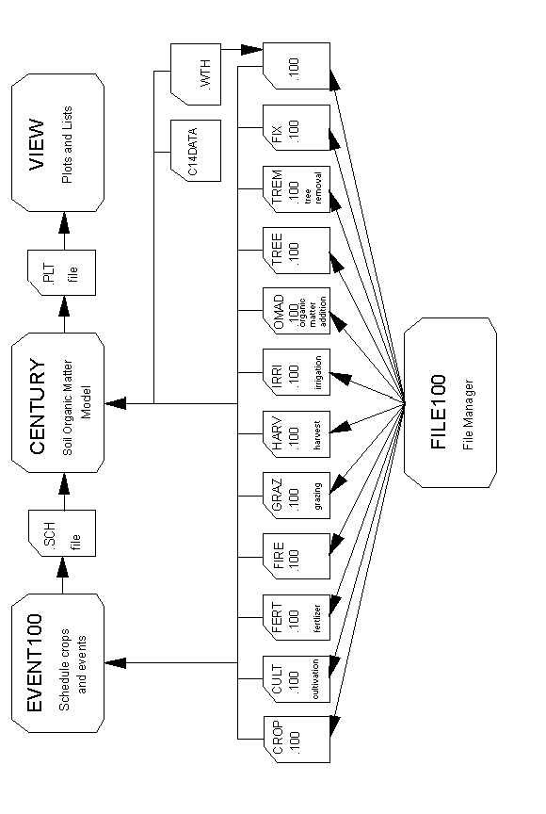
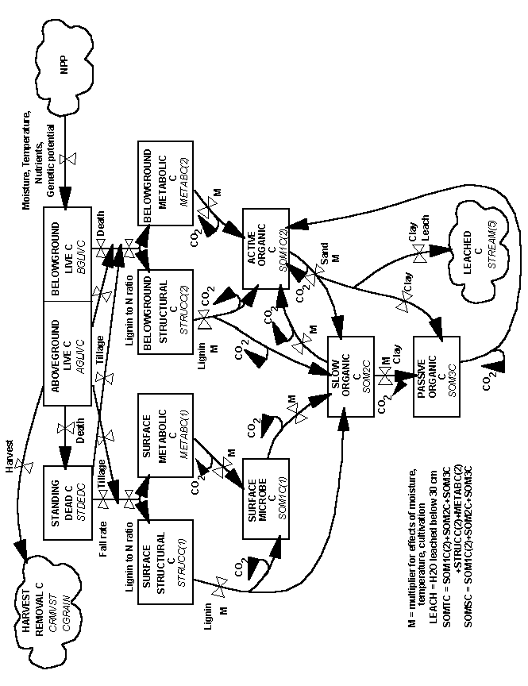
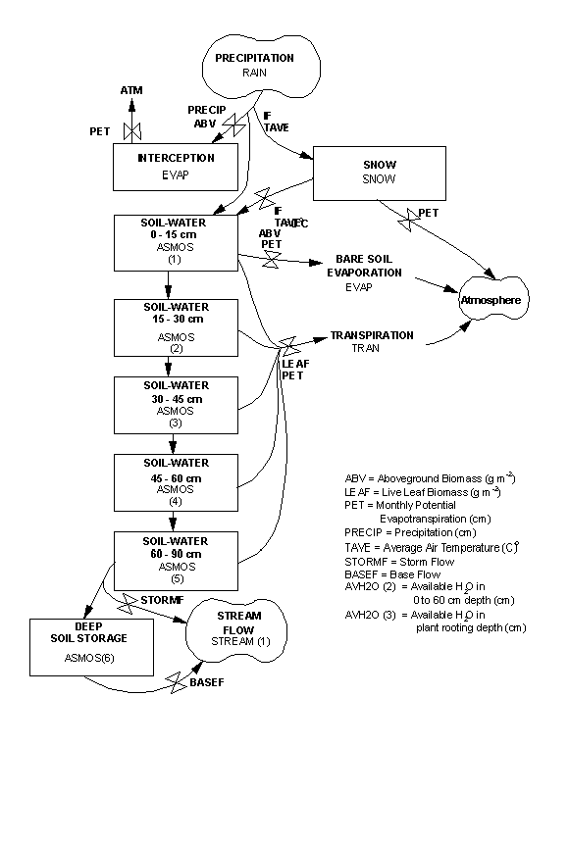
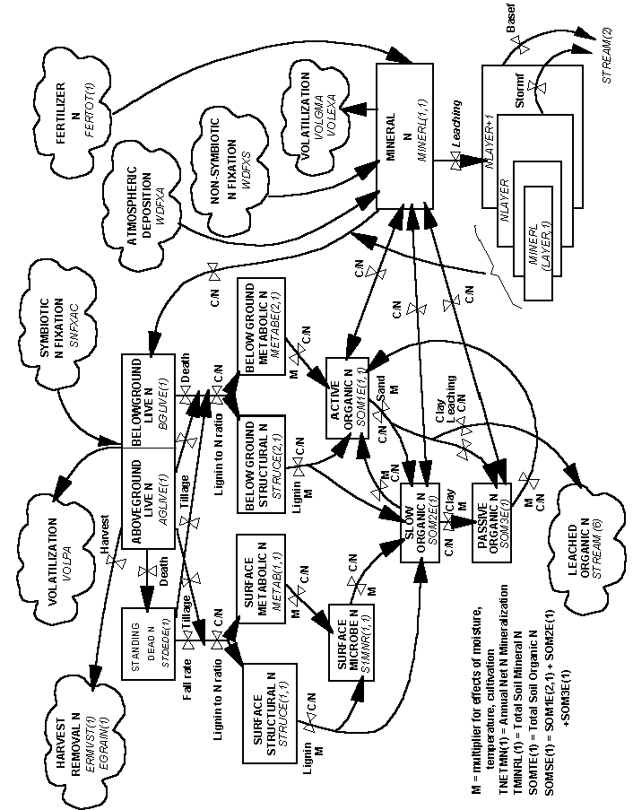
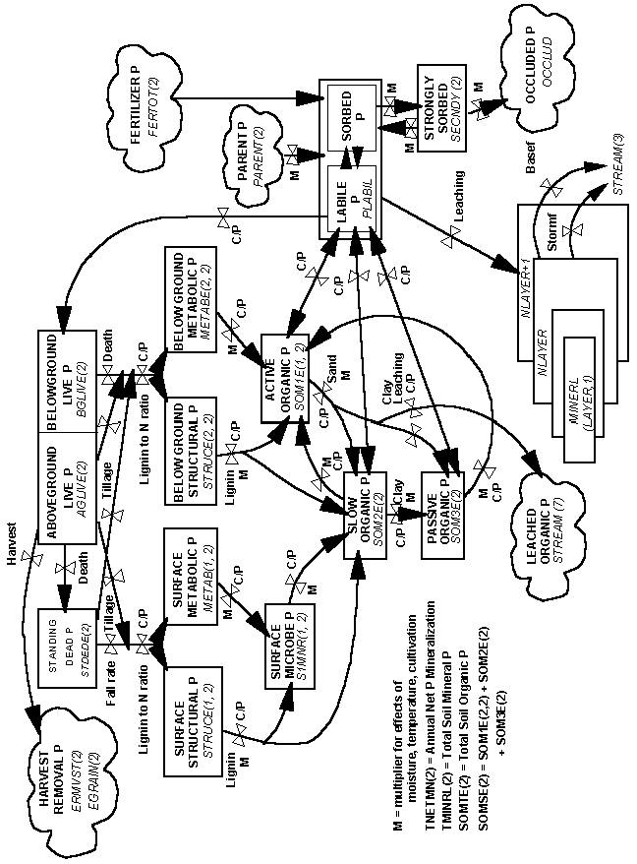
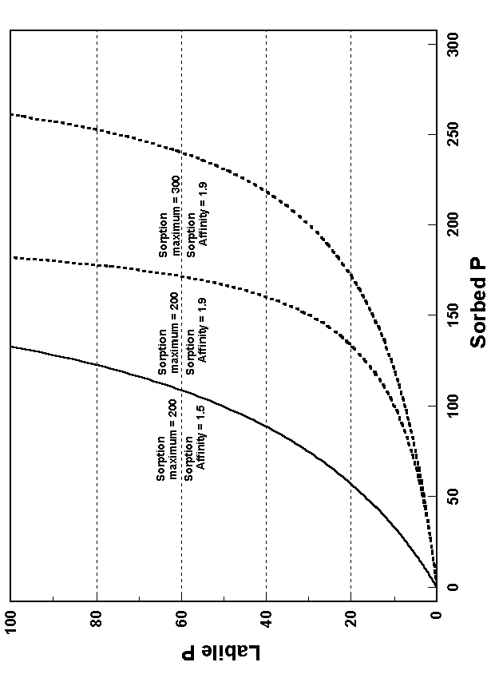
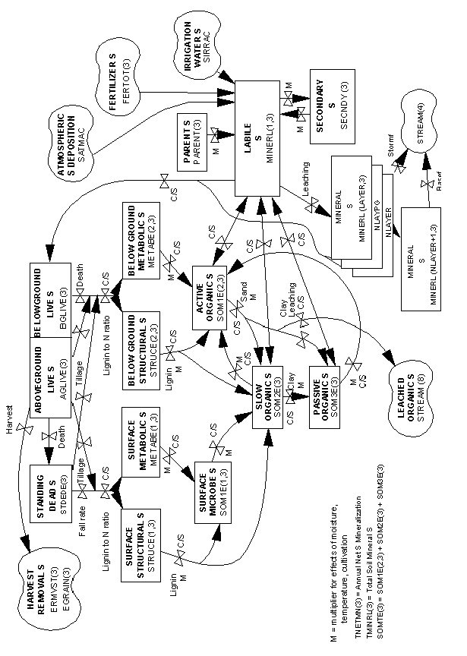
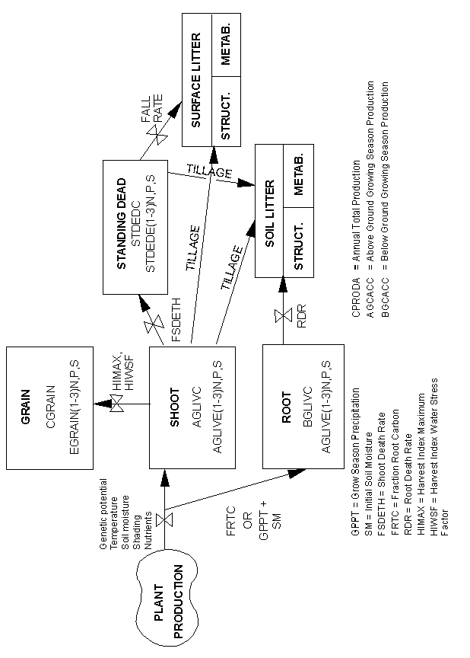
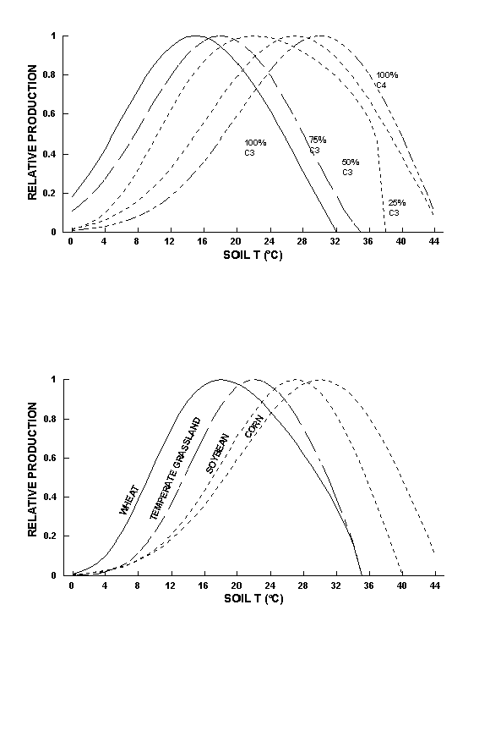
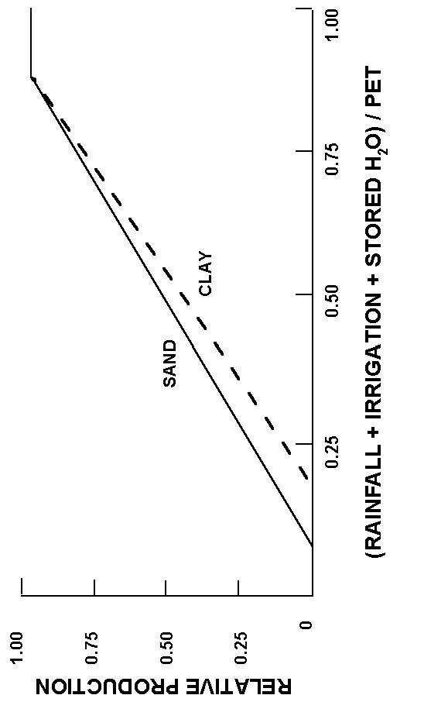
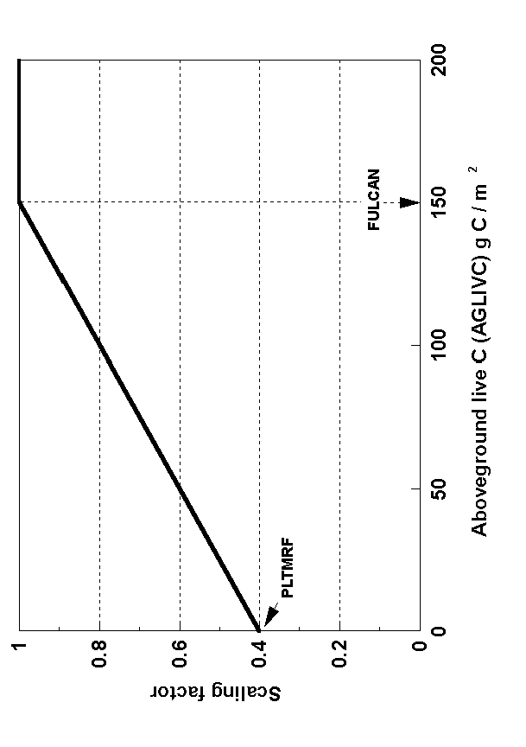
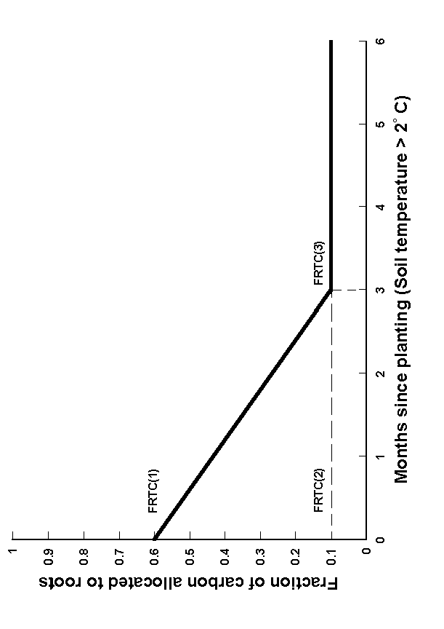
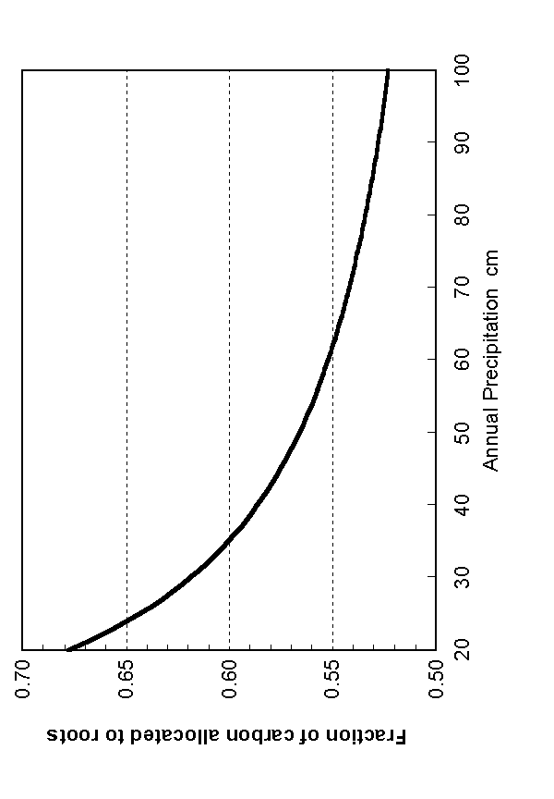
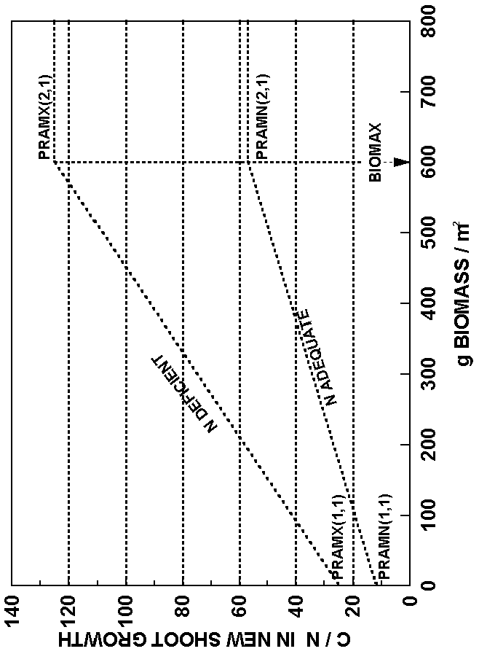
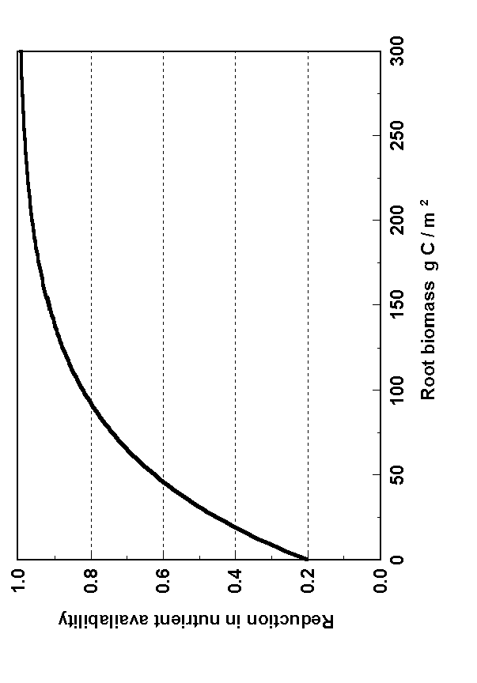
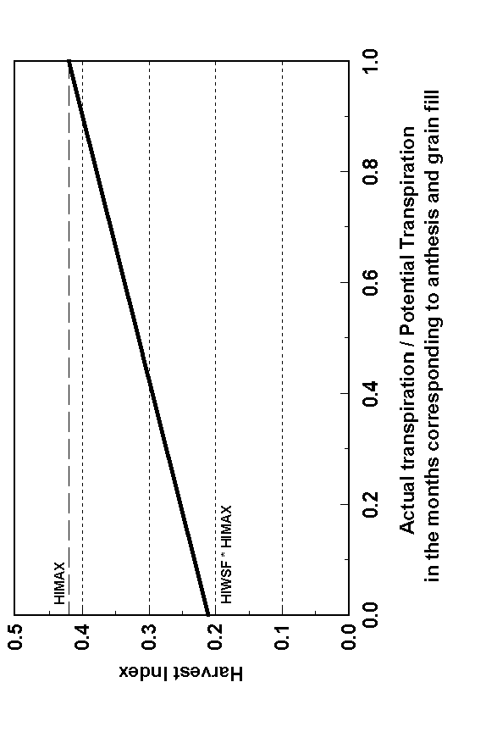
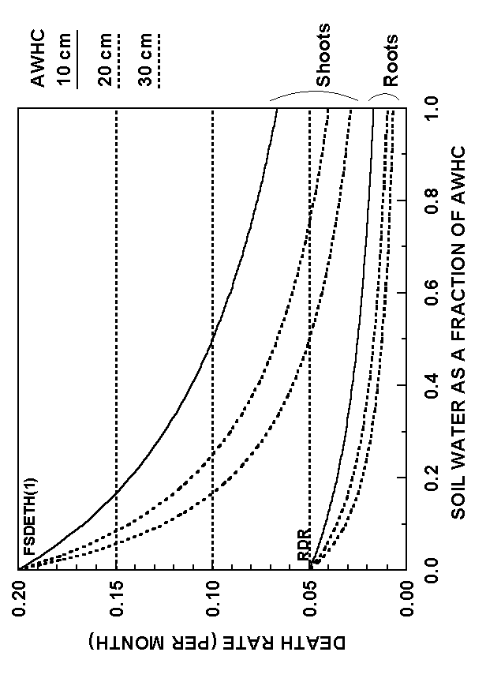
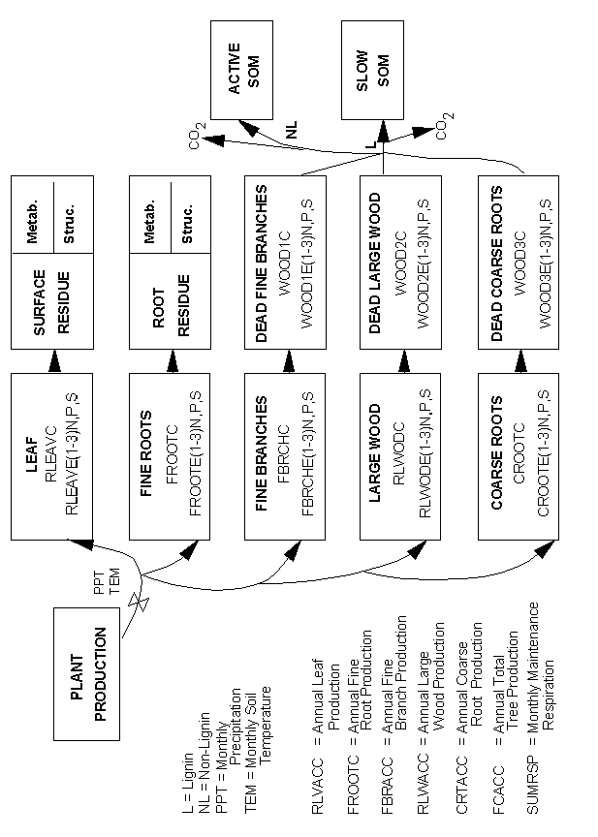
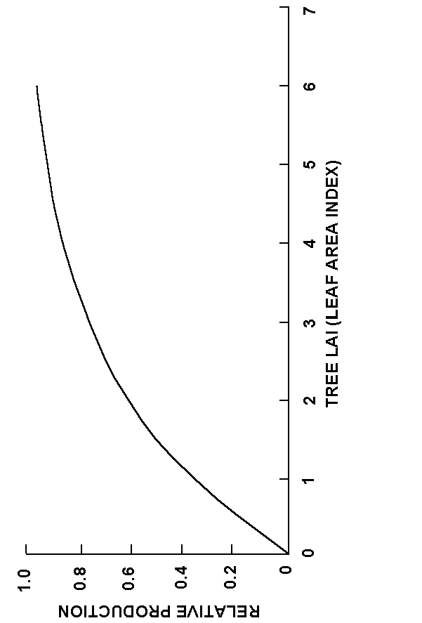
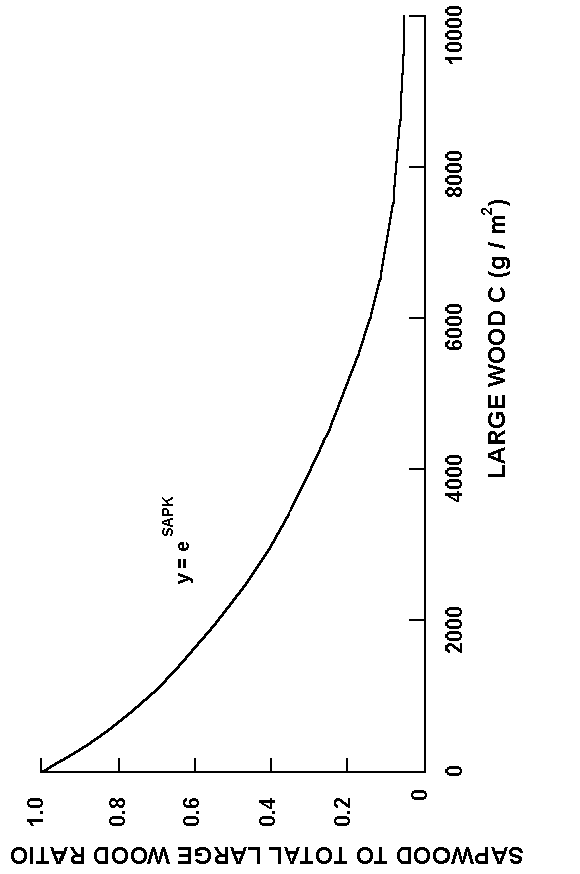
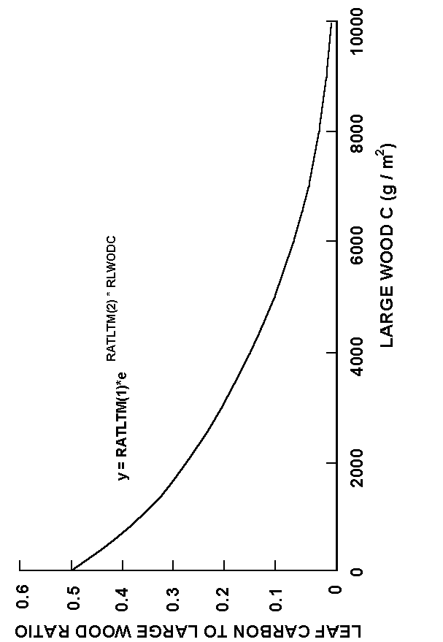
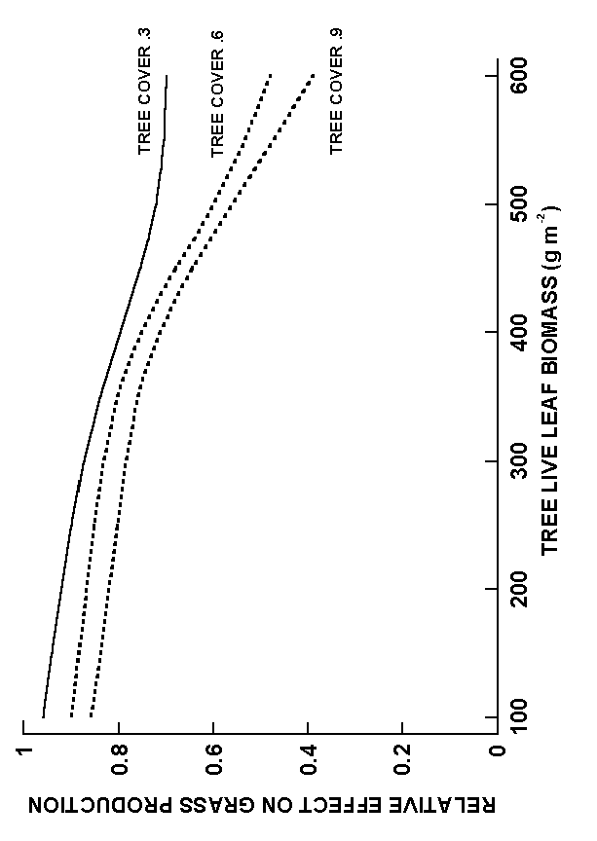
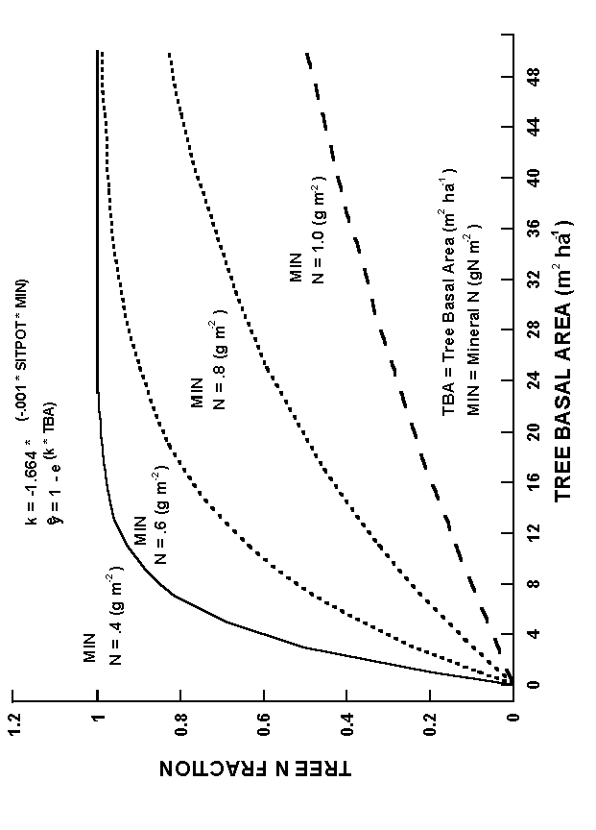
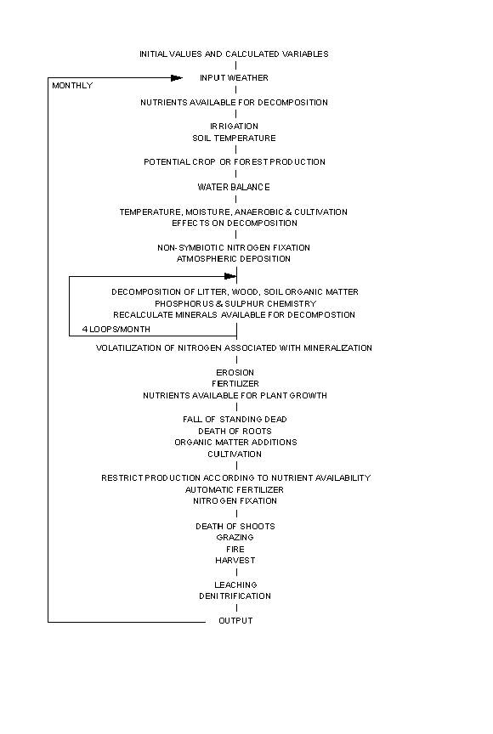

APPENDIX 5
CENTURY DATA FILES

APPENDIX 5 ACTUAL PARAMETER VALUES

Appendix 5.1. CROP.100 Parameter Values

Parameter G5 G4 G3 G2 G1 GCP TG
PRDX(1) 300.0 270.0 300.0 300.0 240.0 350.0 270.0
PPDF(1) 27.0 18.0 22.0 30.0 15.0 22.0 22.0
PPDF(2) 45.0 35.0 38.0 45.0 32.0 35.0 35.0
PPDF(3) 1.0 1.2 0.3 1.0 1.0 0.8 0.8
PPDF(4) 3.0 3.0 5.0 2.5 3.5 3.5 3.5
BIOFLG 1.0 1.0 1.0 1.0 1.0 1.0 1.0
BIOK5 60.0 60.0 60.0 60.0 60.0 200.0 60.0
PLTMRF 1.0 1.0 1.0 1.0 1.0 0.5 0.5
FULCAN 100.0 100.0 100.0 100.0 100.0 150.0 150.0
FRTC(1) 0.0 0.0 0.0 0.0 0.0 0.5 0.5
FRTC(2) 0.0 0.0 0.0 0.0 0.0 0.5 0.5
FRTC(3) 0.0 0.0 0.0 0.0 0.0 1.0 1.0
BIOMAX 400.0 400.0 400.0 400.0 400.0 400.0 400.0
PRAMN(1,1) 30.0 30.0 30.0 30.0 30.0 8.5 30.0
PRAMN(2,1) 390.0 390.0 390.0 390.0 390.0 100.0 133.0
PRAMN(3,1) 340.0 340.0 340.0 340.0 340.0 125.0 133.0
PRAMN(1,2) 90.0 90.0 90.0 90.0 90.0 8.5 90.0
PRAMN(2,2) 390.0 390.0 390.0 390.0 390.0 100.0 160.0
PRAMN(3,2) 340.0 340.0 340.0 340.0 340.0 125.0 160.0
PRAMX(1,1) 35.0 35.0 35.0 35.0 35.0 11.0 35.0
PRAMX(2,1) 440.0 440.0 440.0 440.0 440.0 133.0 200.0
PRAMX(3,1) 440.0 440.0 440.0 440.0 440.0 160.0 200.0
PRAMX(1,2) 95.0 95.0 95.0 95.0 95.0 11.0 95.0
PRAMX(2,2) 440.0 440.0 440.0 440.0 440.0 133.0 260.0
PRAMX(3,2) 440.0 440.0 440.0 440.0 440.0 160.0 260.0
PRBMN(1,1) 50.0 50.0 50.0 50.0 50.0 17.0 50.0
PRBMN(2,1) 390.0 390.0 390.0 390.0 390.0 100.0 390.0
PRBMN(3,1) 340.0 340.0 340.0 340.0 340.0 125.0 340.0
PRBMN(1,2) 0.0 0.0 0.0 0.0 0.0 0.0 0.0
PRBMN(2,2) 0.0 0.0 0.0 0.0 0.0 0.0 0.0
PRBMN(3,2) 0.0 0.0 0.0 0.0 0.0 0.0 0.0
PRBMX(1,1) 55.0 55.0 55.0 55.0 55.0 22.0 55.0
PRBMX(2,1) 420.0 420.0 420.0 420.0 420.0 133.0 420.0
PRBMX(3,1) 420.0 420.0 420.0 420.0 420.0 160.0 420.0
PRBMX(1,2) 0.0 0.0 0.0 0.0 0.0 0.0 0.0
PRBMX(2,2) 0.0 0.0 0.0 0.0 0.0 0.0 0.0
PRBMX(3,2) 0.0 0.0 0.0 0.0 0.0 0.0 0.0
FLIGNI(1,1) 0.02 0.02 0.02 0.02 0.02 0.04 0.02
FLIGNI(2,1) 0.0012 0.0012 0.0012 0.0012 0.0012 0.0 0.0012
FLIGNI(1,2) 0.26 0.26 0.26 0.26 0.26 0.12 0.26
FLIGNI(2,2) -0.0015 -0.0015 -0.0015 -0.0015 -0.0015 0.0 -0.0015
HIMAX 0.0 0.0 0.0 0.0 0.0 0.0 0.0
HIWSF 0.0 0.0 0.0 0.0 0.0 0.0 0.0
HIMON(1) 2.0 2.0 2.0 2.0 2.0 2.0 2.0
HIMON(2) 1.0 1.0 1.0 1.0 1.0 1.0 1.0
EFRGRN(1) 0.0 0.0 0.0 0.0 0.0 0.0 0.0
EFRGRN(2) 0.0 0.0 0.0 0.0 0.0 0.0 0.0
EFRGRN(3) 0.0 0.0 0.0 0.0 0.0 0.0 0.0
VLOSSP 0.15 0.15 0.15 0.15 0.15 0.02 0.04
FSDETH(1) 0.2 0.2 0.2 0.2 0.2 0.3 0.2
FSDETH(2) 0.95 0.95 0.95 0.95 0.95 0.4 0.6
FSDETH(3) 0.2 0.2 0.2 0.2 0.2 0.1 0.2
FSDETH(4) 150.0 150.0 150.0 150.0 150.0 500.0 150.0
FALLRT 0.15 0.15 0.15 0.15 0.15 0.5 0.15
RDR 0.05 0.05 0.05 0.05 0.05 0.6 0.2
RTDTMP 2.0 2.0 2.0 2.0 2.0 2.0 2.0
CRPRTF(1) 0.0 0.0 0.0 0.0 0.0 0.0 0.0
CRPRTF(2) 0.0 0.0 0.0 0.0 0.0 0.0 0.0
CRPRTF(3) 0.0 0.0 0.0 0.0 0.0 0.0 0.0
SNFXMX(1) 0.0 0.0 0.0 0.0 0.0 0.0375 0.0
DEL13C -18.0 -24.0 -21.0 -15.0 -27.0 -27.0 -27.0
CO2IPR(1) 0.0 0.0 0.5 0.0 0.0 0.0 0.0
CO2ITR(1) 0.0 0.0 0.77 0.0 0.0 0.0 0.0
CO2ICE(1,1,1) 0.0 0.0 1.0 0.0 0.0 0.0 0.0
CO2ICE(1,1,2) 0.0 0.0 1.0 0.0 0.0 0.0 0.0
CO2ICE(1,1,3) 0.0 0.0 1.0 0.0 0.0 0.0 0.0
CO2ICE(1,2,1) 0.0 0.0 1.15 0.0 0.0 0.0 0.0
CO2ICE(1,2,2) 0.0 0.0 1.0 0.0 0.0 0.0 0.0
CO2ICE(1,2,3) 0.0 0.0 1.0 0.0 0.0 0.0 0.0
CO2IRS(1) 0.0 0.0 1.0 0.0 0.0 0.0 0.0

Parameter W1 W2 W3
PRDX(1) 300.0 300.0 300.0
PPDF(1) 18.0 18.0 18.0
PPDF(2) 35.0 35.0 35.0
PPDF(3) 0.7 0.7 0.7
PPDF(4) 5.0 5.0 5.0
BIOFLG 0.0 0.0 0.0
BIOK5 1800.0 1800.0 1800.0
PLTMRF 0.4 0.4 0.4
FULCAN 150.0 150.0 150.0
FRTC(1) 0.6 0.6 0.6
FRTC(2) 0.1 0.1 0.1
FRTC(3) 3.0 3.0 3.0
BIOMAX 600.0 600.0 600.0
PRAMN(1,1) 12.0 12.0 12.0
PRAMN(2,1) 100.0 100.0 100.0
PRAMN(3,1) 100.0 100.0 100.0
PRAMN(1,2) 57.0 57.0 57.0
PRAMN(2,2) 160.0 160.0 160.0
PRAMN(3,2) 200.0 200.0 200.0
PRAMX(1,1) 25.0 25.0 25.0
PRAMX(2,1) 200.0 200.0 200.0
PRAMX(3,1) 230.0 230.0 230.0
PRAMX(1,2) 125.0 125.0 125.0
PRAMX(2,2) 260.0 260.0 260.0
PRAMX(3,2) 270.0 270.0 270.0
PRBMN(1,1) 45.0 45.0 45.0
PRBMN(2,1) 390.0 390.0 390.0
PRBMN(3,1) 340.0 340.0 340.0
PRBMN(1,2) 0.0 0.0 0.0
PRBMN(2,2) 0.0 0.0 0.0
PRBMN(3,2) 0.0 0.0 0.0
PRBMX(1,1) 60.0 60.0 60.0
PRBMX(2,1) 420.0 420.0 420.0
PRBMX(3,1) 420.0 420.0 420.0
PRBMX(1,2) 0.0 0.0 0.0
PRBMX(2,2) 0.0 0.0 0.0
PRBMX(3,2) 0.0 0.0 0.0
FLIGNI(1,1) 0.15 0.15 0.15
FLIGNI(2,1) 0.0 0.0 0.0
FLIGNI(1,2) 0.06 0.06 0.06
FLIGNI(2,2) 0.0 0.0 0.0
HIMAX 0.3 0.35 0.42
HIWSF 0.5 0.5 0.5
HIMON(1) 1.0 1.0 1.0
HIMON(2) 0.0 0.0 0.0
EFRGRN(1) 0.6 0.65 0.75
EFRGRN(2) 0.6 0.6 0.6
EFRGRN(3) 0.6 0.6 0.6
VLOSSP 0.04 0.04 0.04
FSDETH(1) 0.0 0.0 0.0
FSDETH(2) 0.0 0.0 0.0
FSDETH(3) 0.0 0.0 0.0
FSDETH(4) 200.0 200.0 200.0
FALLRT 0.12 0.12 0.12
RDR 0.05 0.05 0.05
RTDTMP 2.0 2.0 2.0
CRPRTF(1) 0.0 0.0 0.0
CRPRTF(2) 0.0 0.0 0.0
CRPRTF(3) 0.0 0.0 0.0
SNFXMX(1) 0.0 0.0 0.0
DEL13C -27.0 -27.0 -27.0
CO2IPR(1) 0.0 0.0 1.0
CO2ITR(1) 0.0 0.0 0.77
CO2ICE(1,1,1) 0.0 0.0 1.0
CO2ICE(1,1,2) 0.0 0.0 1.0
CO2ICE(1,1,3) 0.0 0.0 1.0
CO2ICE(1,2,1) 0.0 0.0 1.3
CO2ICE(1,2,2) 0.0 0.0 1.0
CO2ICE(1,2,3) 0.0 0.0 1.0
CO2IRS(1) 0.0 0.0 1.0

Parameter C-HI C6 C5 C4 C3 C2 C1 C
PRDX(1) 650.0 620.0 600.0 550.0 400.0 300.0 250.0 360.0
PPDF(1) 30.0 30.0 30.0 30.0 30.0 30.0 30.0 30.0
PPDF(2) 45.0 45.0 45.0 45.0 45.0 45.0 45.0 45.0
PPDF(3) 1.0 1.0 1.0 1.0 1.0 1.0 1.0 1.0
PPDF(4) 2.5 2.5 2.5 2.5 2.5 2.5 2.5 2.5
BIOFLG 0.0 0.0 0.0 0.0 0.0 0.0 0.0 0.0
BIOK5 1800.0 1800.0 1800.0 1800.0 1800.0 1800.0 1800.0 1800.0
PLTMRF 0.5 0.5 0.5 0.5 0.5 0.5 0.5 0.5
FULCAN 150.0 150.0 150.0 150.0 150.0 150.0 150.0 150.0
FRTC(1) 0.5 0.5 0.5 0.5 0.5 0.5 0.5 0.5
FRTC(2) 0.1 0.1 0.1 0.1 0.1 0.1 0.1 0.1
FRTC(3) 3.0 3.0 3.0 3.0 3.0 3.0 3.0 3.0
BIOMAX 700.0 700.0 700.0 700.0 700.0 700.0 280.0 650.0
PRAMN(1,1) 10.0 10.0 10.0 10.0 10.0 10.0 10.0 10.0
PRAMN(2,1) 150.0 150.0 150.0 150.0 150.0 150.0 150.0 150.0
PRAMN(3,1) 190.0 190.0 190.0 190.0 190.0 190.0 190.0 190.0
PRAMN(1,2) 62.5 62.5 62.5 62.5 62.5 62.5 62.5 62.5
PRAMN(2,2) 150.0 150.0 150.0 150.0 150.0 150.0 150.0 150.0
PRAMN(3,2) 150.0 150.0 150.0 150.0 150.0 150.0 150.0 150.0
PRAMX(1,1) 20.0 20.0 20.0 20.0 20.0 20.0 20.0 16.0
PRAMX(2,1) 230.0 230.0 230.0 230.0 230.0 230.0 230.0 230.0
PRAMX(3,1) 230.0 230.0 230.0 230.0 230.0 230.0 230.0 230.0
PRAMX(1,2) 125.0 125.0 125.0 125.0 125.0 125.0 125.0 95.0
PRAMX(2,2) 230.0 230.0 230.0 230.0 230.0 230.0 230.0 230.0
PRAMX(3,2) 230.0 230.0 230.0 230.0 230.0 230.0 230.0 230.0
PRBMN(1,1) 45.0 45.0 45.0 45.0 45.0 45.0 45.0 45.0
PRBMN(2,1) 390.0 390.0 390.0 390.0 390.0 390.0 390.0 390.0
PRBMN(3,1) 340.0 340.0 340.0 340.0 340.0 340.0 340.0 340.0
PRBMN(1,2) 0.0 0.0 0.0 0.0 0.0 0.0 0.0 0.0
PRBMN(2,2) 0.0 0.0 0.0 0.0 0.0 0.0 0.0 0.0
PRBMN(3,2) 0.0 0.0 0.0 0.0 0.0 0.0 0.0 0.0
PRBMX(1,1) 60.0 60.0 60.0 60.0 60.0 60.0 60.0 60.0
PRBMX(2,1) 420.0 420.0 420.0 420.0 420.0 420.0 420.0 420.0
PRBMX(3,1) 420.0 420.0 420.0 420.0 420.0 420.0 420.0 420.0
PRBMX(1,2) 0.0 0.0 0.0 0.0 0.0 0.0 0.0 0.0
PRBMX(2,2) 0.0 0.0 0.0 0.0 0.0 0.0 0.0 0.0
PRBMX(3,2) 0.0 0.0 0.0 0.0 0.0 0.0 0.0 0.0
FLIGNI(1,1) 0.12 0.12 0.12 0.12 0.12 0.12 0.12 0.12
FLIGNI(2,1) 0.0 0.0 0.0 0.0 0.0 0.0 0.0 0.0
FLIGNI(1,2) 0.06 0.06 0.06 0.06 0.06 0.06 0.06 0.06
FLIGNI(2,2) 0.0 0.0 0.0 0.0 0.0 0.0 0.0 0.0
HIMAX 0.5 0.5 0.45 0.45 0.4 0.35 0.35 0.0
HIWSF 0.0 0.0 0.0 0.0 0.0 0.0 0.5 0.5
HIMON(1) 2.0 2.0 2.0 2.0 2.0 2.0 3.0 3.0
HIMON(2) 1.0 1.0 1.0 1.0 1.0 1.0 2.0 2.0
EFRGRN(1) 0.75 0.75 0.75 0.75 0.75 0.75 0.5 0.7
EFRGRN(2) 0.6 0.6 0.6 0.6 0.6 0.6 0.6 0.6
EFRGRN(3) 0.6 0.6 0.6 0.6 0.6 0.6 0.6 0.6
VLOSSP 0.04 0.04 0.04 0.04 0.04 0.04 0.04 0.04
FSDETH(1) 0.0 0.0 0.0 0.0 0.0 0.0 0.0 0.0
FSDETH(2) 0.0 0.0 0.0 0.0 0.0 0.0 0.0 0.0
FSDETH(3) 0.0 0.0 0.0 0.0 0.0 0.0 0.0 0.0
FSDETH(4) 500.0 500.0 500.0 500.0 500.0 500.0 500.0 500.0
FALLRT 0.1 0.1 0.1 0.1 0.1 0.1 0.1 0.1
RDR 0.05 0.05 0.05 0.05 0.05 0.05 0.05 0.05
RTDTMP 2.0 2.0 2.0 2.0 2.0 2.0 2.0 2.0
CRPRTF(1) 0.0 0.0 0.0 0.0 0.0 0.0 0.0 0.0
CRPRTF(2) 0.0 0.0 0.0 0.0 0.0 0.0 0.0 0.0
CRPRTF(3) 0.0 0.0 0.0 0.0 0.0 0.0 0.0 0.0
SNFXMX(1) 0.0 0.0 0.0 0.0 0.0 0.0 0.0 0.0
DEL13C -15.0 -15.0 -15.0 -15.0 -15.0 -15.0 -15.0 -15.0
CO2IPR(1) 0.0 0.0 0.0 0.0 0.0 0.0 0.0 1.0
CO2ITR(1) 0.0 0.0 0.0 0.0 0.0 0.0 0.0 0.0
CO2ICE(1,1,1) 0.0 0.0 0.0 0.0 0.0 0.0 0.0 0.77
CO2ICE(1,1,2) 0.0 0.0 0.0 0.0 0.0 0.0 0.0 1.0
CO2ICE(1,1,3) 0.0 0.0 0.0 0.0 0.0 0.0 0.0 1.0
CO2ICE(1,2,1) 0.0 0.0 0.0 0.0 0.0 0.0 0.0 1.0
CO2ICE(1,2,2) 0.0 0.0 0.0 0.0 0.0 0.0 0.0 1.0
CO2ICE(1,2,3) 0.0 0.0 0.0 0.0 0.0 0.0 0.0 1.0
CO2IRS(1) 0.0 0.0 0.0 0.0 0.0 0.0 0.0 1.0

Parameter E M SYBN
PRDX(1) 300.0 500.0 300.0
PPDF(1) 27.0 30.0 27.0
PPDF(2) 45.0 45.0 40.0
PPDF(3) 1.0 1.0 1.0
PPDF(4) 3.0 2.5 2.5
BIOFLG 0.0 0.0 0.0
BIOK5 1800.0 1800.0 1800.0
PLTMRF 0.2 0.5 0.5
FULCAN 100.0 150.0 150.0
FRTC(1) 0.3 0.5 0.5
FRTC(2) 0.3 0.0 0.1
FRTC(3) 1.0 1.0 3.0
BIOMAX 400.0 500.0 800.0
PRAMN(1,1) 30.0 10.0 7.55
PRAMN(2,1) 390.0 150.0 150.0
PRAMN(3,1) 340.0 190.0 190.0
PRAMN(1,2) 90.0 72.5 30.0
PRAMN(2,2) 390.0 150.0 150.0
PRAMN(3,2) 340.0 190.0 190.0
PRAMX(1,1) 35.0 20.0 10.0
PRAMX(2,1) 440.0 230.0 230.0
PRAMX(3,1) 440.0 230.0 230.0
PRAMX(1,2) 95.0 95.0 40.0
PRAMX(2,2) 440.0 230.0 230.0
PRAMX(3,2) 440.0 230.0 230.0
PRBMN(1,1) 50.0 45.0 24.0
PRBMN(2,1) 390.0 390.0 390.0
PRBMN(3,1) 340.0 340.0 340.0
PRBMN(1,2) 0.0 0.0 0.0
PRBMN(2,2) 0.0 0.0 0.0
PRBMN(3,2) 0.0 0.0 0.0
PRBMX(1,1) 55.0 60.0 28.0
PRBMX(2,1) 420.0 420. 420.0
PRBMX(3,1) 420.0 420.0 420.0
PRBMX(1,2) 0.0 0.0 0.0
PRBMX(2,2) 0.0 0.0 0.0
PRBMX(3,2) 0.0 0.0 0.0
FLIGNI(1,1) 0.05 0.12 0.12
FLIGNI(2,1) 0.0 0.0 0.0
FLIGNI(1,2) 0.06 0.06 0.06
FLIGNI(2,2) 0.1 0.0 0.0
HIMAX 0.0 0.45 0.31
HIWSF 0.0 0.0 0.0
HIMON(1) 2.0 2.0 2.0
HIMON(2) 1.0 1.0 1.0
EFRGRN(1) 0.0 0.7 0.67
EFRGRN(2) 0.0 0.6 0.6
EFRGRN(3) 0.0 0.6 0.6
VLOSSP 0.15 0.04 0.04
FSDETH(1) 0.2 0.0 0.0
FSDETH(2) 0.95 0.0 0.0
FSDETH(3) 0.2 0.0 0.0
FSDETH(4) 150.0 500.0 500.0
FALLRT 0.18 0.12 0.1
RDR 0.05 0.05 0.05
RTDTMP 2.0 2.0 2.0
CRPRTF(1) 0.0 0.0 0.0
CRPRTF(2) 0.0 0.0 0.0
CRPRTF(3) 0.0 0.0 0.0
SNFXMX(1) 0.0 0.0 0.0375
DEL13C -18.0 -15.0 -27.0
CO2IPR(1) 0.0 0.0 0.0
CO2ITR(1) 0.0 0.0 0.0
CO2ICE(1,1,1) 0.0 0.0 0.0
CO2ICE(1,1,2) 0.0 0.0 0.0
CO2ICE(1,1,3) 0.0 0.0 0.0
CO2ICE(1,2,1) 0.0 0.0 0.0
CO2ICE(1,2,2) 0.0 0.0 0.0
CO2ICE(1,2,3) 0.0 0.0 0.0
CO2IRS(1) 0.0 0.0 0.0
Appendix 5.2. CULT.100 Parameter Values

Parameters P S C ROW R D N H
CULTRA(1) 0.0 0.7 0.0 0.0 0.4 0.05 0.05 1.0
CULTRA(2) 0.1 0.25 0.5 0.0 0.4 0.05 0.05 0.0
CULTRA(3) 0.9 0.05 0.5 0.0 0.2 0.1 0.0 0.0
CULTRA(4) 0.1 0.1 0.5 0.0 0.2 0.05 0.05 0.0
CULTRA(5) 0.9 0.1 0.5 0.0 0.2 0.15 0.05 0.0
CULTRA(6) 0.9 0.1 0.5 0.5 0.2 0.2 0.05 0.0
CULTRA(7) 1.0 1.0 1.0 0.0 1.0 0.2 0.1 1.0
CLTEFF(1) 1.6 1.3 1.6 1.3 1.3 1.1 1.0 1.0
CLTEFF(2) 1.6 1.3 1.6 1.3 1.3 1.1 1.0 1.0
CLTEFF(3) 1.6 1.3 1.6 1.3 1.3 1.1 1.0 1.0
CLTEFF(4) 1.6 1.3 1.6 1.3 1.3 1.1 1.0 1.0
Appendix 5.3. FERT.100 Parameter Values

Parameters A A90 A80 A75
FERAMT(1) 0 0 0 0
FERAMT(2) 0 0 0 0
FERAMT(3) 0 0 0 0
AUFERT 1.0 0.9 0.8 0.75

Parameters N5 N45 N3 N1
FERAMT(1) 5.0 4.5 3.0 1.0
FERAMT(2) 0 0 0 0
FERAMT(3) 0 0 0 0
AUFERT 0 0 0 0

Parameters PS1 PS2 PS3 PS4 PS5
FERAMT(1) 0 0 0 0 0
FERAMT(2) 1.125 2.25 1.75 3.5 5.25
FERAMT(3) 1.375 2.75 2.07 4.14 6.21
AUFERT 0 0 0 0 0

Parameters MAX MED
FERAMT(1) 0 0
FERAMT(2) 0 0
FERAMT(3) 0 0
AUFERT 2.0 1.5
Appendix 5.4. FIRE.100 Parameter Values

Parameters C M H
FLFREM 0.6 0.7 0.8
FDFREM(1) 0.6 0.7 0.8
FDFREM(2) 0.2 0.3 0.4
FRET(1) 0.3 0.2 0.1
FRET(2) 1.0 1.0 1.0
FRET(3) 1.0 1.0 1.0
FRTSH 0.2 0.2 0.2
FNUE(1) 10.0 10.0 10.0
FNUE(2) 30.0 30.0 30.0
Appendix 5.5. FIX.100 Parameter Values

Parameters ONLY ONE OPTION AVAILABLE

ADEP(1) 15 DRESP 0.999 PEFTXB 0.75
ADEP(2) 15 EDEPTH 0.2 PHESP(1) 5
ADEP(3) 15 ELITST 0.4 PHESP(2) 0.0008
ADEP(4) 15 ENRICH 2 PHESP(3) 7.6
ADEP(5) 30 FAVAIL(1) 0.9 PHESP(4) 0.015
ADEP(6) 30 FAVAIL(3) 0.5 PLIGST(1) 3
ADEP(7) 30 FAVAIL(4) 0.4 PLIGST(2) 3
ADEP(8) 30 FAVAIL(5) 0.8 PMCO2(1) 0.55
ADEP(9) 0 FAVAIL(6) 2 PMCO2(2) 0.55
ADEP(10) 0 FLEACH(1) 0.2 PMNSEC(1) 0
AGPPA -40 FLEACH(2) 0.7 PMNSEC(2) 2
AGPPB 7.7 FLEACH(3) 1 PMNSEC(3) 0
ANEREF(1) 1.5 FLEACH(4) 0 PMNTMP 0.004
ANEREF(2) 3 FLEACH(5) 0.1 PMXBIO 600
ANEREF(3) 0.4 FWLOSS(1) 0.8 PMXTMP -0.0035
ANIMPT 2 FWLOSS(2) 0.8 PPARMN(1) 0
AWTL(1) 0.8 FWLOSS(3) 0.65 PPARMN(2) 0.0001
AWTL(2) 0.6 FWLOSS(4) 0.75 PPARMN(3) 0.0005
AWTL(3) 0.4 FXMCA -0.125 PPRPTS(1) 0
AWTL(4) 0.3 FXMCB 0.005 PPRPTS(2) 1
AWTL(5) 0.2 FXMXS 0.35 PPRPTS(3) 0.8
AWTL(6) 0.2 FXNPB 7 PS1CO2(1) 0.45
AWTL(7) 0.2 GREMB 0 PS1CO2(2) 0.55
AWTL(8) 0.2 IDEF 2 PS1S3(1) 0.003
AWTL(9) 0 LHZF(1) 0.2 PS1S3(2) 0.032
AWTL(10) 0 LHZF(2) 0.4 PS2S3(1) 0.003
BGPPA 100 LHZF(3) 0.8 PS2S3(2) 0.009
BGPPB 7 MINLCH 18 PSECMN(1) 0
CO2PPM(1) 350 NSNFIX 0 PSECMN(2) 0.0022
CO2PPM(2) 700 NTSPM 4 PSECMN(3) 0.2
CO2RMP 1 OMLECH(1) 0.01 PSECOC 1E-06
DAMR(1,1) 0 OMLECH(2) 0.04 RAD1P(1,1) -8
DAMR(1,2) 0 OMLECH(3) 18 RAD1P(2,1) 3
DAMR(1,3) 0 P1CO2A(1) 0.6 RAD1P(3,1) 5
DAMR(2,1) 0 P1CO2A(2) 0.17 RAD1P(1,2) -200
DAMR(2,2) 0 P1CO2B(1) 0 RAD1P(2,2) 5
DAMR(2,3) 0 P1CO2B(2) 0.68 RAD1P(3,2) 100
DAMRMN(1) 15 P2CO2 0.55 RAD1P(1,3) -200
DAMRMN(2) 150 P3CO2 0.55 RAD1P(2,3) 5
DAMRMN(3) 150 PABRES 100 RAD1P(3,3) 100
DEC1(1) 3.9 PCEMIC(1,1) 20 RCESTR(1) 150
DEC1(2) 4.9 PCEMIC(1,2)180 RCESTR(2) 500
DEC2(1) 14.8 PCEMIC(1,3)150 RCESTR(3) 500
DEC2(2) 18.5 PCEMIC(2,1) 10 RICTRL 0.015
DEC3(1) 6 PCEMIC(2,2) 80 RIINT 0.8
DEC3(2) 7.3 PCEMIC(2,3) 50 RSPLIG 0.3
DEC4 0.0066 PCEMIC(3,1) 0.02 SEED -1
DEC5 0.2 PCEMIC(3,2)0.0015 SPL(1) 0.99
DECK5 5 PCEMIC(3,3)0.0015 SPL(2) 0.018
DLIGDF -4 PEFTXA 0.25 STRMAX(1) 500
STRMAX(2) 1000
TEXEPP(1) 1
TEXEPP(2) 0.7
TEXEPP(3) 0.0001
TEXEPP(4) 0.00016
TEXEPP(5) 2
TEXESP(1) 1
TEXESP(3) 0.004
TMAX 45
TMELT(1) 0
TMELT(2) 4
TOPT 35
TSHL 2.63
TSHR 0.2
VARAT1(1,1) 14
VARAT1(2,1) 3
VARAT1(3,1) 2
VARAT1(1,2) 100
VARAT1(2,2) 30
VARAT1(3,2) 2
VARAT1(1,3) 80
VARAT1(2,3) 20
VARAT1(3,3) 3
VARAT2(1,1) 18
VARAT2(2,1) 12
VARAT2(3,1) 2
VARAT2(1,2) 200
VARAT2(2,2) 90
VARAT2(3,2) 2
VARAT2(1,3) 200
VARAT2(2,3) 90
VARAT2(3,3) 3
VARAT3(1,1) 8
VARAT3(2,1) 6
VARAT3(3,1) 2
VARAT3(1,2) 200
VARAT3(2,2) 20
VARAT3(3,2) 2
VARAT3(1,3) 200
VARAT3(2,3) 20
VARAT3(3,3) 3
VLOSSE 0.05
VLOSSG 0.03
Appendix 5.6. GRAZ.100 Parameter Values

Parameters GM G GCS W GL GH P
FLGREM 0.1 0.25 0.9 0.15 0.1 0.3 0.6
FDGREM 0.01 0.02 0.9 0.07 0.05 0.15 0.05
GFCRET 0.3 0.3 0.25 0.3 0.3 0.3 0.2
GRET(1) 0.8 0.8 0.7 0.8 0.8 0.8 0.66
GRET(2) 0.95 0.95 0.95 0.95 0.95 0.95 0.95
GRET(3) 0.95 0.95 0.95 0.95 0.95 0.95 0.9
GRZEFF 1.0 1.0 0.0 1.0 0.0 2.0 0.0
FECF(1) 0.5 0.5 0.6 0.5 0.5 0.5 0.32
FECF(2) 0.9 0.9 0.9 0.9 0.9 0.9 0.8
FECF(3) 0.5 0.5 0.5 0.5 0.5 0.5 0.5
FECLIG 0.25 0.25 0.25 0.25 0.25 0.25 0.25
Appendix 5.7. HARV.100 Parameter Values

Parameters GS G R H T
AGLREM 0.0 0.0 0.0 0.2 0.7
BGLREM 0.0 0.0 0.0 0.9 0.7
FLGHRV 1.0 1.0 0.0 0.0 0.0
RMVSTR 0.5 0.0 0.0 0.75 1.0
REMWSD 0.5 0.5 0.0 0.0 0.0
HIBG 0.0 0.0 0.9 0.0 1.0
Appendix 5.8. IRRI.100 Parameter Values

Parameters A50 A25 A15 A75 A95 AF F5 FLOOD
AUIRRI 1.0 1.0 1.0 1.0 1.0 2.0 0.0 0.0
FAWHC 0.75 0.25 0.15 0.75 0.95 0.25 0.0 0.0
IRRAUT 0.0 0.0 0.0 0.0 0.0 10.0 0.0 0.0
IRRAMT 0.0 0.0 0.0 0.0 0.0 0.0 5.0 15.0
Appendix 5.9. OMAD.100 Parameter Values

Parameters M W
ASTGC 100.0 100.0
ASTLBL 0.0 0.0
ASTLIG 0.25 0.15
ASTREC(1) 30.0 80.0
ASTREC(2) 300.0 300.0
ASTREC(3) 300.0 300.0
Appendix 5.10. TREE.100 Parameter Values

Parameters HRDW CONIF CONOR PRTP HRDWD6 BFGN
DECID 1.0 1.0 0.0 0.0 1.0 0.0
PRDX(2) 800.0 1500.0 800.0 800.0 300.0 680.0
PRDX(3) 300.0 400.0 300.0 300.0 3000.0 460.0
PPDF(1) 30.0 0.0 27.0 30.0 22.0 15.0
PPDF(2) 45.0 0.0 45.0 45.0 42.0 32.0
PPDF(3) 1.0 0.0 1.0 1.0 0.3 1.0
PPDF(4) 2.5 0.0 3.0 2.5 7.0 3.5
CERFOR(1,1,1) 39.3 60.0 47.0 40.0 48.0 99.0
CERFOR(1,1,2) 300.0 300.0 300.0 2122.0 745.0 300.0
CERFOR(1,1,3) 300.0 300.0 300.0 0.0 500.0 300.0
CERFOR(1,2,1) 46.9 55.0 81.0 76.0 34.0 100.0
CERFOR(1,2,2) 250.0 250.0 250.0 765.0 652.0 250.0
CERFOR(1,2,3) 250.0 250.0 250.0 0.0 500.0 250.0
CERFOR(1,3,1) 130.0 192.0 168.0 84.0 53.0 790.0
CERFOR(1,3,2) 1100.0 1100.0 1100.0 1366.0 589.0 1100.0
CERFOR(1,3,3) 1100.0 1100.0 1100.0 0.0 1000.0 1100.0
CERFOR(1,4,1) 557.0 261.0 892.0 155.0 405.0 1036.0
CERFOR(1,4,2) 4000.0 4000.0 4000.0 2260.0 2500.0 4000.0
CERFOR(1,4,3) 4000.0 4000.0 4000.0 0.0 1000.0 4000.0
CERFOR(1,5,1) 450.0 740.0 556.0 155.0 120.0 840.0
CERFOR(1,5,2) 4000.0 4000.0 4000.0 2478.0 1409.0 4000.0
CERFOR(1,5,3) 4000.0 4000.0 4000.0 0.0 1000.0 4000.0
CERFOR(2,1,1) 39.3 60.0 47.0 40.0 48.0 99.0
CERFOR(2,1,2) 300.0 300.0 300.0 2122.0 745.0 300.0
CERFOR(2,1,3) 300.0 300.0 300.0 0.0 500.0 300.0
CERFOR(2,2,1) 46.9 55.0 81.0 76.0 34.0 100.0
CERFOR(2,2,2) 250.0 250.0 250.0 765.0 652.0 250.0
CERFOR(2,2,3) 250.0 250.0 250.0 0.0 500.0 250.0
CERFOR(2,3,1) 130.0 192.0 168.0 84.0 53.0 790.0
CERFOR(2,3,2) 1100.0 1100.0 1100.0 1366.0 589.0 1100.0
CERFOR(2,3,3) 1100.0 1100.0 1100.0 0.0 1000.0 1100.0
CERFOR(2,4,1) 557.0 261.0 892.0 155.0 405.0 1036.0
CERFOR(2,4,2) 4000.0 4000.0 4000.0 2260.0 2500.0 4000.0
CERFOR(2,4,3) 4000.0 4000.0 4000.0 0.0 1000.0 4000.0
CERFOR(2,5,1) 450.0 740.0 556.0 155.0 120.0 840.0
CERFOR(2,5,2) 4000.0 4000.0 4000.0 2478.0 1409.0 4000.0
CERFOR(2,5,3) 4000.0 4000.0 4000.0 0.0 1000.0 4000.0
CERFOR(3,1,1) 39.3 60.0 47.0 40.0 48.0 99.0
CERFOR(3,1,2) 300.0 300.0 300.0 2122.0 745.0 300.0
CERFOR(3,1,3) 300.0 300.0 300.0 0.0 500.0 300.0
CERFOR(3,2,1) 46.9 55.0 81.0 76.0 34.0 100.0
CERFOR(3,2,2) 250.0 250.0 250.0 765.0 652.0 250.0
CERFOR(3,2,3) 250.0 250.0 250.0 0.0 500.0 250.0
CERFOR(3,3,1) 130.0 192.0 168.0 84.0 53.0 790.0
CERFOR(3,3,2) 1100.0 1100.0 1100.0 1366.0 589.0 1100.0
CERFOR(3,3,3) 1100.0 1100.0 1100.0 0.0 1000.0 1100.0
CERFOR(3,4,1) 557.0 261.0 892.0 155.0 405.0 1036.0
CERFOR(3,4,2) 4000.0 4000.0 4000.0 2260.0 2500.0 4000.0
CERFOR(3,4,3) 4000.0 4000.0 4000.0 0.0 1000.0 4000.0
CERFOR(3,5,1) 450.0 740.0 556.0 155.0 120.0 840.0
CERFOR(3,5,2) 4000.0 4000.0 4000.0 2478.0 1409.0 4000.0
CERFOR(3,5,3) 4000.0 4000.0 4000.0 0.0 1000.0 4000.0
DECW1 0.2 0.3 0.3 0.5 2.0 0.3
DECW2 0.0 0.0 0.0 0.1 0.6 0.0
DECW3 0.1 0.0 0.0 0.1 0.5 0.0
FCFRAC(1,1) 0.3 0.2 0.3 0.2 0.3 0.3
FCFRAC(2,1) 0.3 0.6 0.3 0.3 0.3 0.3
FCFRAC(3,1) 0.0 0.1 0.0 0.2 0.3 0.0
FCFRAC(4,1) 0.3 0.2 0.4 0.3 0.1 0.4
FCFRAC(5,1) 0.1 0.1 0.1 0.2 0.1 0.1
FCFRAC(1,2) 0.3 0.2 0.3 0.3 0.2 0.2
FCFRAC(2,2) 0.3 0.3 0.3 0.4 0.4 0.1
FCFRAC(3,2) 0.0 0.1 0.0 0.2 0.1 0.2
FCFRAC(4,2) 0.3 0.4 0.4 0.1 0.3 0.5
FCFRAC(5,2) 0.1 0.1 0.1 0.1 0.1 0.1
LEAFDR(1) 0.0 0.0 0.0 0.0 0.0 0.0
LEAFDR(2) 0.0 0.0 0.0 0.0 0.0 0.0
LEAFDR(3) 0.0 0.0 0.0 0.0 0.0 0.0
LEAFDR(4) 0.0 0.0 0.0 0.0 0.0 0.0
LEAFDR(5) 0.0 0.0 0.0 0.0 0.0 0.0
LEAFDR(6) 0.0 0.0 0.0 0.0 0.0 0.0
LEAFDR(7) 0.0 0.0 0.0 0.0 0.0 0.0
LEAFDR(8) 0.0 0.0 0.0 0.0 0.0 0.0
LEAFDR(9) 0.1 0.0 0.0 0.0 0.0 0.0
LEAFDR(10) 0.8 0.0 0.0 0.0 0.0 0.0
LEAFDR(11) 0.0 0.0 0.0 0.0 0.0 0.0
LEAFDR(12) 0.0 0.0 0.0 0.0 0.0 0.0
BTOLAI 0.008232 0.008232 0.008232 0.008232 0.008232 0.008232
KLAI 1000.0 20000.0 20000.0 1000.0 1000.0 700.0
LAITOP -0.5 -0.5 -0.5 -0.5 -0.5 -0.5
MAXLAI 4.0 20.0 20.0 4.0 4.0 4.0
MAXLDR 0.0 0.0 0.0 0.0 0.0 0.0
FORRTF(1) 0.5 0.5 0.5 0.5 0.5 0.5
FORRTF(2) 0.0 0.0 0.0 0.0 0.0 0.0
FORRTF(3) 0.0 0.0 0.0 0.0 0.0 0.0
SAPK 1500.0 5000.0 5000.0 1500.0 1500.0 1500.0
SWOLD 6.0 6.0 6.0 0.0 10.0 0.0
WDLIG(1) 0.2 0.2 0.2 0.2 0.2 0.2
WDLIG(2) 0.3 0.2 0.2 0.2 0.3 0.2
WDLIG(3) 0.3 0.3 0.4 0.3 0.3 0.4
WDLIG(4) 0.2 0.4 0.4 0.4 0.3 0.4
WDLIG(5) 0.2 0.4 0.4 0.4 0.3 0.4
WOODDR(1) 0.0 0.0 0.0 0.0 0.0 0.0
WOODDR(2) 0.1 0.1 0.1 0.1 0.0 0.1
WOODDR(3) 0.0 0.0 0.0 0.0 0.0 0.0
WOODDR(4) 0.0 0.0 0.0 0.0 0.0 0.0
WOODDR(5) 0.0 0.0 0.0 0.0 0.0 0.0
SNFXMX(2) 0.0 0.0 0.0 0.0 0.0 0.0
DEL13C 0.0 0.0 0.0 0.0 0.0 0.0
CO2IPR(2) 0.0 0.0 0.0 0.0 0.0 0.0
CO2ITR(2) 0.0 0.0 0.0 0.0 0.0 0.0
CO2ICE(2,1,1) 0.0 0.0 0.0 0.0 0.0 0.0
CO2ICE(2,1,2) 0.0 0.0 0.0 0.0 0.0 0.0
CO2ICE(2,1,3) 0.0 0.0 0.0 0.0 0.0 0.0
CO2ICE(2,2,1) 0.0 0.0 0.0 0.0 0.0 0.0
CO2ICE(2,2,2) 0.0 0.0 0.0 0.0 0.0 0.0
CO2ICE(2,2,3) 0.0 0.0 0.0 0.0 0.0 0.0
CO2IRS(2) 0.0 0.0 0.0 0.0 0.0 0.0
BASFC2 1.0 1.0 1.0 1.0 1.0 1.0
BASFCT 40.0 400.0 400.0 400.0 400.0 400.0
SITPOT 4800.0 2400.0 4800.0 2400.0 2400.0 2400.0
Appendix 5.11. TREM.100 Parameter Values

Parameters SAMP
EVNTYP 0.0
REMF(1) 0.2
REMF(2) 0.1
REMF(3) 0.1
REMF(4) 0.6
REMF(5) 0.2
FD(1) 0.0
FD(2) 0.0
RETF(1,1) 0.8
RETF(1,2) 0.8
RETF(1,3) 0.8
RETF(1,4) 0.0
RETF(2,1) 0.8
RETF(2,2) 0.8
RETF(2,3) 0.8
RETF(2,4) 0.0
RETF(3,1) 0.8
RETF(3,2) 0.8
RETF(3,3) 0.8
RETF(3,4) 0.0
Appendix 5.12. <SITE.100> Parameter Values

Parameters Only one option allowed
Climate values TMX2M(3) 10.60 EPNFS(1) -0.92
PRECIP(1) 1.00 TMX2M(4) 16.20 EPNFS(2) 0.03
PRECIP(2) 0.85 TMX2M(5) 21.60 SATMOS(1) 0.00
PRECIP(3) 2.00 TMX2M(6) 27.50 SATMOS(2) 0.00
PRECIP(4) 3.05 TMX2M(7) 31.40 SIRRI 0.00
PRECIP(5) 5.95 TMX2M(8) 30.30 Organic matter values
PRECIP(6) 4.45 TMX2M(9) 25.70 SOM1CI(1,1) 56.00
PRECIP(7) 3.20 TMX2M(10) 19.10 SOM1CI(1,2) 0.00
PRECIP(8) 2.95 TMX2M(11) 10.60 SOM1CI(2,1) 60.00
PRECIP(9) 3.00 TMX2M(12) 5.90 SOM1CI(2,2) 15.00
PRECIP(10) 1.90 Site and control SOM2CI(1) 3700.00
PRECIP(11) 1.20 IVAUTO 1.00 SOM2CI(2) 0.00
PRECIP(12) 0.80 NELEM 1.00 SOM3CI(1) 2150.00
PRCSTD(1) 0.68 SITLAT 39.52 SOM3CI(2) 0.00
PRCSTD(2) 0.78 SITLNG 104.60 RCES1(1,1) 10.00
PRCSTD(3) 1.77 SAND 0.20 RCES1(1,2) 50.00
PRCSTD(4) 2.73 SILT 0.30 RCES1(1,3) 50.00
PRCSTD(5) 4.98 CLAY 0.50 RCES1(2,1) 10.00
PRCSTD(6) 4.17 BULKD 1.20 RCES1(2,2) 50.00
PRCSTD(7) 2.57 NLAYER 5.00 RCES1(2,3) 50.00
PRCSTD(8) 2.58 NLAYPG 5.00 RCES2(1) 17.00
PRCSTD(9) 2.91 DRAIN 0.50 RCES2(2) 117.00
PRCSTD(10) 1.99 BASEF 0.30 RCES2(3) 117.00
PRCSTD(11) 1.07 STORMF 0.60 RCES3(1) 7.00
PRCSTD(12) 0.97 SWFLAG 1.00 RCES3(2) 62.00
PRCSKW(1) 0.00 AWILT(1) 0.20 RCES3(3) 62.00
PRCSKW(2) 0.00 AWILT(2) 0.20 CLITTR(1,1) 100.00
PRCSKW(3) 0.00 AWILT(3) 0.20 CLITTR(1,2) 0.00
PRCSKW(4) 0.00 AWILT(4) 0.20 CLITTR(2,1) 100.00
PRCSKW(5) 0.00 AWILT(5) 0.20 CLITTR(2,2) 0.00
PRCSKW(6) 0.00 AWILT(6) 0.20 RCELIT(1,1) 66.00
PRCSKW(7) 0.00 AWILT(7) 0.20 RCELIT(1,2) 300.00
PRCSKW(8) 0.00 AWILT(8) 0.20 RCELIT(1,3) 300.00
PRCSKW(9) 0.00 AWILT(9) 0.20 RCELIT(2,1) 66.00
PRCSKW(10) 0.00 AWILT(10) 0.20 RCELIT(2,2) 300.00
PRCSKW(11) 0.00 AFIEL(1) 0.30 RCELIT(2,3) 300.00
PRCSKW(12) 0.00 AFIEL(2) 0.30 AGLCIS(1) 0.00
TMN2M(1) -11.00 AFIEL(3) 0.30 AGLCIS(2) 0.00
TMN2M(2) -8.40 AFIEL(4) 0.30 AGLIVE(1) 0.00
TMN2M(3) -4.90 AFIEL(5) 0.30 AGLIVE(2) 0.00
TMN2M(4) -0.20 AFIEL(6) 0.30 AGLIVE(3) 0.00
TMN2M(5) 5.10 AFIEL(7) 0.30 BGLCIS(1) 0.00
TMN2M(6) 9.90 AFIEL(8) 0.30 BGLCIS(2) 0.00
TMN2M(7) 13.50 AFIEL(9) 0.30 BGLIVE(1) 3.60
TMN2M(8) 12.30 AFIEL(10) 0.30 BGLIVE(2) 0.45
TMN2M(9) 7.00 PH 6.80 BGLIVE(3) 0.45
TMN2M(10) 0.80 PSLSRB 1.00 STDCIS(1) 50.00
TMN2M(11) -5.30 SORPMX 100.00 STDCIS(2) 0.00
TMN2M(12) -9.50 External nutrients STDEDE(1) 0.80
TMX2M(1) 4.70 EPNFA(1) 0.21 STDEDE(2) 0.20
TMX2M(2) 7.50 EPNFA(2) 0.00 STDEDE(3) 0.20
Forest organic matter MINERL(6,2) 0.00
RLVCIS(1) 0.00 MINERL(7,2) 0.00
RLVCIS(2) 0.00 MINERL(8,2) 0.00
RLEAVE(1) 0.00 MINERL(9,2) 0.00
RLEAVE(2) 0.00 MINERL(10,2) 0.00
RLEAVE(3) 0.00 MINERL(1,3) 0.50
FBRCIS(1) 0.00 MINERL(2,3) 0.00
FBRCIS(2) 0.00 MINERL(3,3) 0.00
FBRCHE(1) 0.00 MINERL(4,3) 0.00
FBRCHE(2) 0.00 MINERL(5,3) 0.00
FBRCHE(3) 0.00 MINERL(6,3) 0.00
RLWCIS(1) 0.00 MINERL(7,3) 0.00
RLWCIS(2) 0.00 MINERL(8,3) 0.00
RLWODE(1) 0.00 MINERL(9,3) 0.00
RLWODE(2) 0.00 MINERL(10,3) 0.00
RLWODE(3) 0.00 PARENT(1) 0.00
FRTCIS(1) 0.00 PARENT(2) 50.00
FRTCIS(2) 0.00 PARENT(3) 50.00
FROOTE(1) 0.00 SECNDY(1) 0.00
FROOTE(2) 0.00 SECNDY(2) 15.00
FROOTE(3) 0.00 SECNDY(3) 2.00
CRTCIS(1) 0.00 OCCLUD 0.00
CRTCIS(2) 0.00 Water initial values
CROOTE(1) 0.00 RWCF(1) 0.00
CROOTE(2) 0.00 RWCF(2) 0.00
CROOTE(3) 0.00 RWCF(3) 0.00
WD1CIS(1) 0.00 RWCF(4) 0.00
WD1CIS(2) 0.00 RWCF(5) 0.00
WD2CIS(1) 0.00 RWCF(6) 0.00
WD2CIS(2) 0.00 RWCF(7) 0.00
WD3CIS(1) 0.00 RWCF(8) 0.00
WD3CIS(2) 0.00 RWCF(9) 0.00
W1LIG 0.30 RWCF(10) 0.00
W2LIG 0.30 SNLQ 0.00
W3LIG 0.30 SNOW 0.00
Mineral initial values
MINERL(1,1) 0.25
MINERL(2,1) 0.00
MINERL(3,1) 0.00
MINERL(4,1) 0.00
MINERL(5,1) 0.00
MINERL(6,1) 0.00
MINERL(7,1) 0.00
MINERL(8,1) 0.00
MINERL(9,1) 0.00
MINERL(10,1) 0.00
MINERL(1,2) 0.50
MINERL(2,2) 0.00
MINERL(3,2) 0.00
MINERL(4,2) 0.00
MINERL(5,2) 0.00

